Phloroglucinol and hydrates
(Last updated 11 November 2024)
Figure 1. The molecular diagram of Phloroglucinol.
Phloroglucinol was studied by Doris Braun as part of a series of compounds which have hydrate and anhydrate crystal structures.

CSP studies
REFCODE | PHGLOL
Formula | C6 H6 O3
Common Name | Phloroglucinol
IUPAC Systematic Name | 1,3,5-trihydroxybenzene
CSD Refcodes | PHGLOL01
Search Identifier | A
Scientist | Doris Braun
Date | 2012
Publication | Braun DE, Tocher DA, Price SL, Griesser UJ 2012. The Journal of Physical Chemistry B 116, 3961-3972.
Energy Model | 1
Study_ID | 20
Programs | Rigid CrystalPredictor, DMACRYS (2.0.2)
Location on S Drive | \CHEMISTRY_CPOSS\Phloroglucinol\Phloroglucinol_CP
Potential Description | CrystalPredictor GDMA2 (MP2/6-31G(d,p)) + FIT
Energy Model | 2
Study_ID | 11 (published)
Programs | Study_ID=20, DMAflex (2.0), DMACRYS (1.1.1)
Location on S Drive | \CHEMISTRY_CPOSS\Phloroglucinol\Phloroglucinol_CO
Potential Description | CrystalOptimizer GDMA2 (MP2/6-31G(d,p)) + FIT
Scientist | Louise Price
Date | January 2024
Energy Model | 2a
Study_ID | 12
Programs | Study_ID=20, CrystalOptimizer (2.4.7.1), DMACRYS (2.3.1.1)
Location on S Drive | \CHEMISTRY_CPOSS\Phloroglucinol\Phloroglucinol_CO2
Potential Description | CrystalOptimizer GDMA2 (MP2/6-31G(d,p)) + FIT
Energy Model | 3
Study_ID | 30
Programs | Study_ID=12, DMACRYS (2.3.1.1), BZ-averaged props
Location on S Drive | \CHEMISTRY_CPOSS\Phloroglucinol\Phloroglucinol_PCM
Potential Description | GDMA2.2(PCMdielectric3(MP2/6-31G(d,p))) + FIT
REFCODE | PHGLOH
Formula | C6 H6 O3 - 2(H2 O1)
Common Name | Phloroglucinol dihydrate
IUPAC Systematic Name | 1,3,5-trihydroxybenzene dihydrate
CSD Refcodes | PHGLOH02 (proton disordered)
Search Identifier | B
Scientist | Doris Braun
Date | 2012
Publication | Braun DE, Tocher DA, Price SL, Griesser UJ 2012. J. Phys. Chem. B 116, 3961-3972.
Energy Model | 1
Study_ID | 20
Programs | Rigid CrystalPredictor (unknown), DMACRYS (2.0.2)
Location on S Drive | \CHEMISTRY_CPOSS\Phloroglucinol\Phloroglucinoldihydrate_CP
Potential Description | CrystalPredictor GDMA2 (MP2/6-31G(d,p)) (PBE1PBE/aug-cc-pvtz for water) + FIT
Energy Model | 2
Study_ID | 10
Programs | Study_ID=20, DMAflex (2.0), DMACRYS (1.1.1)
Location on S Drive | \CHEMISTRY_CPOSS\Phloroglucinol\Phloroglucinoldihydrate_CO
Potential Description | CrystalOptimizer GDMA2 (MP2/6-31G(d,p)) + FIT

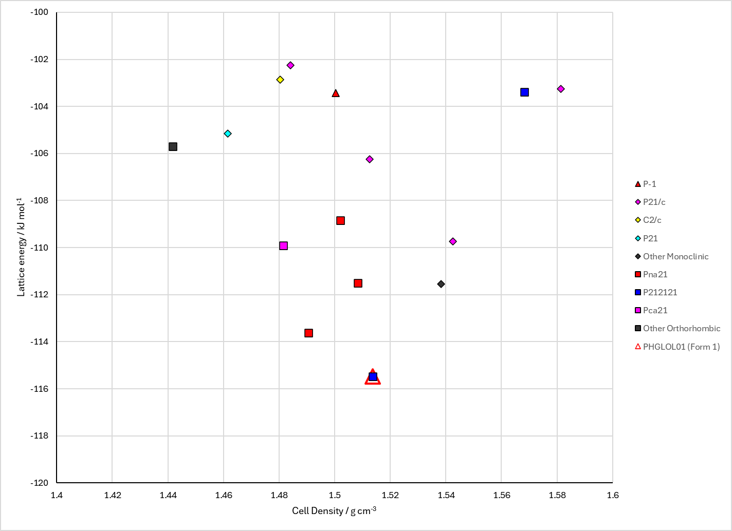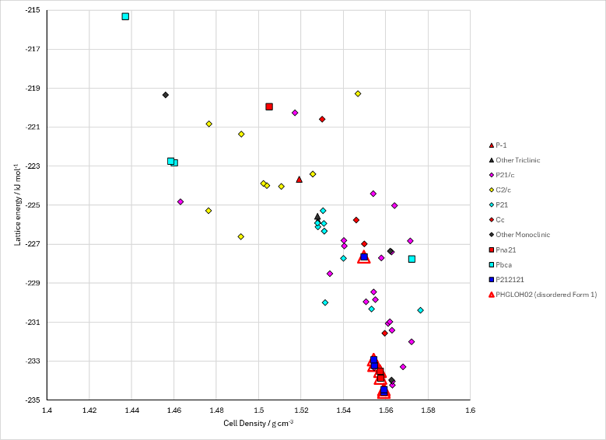
Figure 2. Crystal energy landscape of (left) phloroglucinol and (right) phloroglucinol dihydrate from previous work.

CSD structures (CSD version 5.44 with Jun and Sep Nov 2023 updates)
Table 1. Crystallographic information for CSD entries for phloroglucinol. Different forms (including hydrates) are coloured differently.
REFCODE | space group | Z’ | a / Å | b / Å | c / Å | α / ° | β / ° | γ / ° | density / g cm⁻³ | Form
PHGLOH | Pnma | 0.5 | 6.73 | 13.58 | 8.09 | 90 | 90 | 90 | 1.457 | Dihydrate
PHGLOH01 | Pnma | 0.5 | 6.5841 | 13.5128 | 8.0382 | 90 | 90 | 90 | 1.506 | Dihydrate
PHGLOH02 | Pnma | 0.5 | 6.5942 | 13.5455 | 8.0423 | 90 | 90 | 90 | 1.499 | Dihydrate
PHGLOH03 | Pnma | 0.5 | 6.5876 | 13.517 | 8.0345 | 90 | 90 | 90 | 1.505 | Dihydrate
PHGLOH04 | Pnma | 0.5 | 6.6209 | 13.5606 | 8.0462 | 90 | 90 | 90 | 1.491 | Dihydrate
PHGLOL | P212121 | 1 | 4.83 | 9.37 | 12.56 | 90 | 90 | 90 | 1.474 | I
PHGLOL01 | P212121 | 1 | 4.7778 | 9.3581 | 12.4433 | 90 | 90 | 90 | 1.506 | I

Table 2. Experimental information for CSD entries for phloroglucinol and phloroglucinol dihydrate.
REFCODE | space group | R factor | T / K | Year | Comments
PHGLOH | Pnma | 23 | 295 | 1957 | Recrystallized from water.¹
PHGLOH01 | Pnma | 4.88 | 100 | 2009 | Hydrogen disorder. Private communication.
PHGLOH02 | Pnma | 3.57 | 100 | 2011 | Hydrogen disorder. Crystallization method not reported.²
PHGLOH03 | Pnma | 4.63 | 100 | 2011 | Hydrogen disorder. Cocrystallization of 2,4,6-trihydroxybenzoic acid and benzamide (phloroglucinol is the main impurity in commercially available 2,4,6-trihydroxybenzoic acid).³
PHGLOH04 | Pnma | 3.73 | 293 | 2012 | Hydrogen disorder. Slow cooling crystallization from water.⁴
PHGLOL | P212121 | 7.5 | 295 | 1965 | Sublimation under vacuum.⁵
PHGLOL01 | P212121 | 2.65 | 105 | 2008 | Crystallization method not reported.⁶

Other notes

1. S. C. Wallwork and H. M. Powell, Acta Crystallographica, 1957, 10, 48-52.
2. L. H. Thomas, G. A. Craig, C. A. Morrison, A. M. Reilly and C. C. Wilson, Crystal Growth & Design, 2011, 11, 2045-2049.
3. C. C. Seaton and A. Parkin, Crystal Growth & Design, 2011, 11, 1502-1511.
4. D. E. Braun, D. A. Tocher, S. L. Price and U. J. Griesser, Journal of Physical Chemistry B, 2012, 116, 3961-3972.
5. K. Maartmann-Moe, Acta Crystallographica, 1965, 19, 155-157.
6. C. H. Gorbitz, M. Kaboli, M. L. Read and K. Vestli, Acta Crystallographica Section E, 2008, 64, o2023.

