Propenal
(Last updated March 2026)
Figure 1. The molecular diagram of Propenal.

CSP studies
REFCODE | AXOSOW
Formula | C3 H4 O1
Common Name | Propenal
IUPAC Systematic Name | Propenal
Other Names
CSD Refcodes | AXOSOW
Search Identifier | A
Scientist | Unknown
Date | 2008
Publication | Day GM, 2009. Acta Crystallogr , Sect B 65, 107-125.
Energy model | 1
Study_ID | 0
Programs | MOLPAK, DMAREL (4.1.1)
Location on S Drive | \CHEMISTRY_CPOSS\0-EarlySearches\home\louise_price.eminerals\BlindTestXII\fit
Potential Description | DMA + FIT
Intramolecular Description | MP2/6-31G(d,p)
Search Identifier | B
Scientist | Unknown
Date | 2008
Publication | See Study_ID=0
Energy model | 1
Study_ID | 1
Programs | MOLPAK, DMAREL (4.3.6)
Location on S Drive | \CHEMISTRY_CPOSS\0-EarlySearches\home\louise_price.eminerals\BlindTestXII\williams
Potential Description | DMA + Williams99
Intramolecular Description | MP2/6-31G(d,p)

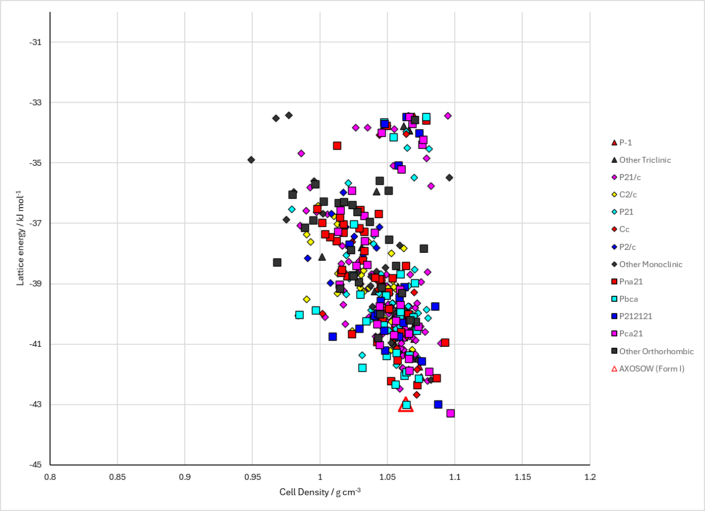
Figure 2. Crystal energy landscape of Propenal from previous work.

CSD structures (CSD version 6.01)

Table 1. Crystallographic information for CSD entries for Propenal. Different polymorphs are coloured differently.
REFCODE | space group | Z’ | a / Å | b / Å | c / Å | α / ° | β / ° | γ / ° | density / g cm⁻³ | Form
AXOSOW | Pbca | 1.0 | 7.134 | 9.694 | 9.93 | 90.0 | 90.0 | 90.0 | 1.0845 | None
AXOSOW01 | Pbca | 1.0 | 6.97 | 9.514 | 9.752 | 90.0 | 90.0 | 90.0 | 1.1516 | None
AXOSOW03 | Pbca | 1.0 | 6.97 | 9.514 | 9.752 | 90.0 | 90.0 | 90.0 | 1.1516 | None

Table 2. Experimental information for CSD entries for Propenal.
REFCODE | space group | R factor | T / K | Year | Comments
AXOSOW | Pbca | 3.5 | at 133 K | 2011 | 10.1039/c0cp02236e
AXOSOW01 | Pbca | 4.47 | 150 K | 2009 | 10.1107/S0108768109004066
AXOSOW03 | Pbca | 4.47 | 150 K | 2015 | None

Make this table include whether polymorphs are solution-grown, sublimation grown, templated or otherwise. Add references.

Other notes

