Alloxan
(Last updated April 2026)
Figure 1. The molecular diagram of Alloxan.

CSP studies
REFCODE | ALOXAN
Formula | C4 H2 N2 O4
Common Name | Alloxan
IUPAC Systematic Name | Pyrimidine-2,4,5,6-tetraone
Other Names
CSD Refcodes | ALOXAN11, ALOXAN14
Search Identifier | A
Scientist | Tom Lewis
Date | 2005
Publication | Lewis, T. C., Tocher, D. A., Price, S. L., Cryst. Growth Des., 5(3), 983-993 (2005)
Energy model | 1
Study_ID | 0
Programs | MOLPAK, DMAREL (3.0)
Location on S Drive | \CHEMISTRY_CPOSS\0-EarlySearches\home\louise_price.eminerals\alloxan
Potential Description | DMA + adjusted FIT
Intramolecular Description | Ab initio MP2

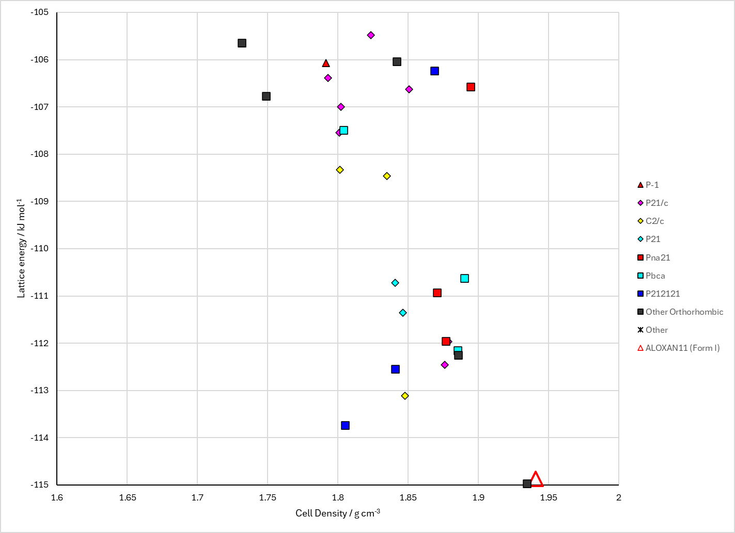
Figure 2. Crystal energy landscape of Alloxan from previous work.

CSD structures (CSD version 6.01 with Feb 2026 update)

Table 1. Crystallographic information for CSD entries for Alloxan. Different polymorphs are coloured differently.
REFCODE | space group | Z’ | a / Å | b / Å | c / Å | α / ° | β / ° | γ / ° | density / g cm⁻³ | Form
ALOXAN | P41212 | 0.5 | 5.886 | 5.886 | 14.1 | 90.0 | 90.0 | 90.0 | 1.9317 | Form I
ALOXAN11 | P41212 | 0.5 | 5.841 | 5.841 | 13.853 | 90.0 | 90.0 | 90.0 | 1.9966 | Form I
ALOXAN12 | P41212 | 0.5 | 5.85000 | 5.85000 | 13.913 | 90.0 | 90.0 | 90.0 | 1.9818 | Form I
ALOXAN14 | P212121 | 1.0 | 5.82141 | 5.85450 | 13.8525 | 90.0 | 90.0 | 90.0 | 1.9987 | Form II
ALOXAN15 | P41212 | 0.5 | 5.8059 | 5.8059 | 13.9050 | 90.0 | 90.0 | 90.0 | 2.0132 | Form I
ALOXAN16 | P41212 | 0.5 | 5.758 | 5.758 | 13.794 | 90.0 | 90.0 | 90.0 | 2.0633 | Form I
ALOXAN17 | P41212 | 0.5 | 5.7382 | 5.7382 | 13.747 | 90.0 | 90.0 | 90.0 | 2.0847 | Form I
ALOXAN18 | P41212 | 0.5 | 5.7051 | 5.7051 | 13.6603 | 90.0 | 90.0 | 90.0 | 2.1223 | Form I
ALOXAN19 | P41212 | 0.5 | 5.6753 | 5.6753 | 13.593 | 90.0 | 90.0 | 90.0 | 2.1553 | Form I
ALOXAN20 | P41212 | 0.5 | 5.6443 | 5.6443 | 13.507 | 90.0 | 90.0 | 90.0 | 2.1929 | Form I
ALOXAN21 | P41212 | 0.5 | 5.5997 | 5.5997 | 13.351 | 90.0 | 90.0 | 90.0 | 2.2540 | Form I
ALOXAN22 | P41212 | 0.5 | 5.56040 | 5.56040 | 13.2450 | 90.0 | 90.0 | 90.0 | 2.3043 | Form I
ALOXAN23 | P41212 | 0.5 | 5.5308 | 5.5308 | 13.126 | 90.0 | 90.0 | 90.0 | 2.3501 | Form I

Table 2. Experimental information for CSD entries for Alloxan.
REFCODE | space group | R factor | T / K | Year | Comments
ALOXAN | P41212 | 9.200 | None | 1964 | 10.1107/S0365110X6400041X
ALOXAN11 | P41212 | 2.9 | at 42 K | 1985 | 10.1107/S0108768185001732
ALOXAN12 | P41212 | 3.2 | at 123 K | 1985 | 10.1107/S0108768185001732
ALOXAN14 | P212121 | 4.600 | at 2 K | 2008 | 10.1039/b716960d
ALOXAN15 | P41212 | 3.309 | 293 K | 2020 | 10.1039/D0CC02418J
ALOXAN16 | P41212 | 3.226 | 293 K | 2020 | 10.1039/D0CC02418J
ALOXAN17 | P41212 | 3.16 | 293 K | 2020 | 10.1039/D0CC02418J
ALOXAN18 | P41212 | 2.543 | 293 K | 2020 | 10.1039/D0CC02418J
ALOXAN19 | P41212 | 3.328 | 293 K | 2020 | 10.1039/D0CC02418J
ALOXAN20 | P41212 | 2.625 | 293 K | 2020 | 10.1039/D0CC02418J
ALOXAN21 | P41212 | 2.7 | 293 K | 2020 | 10.1039/D0CC02418J
ALOXAN22 | P41212 | 2.413 | 293 K | 2020 | 10.1039/D0CC02418J
ALOXAN23 | P41212 | 2.498 | 293 K | 2020 | 10.1039/D0CC02418J

Make this table include whether polymorphs are solution-grown, sublimation grown, templated or otherwise. Add references.

Other notes

