5-azauracil and monohydrate
(Last updated May 2026)
Figure 1. The molecular diagram of 5-azauracil.

CSP studies
REFCODE | XERBEB
Formula | C3 H3 N3 O2
Common Name | 5-azauracil
IUPAC Systematic Name | 1H-[1,3,5]triazin-2,4-dione
Other Names
CSD Refcodes | XERBEB
Search Identifier | A
Scientist | Ashley Hulme
Date | 2007
Publication | See HOQHAW search
Energy model | 1
Study_ID | 0
Programs | MOLPAK, DMAREL (4.1.1)
Location on S Drive | \CHEMISTRY_CPOSS\0-EarlySearches\home\louise_price.eminerals\5-azauracil
Potential Description | MP2 6-31G(d,p) DMA +FIT
Intramolecular Description | MP2 6-31G(d,p) optimized
REFCODE | HOQHAW
Formula | C3 H3 N3 O2 . H2 O1
Common Name | 5-azauracil monohydrate
IUPAC Systematic Name | 1H-[1,3,5]triazin-2,4-dione monohydrate
Other Names
CSD Refcodes | HOQHAW
Search Identifier | A
Scientist | Ashley Hulme
Date | 2007
Publication | Hulme, A.T.; Price, S.L. J. Chem. Theory Comput. 2007, 3(4), 1597-1608.
Energy model | 1
Study_ID | 0
Programs | MOLPAK, DMAREL (3.11)
Location on S Drive | \CHEMISTRY_CPOSS\0-EarlySearches\home\louise_price.eminerals\5azahydrates
Potential Description | DMA + FIT
Intramolecular Description | MP2/6-31G(d,p)

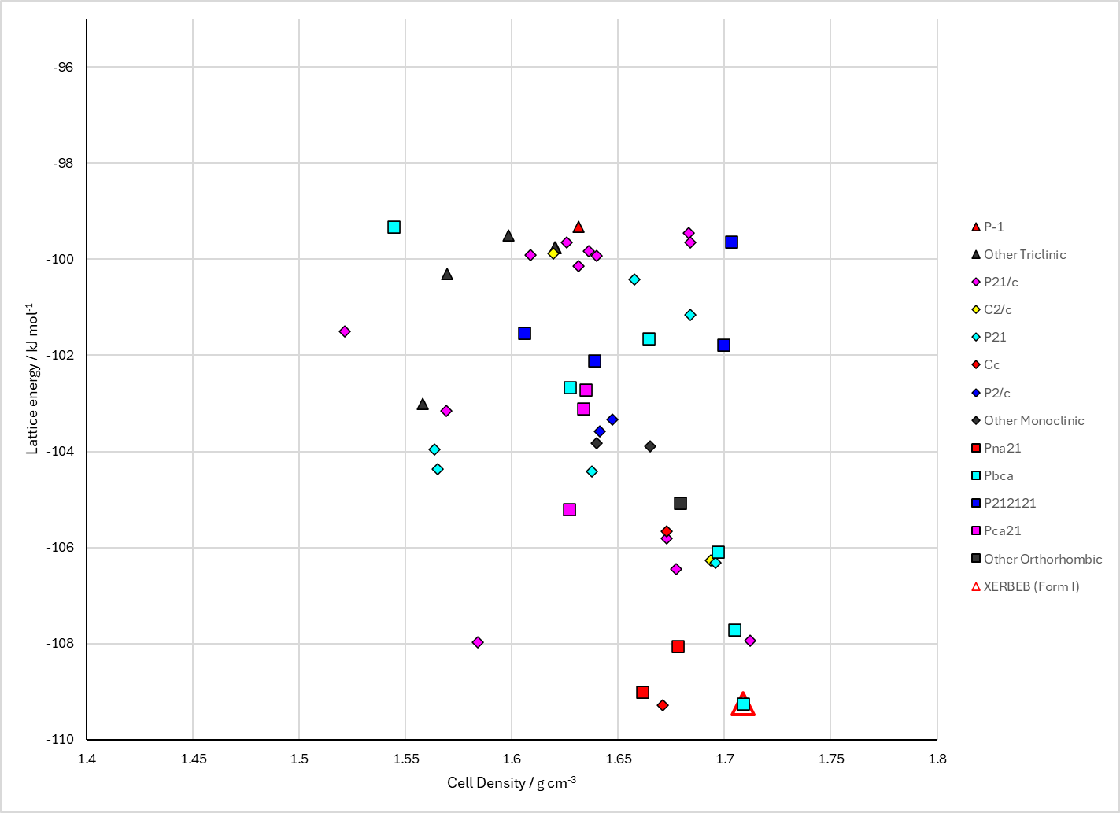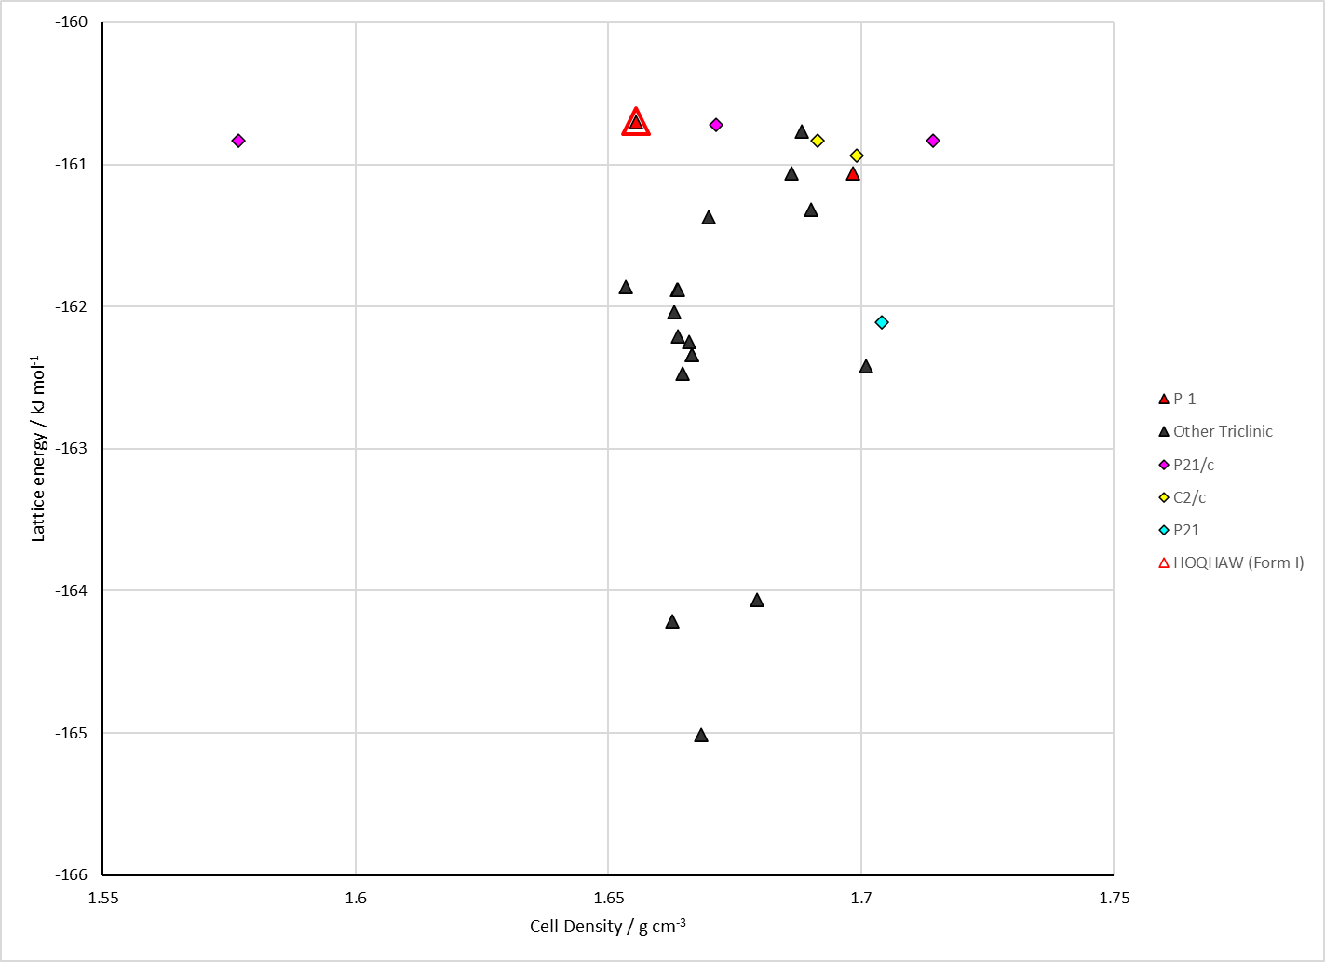
Figure 2. Crystal energy landscape of 5-azauracil from previous work. Left: Anhydrous. Right: Monohydrate.

CSD structures (CSD version 6.01 with Feb 2026 update)

Table 1. Crystallographic information for CSD entries for 5-azauracil. Different polymorphs are coloured differently.
REFCODE | space group | Z’ | a / Å | b / Å | c / Å | α / ° | β / ° | γ / ° | density / g cm⁻³ | Form
XERBEB | Pbca | 1.0 | 6.51350 | 13.5217 | 9.5824 | 90.0 | 90.0 | 90.0 | 1.7798 | None
HOQHAW | P21/m | 0.5 | 6.4316 | 6.2108 | 6.8205 | 90.0 | 99.719000 | 90.0 | 1.6212 | None

Table 2. Experimental information for CSD entries for 5-azauracil.
REFCODE | space group | R factor | T / K | Year | Comments
XERBEB | Pbca | 3.37 | None | 1999 | 10.1016/S0022-2860(98)00849-7
HOQHAW | P21/m | 3.320 | None | 1999 | 10.1039/a804613a

Make this table include whether polymorphs are solution-grown, sublimation grown, templated or otherwise. Add references.

Other notes

