3-[4-(1,2-benzisoxazol-3-yl)piperazin-1-yl]-2,2-dimethylpropanoic acid (Eli-Lilly III, LY2806920, 5HT2a Antagonist) and chloride salt
(Last updated March 2026)
Figure 1. The molecular diagram of Eli-Lilly LY2806920.

CSP studies
REFCODE | FOCWOL
Formula | C16 H21 N3 O3
Common Name | LY2806920
IUPAC Systematic Name | 3-[4-(1,2-benzisoxazol-3-yl)piperazin-1-yl]-2,2-dimethylpropanoic acid
Other Names | Eli-Lilly III, 5HT2a Antagonist
CSD Refcodes | FOCWOL
Search Identifier | A
Scientist | Doris Braun
Date | 2012
Publication | Braun DE, McMahon JA, Koztecki LH, Price SL, Reutzel-Edens SM, Crystal Growth & Design 2014, 14 (4), 2056-2072
Energy model | 3
Study_ID | 30
Programs | Study_ID=11, DMACRYS (2.0.4)
Location on S Drive | \CHEMISTRY_CPOSS\LY2806920\PCM
Potential Description | GDMA2.2(PCMdielectric3(PBE0/6-31G(d,p)) + FIT
Intramolecular Description | PBE0/6-31G(d,p)
Energy model | 2
Study_ID | 11
Programs | Study_ID=10, CrystalOptimizer, DMACRYS (2.0.4)
Location on S Drive | \CHEMISTRY_CPOSS\LY2806920\CrystOpt
Potential Description | CrystalOptimizer with PBE0/6-31G(d,p) intramolecular energy, DMA(PBE0/6-31G(d,p)) + FIT
Intramolecular Description | PBE0/6-31G(d,p)
Energy model | 1
Study_ID | 10
Programs | Flexible CrystalPredictor (1), DMAflex-Quick, DMACRYS (2.0.4)
Location on S Drive | \CHEMISTRY_CPOSS\LY2806920\DMAflex-Quick
Potential Description | Dmaflex-Quick, rotated charge densities from PBE0/6-31G(d,p) + FIT
Intramolecular Description | B3LYP/6-31G(d,p)
REFCODE | HEBZAS
Formula | (C16 H22 N3 O3)+ Cl-
Common Name | LY2806920 HCl
IUPAC Systematic Name | 3-[4-(1,2-benzisoxazol-3-yl)piperazin-1-yl]-2,2-dimethylpropanoic acid hydrochloride
Other Names | Eli-Lilly III, 5HT2a Antagonist
CSD Refcodes | HEBZAS, HEBZAS01
Search Identifier | A
Scientist | Louise Price
Date | 2013
Publication | Braun DE, Lingireddy SR, Beidelschies MD, Guo R, Muller P, Price SL, Reutzel-Edens SM, Crystal Growth & Design 2017, 17 (10), 5349-5365
Energy model | 1
Study_ID | 10
Programs | Flexible CrystalPredictor (1), DMAflex-Quick, CrystalOptimizer, DMACRYS (2.0.8RC1)
Location on S Drive | \CHEMISTRY_CPOSS\LY2806920\ELLSPA_CO
Potential Description | CrystalOptimizer with PBE0/6-31G(d,p) Intra and GDMA2.2(PBE0/6-31G(d,p)) + FIT
Intramolecular Description | GDMA2.2(PBE0/6-31G(d,p))

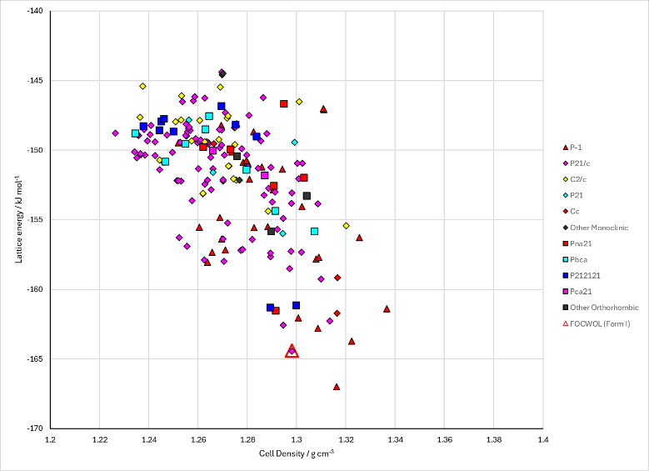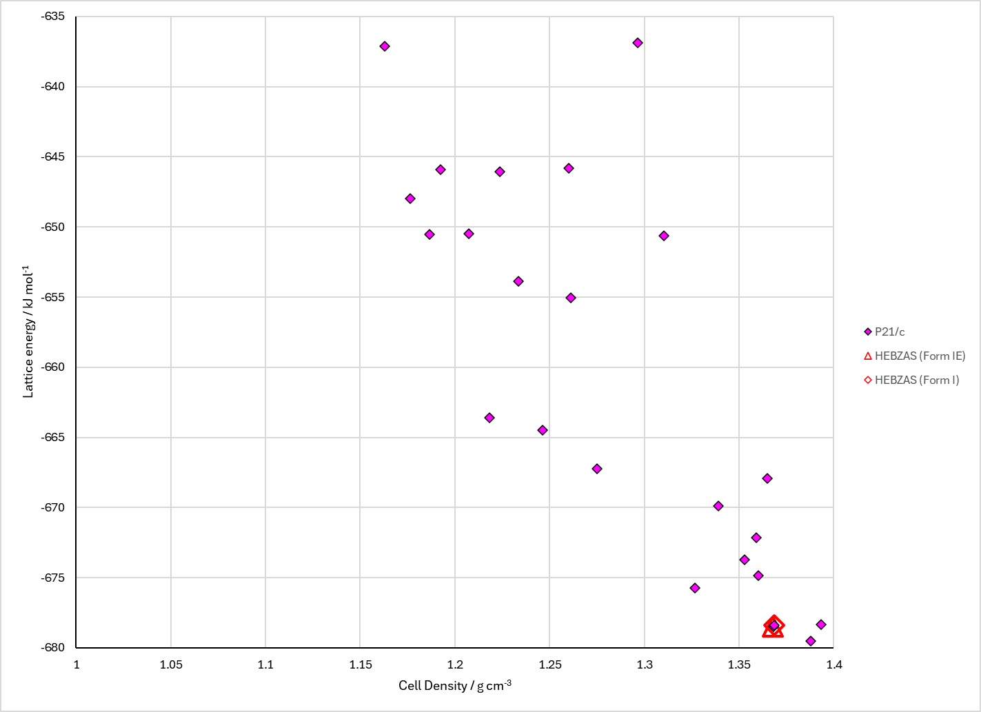
Figure 2. Crystal energy landscape of Eli-Lilly LY2806920 from previous work. Left: Free base with PCM model (Energy model A3). Right: Hydrochloride salt (Energy model A1).

CSD structures (CSD version 6.01)

Table 1. Crystallographic information for CSD entries for Eli-Lilly LY2806920. Different polymorphs are coloured differently.
REFCODE | space group | Z’ | a / Å | b / Å | c / Å | α / ° | β / ° | γ / ° | density / g cm⁻³ | Form
FOCWOL | P21/n | 1.0 | 14.0905 | 6.2506 | 17.017 | 90.0 | 91.321 | 90.0 | 1.3447 | None
HEBZAS | P21/c | 1.0 | 9.49350 | 7.28550 | 24.0201 | 90.0 | 94.227700 | 90.0 | 1.3623 | Form I
HEBZAS01 | P21/c | 1.0 | 19.4919 | 6.51644 | 13.2350 | 90.0 | 91.404000 | 90.0 | 1.3430 | Form II

Table 2. Experimental information for CSD entries for Eli-Lilly LY2806920.
REFCODE | space group | R factor | T / K | Year | Comments
FOCWOL | P21/n | 4.020 | at 100 K | 2014 | 10.1021/cg500185h
HEBZAS | P21/c | 2.84 | 100 K | 2017 | 10.1021/acs.cgd.7b00842
HEBZAS01 | P21/c | 1.28 | 298 K | 2017 | 10.1021/acs.cgd.7b00842

Make this table include whether polymorphs are solution-grown, sublimation grown, templated or otherwise. Add references.

Other notes

