2,9-diiodoanthanthrone (Blind Test IX)
(Last updated March 2026)
Figure 1. The molecular diagram of 2,9-diiodoanthanthrone.

CSP studies
REFCODE | XATMIP
Formula | C22 H8 O2 I2
Common Name | 2,9-di-iodo-anthathrone
IUPAC Systematic Name | 4,10-diiododibenzo[def.mno]chrysene-6,12-dione
Other Names
CSD Refcodes | XATMIP
Search Identifier | A
Scientist | Sally Price
Date | 2005
Publication | Day GM et al, Acta Cryst. B 2005, 61 (5), 511-527
Energy model | 1
Study_ID | 0
Programs | MOLPAK, DMAREL (3.11)
Location on S Drive | \CHEMISTRY_CPOSS\0-EarlySearches\home\louise_price.eminerals\2,9-diiodoanthanthrone
Potential Description | DMA FIT+Halgren mmff I potential
Intramolecular Description | SCF 6-311G**

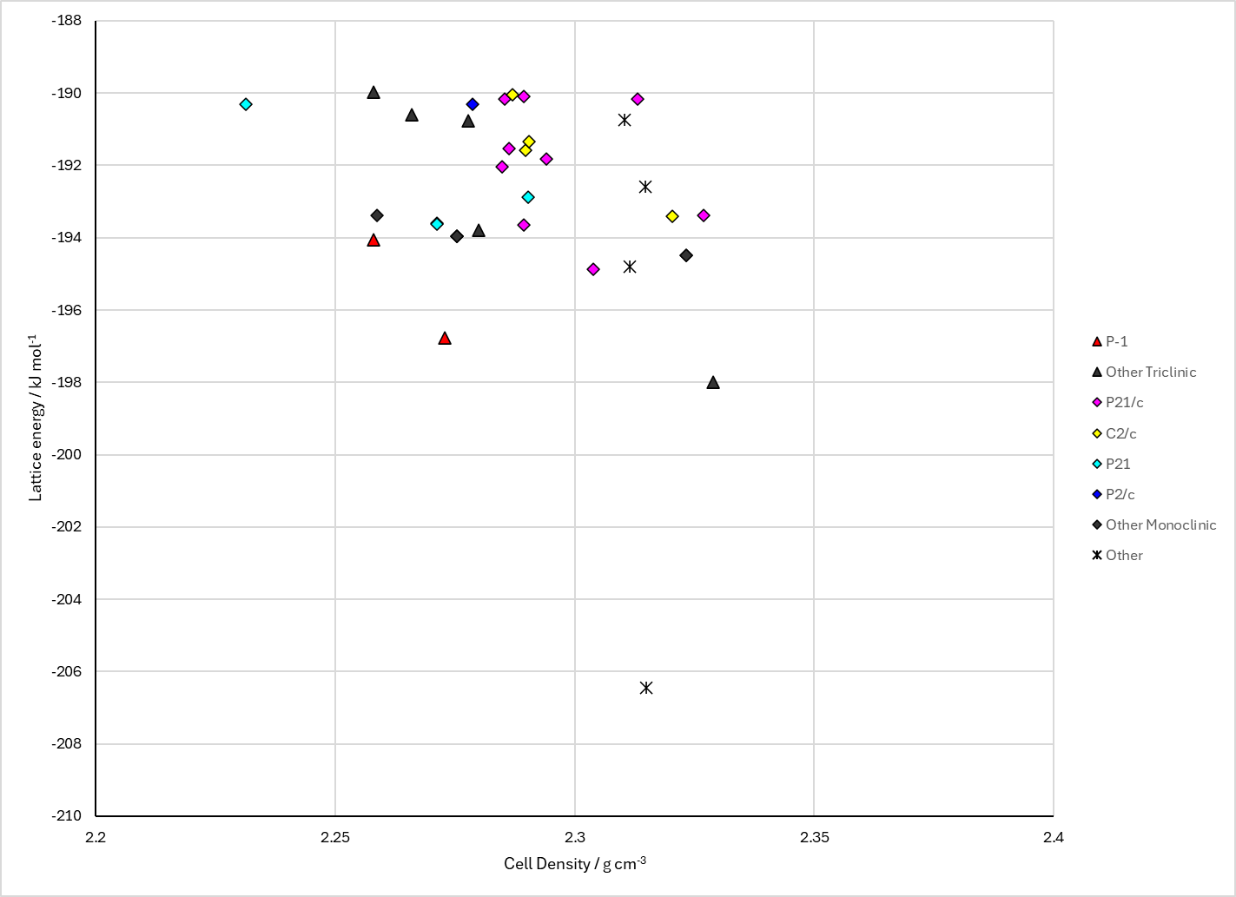
Figure 2. Crystal energy landscape of 2,9-diiodoanthanthrone from previous work.

CSD structures (CSD version 6.01)

Table 1. Crystallographic information for CSD entries for 2,9-diiodoanthanthrone. Different polymorphs are coloured differently.
REFCODE | space group | Z’ | a / Å | b / Å | c / Å | α / ° | β / ° | γ / ° | density / g cm⁻³ | Form
XATMIP | P21/c | 0.5 | 4.202 | 20.956 | 9.276 | 90.0 | 100.63 | 90.0 | 2.3088 | None
XATMIP01 | P21/c | 0.5 | 4.202 | 20.956 | 9.276 | 90.0 | 100.63 | 90.0 | 2.3088 | None

Table 2. Experimental information for CSD entries for 2,9-diiodoanthanthrone.
REFCODE | space group | R factor | T / K | Year | Comments
XATMIP | P21/c | 3.550 | at 293 K | 2005 | 10.1107/S0108768105016563
XATMIP01 | P21/c | 4.17 | at 293 K | 2010 | 10.1107/S0108768110028247

Make this table include whether polymorphs are solution-grown, sublimation grown, templated or otherwise. Add references.

Other notes
The search uploaded to the database only contains 35 structures, yet the experimental structure was found about 40th in the search. Two structures, XATMIP_opt_aa1 and XATMIP_opt_dc25, overlay a sheet with the experimental structure.

