Azetidine
(Last updated March 2026)
Figure 1. The molecular diagram of Azetidine.

CSP studies
REFCODE | XATMOV
Formula | C3 H7 N1
Common Name | Azetidine
IUPAC Systematic Name | Azetidine
Other Names | Azetidine
CSD Refcodes | XATMOV
Search Identifier | A
Scientist | Antonio Torrisi
Date | 2005
Publication | Day GM et al, Acta Cryst. B 2005, 61 (5), 511-527
Energy model | 1
Study_ID | 0
Programs | MOLPAK, DMAREL (3.0)
Location on S Drive | \CHEMISTRY_CPOSS\0-EarlySearches\home\louise_price.eminerals\azetidine
Potential Description | DMA + FIT
Intramolecular Description | Ab initio optimized

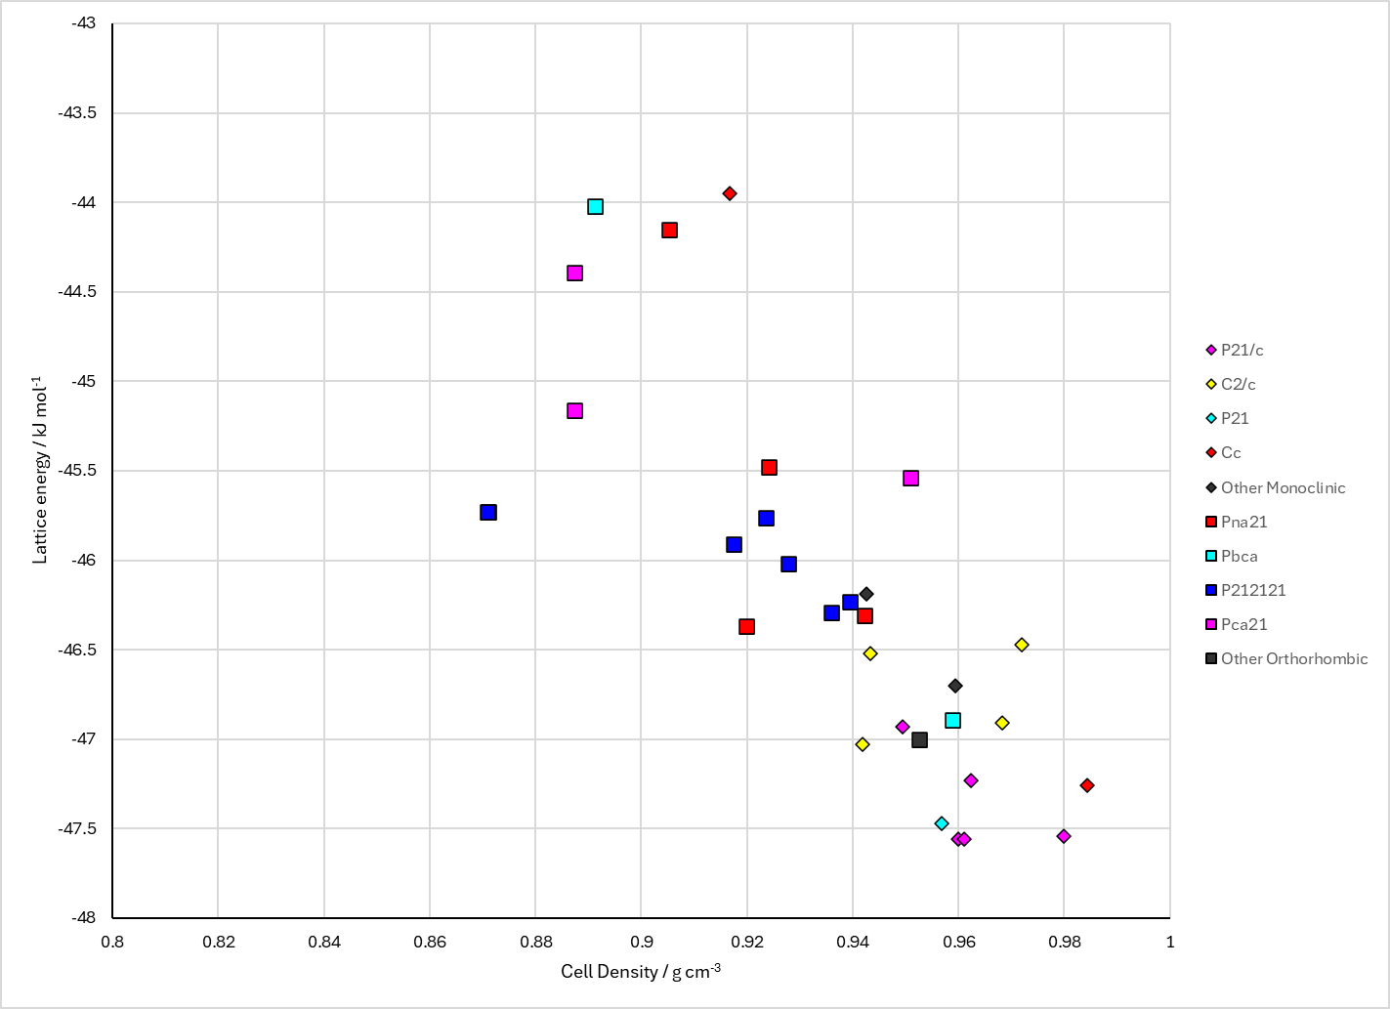
Figure 2. Crystal energy landscape of Azetidine from previous work.

CSD structures (CSD version 6.01)

Table 1. Crystallographic information for CSD entries for Azetidine. Different polymorphs are coloured differently.
REFCODE | space group | Z’ | a / Å | b / Å | c / Å | α / ° | β / ° | γ / ° | density / g cm⁻³ | Form
XATMOV | P21/c | 2.0 | 9.507 | 9.122 | 9.79000 | 90.0 | 117.46900 | 90.0 | 1.0068 | None
XATMOV01 | P21/c | 2.0 | 9.507 | 9.122 | 9.79000 | 90.0 | 117.46900 | 90.0 | 1.0068 | None

Table 2. Experimental information for CSD entries for Azetidine.
REFCODE | space group | R factor | T / K | Year | Comments
XATMOV | P21/c | 5.01 | at 170 K | 2005 | 10.1107/S0108768105016563
XATMOV01 | P21/c | 5.57 | at 170 K | 2008 | 10.1107/S0108270108026012

Make this table include whether polymorphs are solution-grown, sublimation grown, templated or otherwise. Add references.

Other notes
This was not found in the search, as is it Z’=2.

