2-Chlorobenzoic Acid
(Last updated June 2026)
Figure 1. The molecular diagram of 2-Chlorobenzoic Acid.

CSP studies
REFCODE | CLBZAC
Formula | C7 H5 O2 Cl1
Common Name | o-Chlorobenzoic acid
IUPAC Systematic Name | o-Chlorobenzoic acid
Other Names | 2-Chlorobenzoic acid
CSD Refcodes | CLBZAC03
Search Identifier | A
Scientist | Emiliana D'Oria
Date | pre-2010
Publication | Polito M, D'Oria E, Maini L, Karamertzanis PG, Grepioni F, Braga D, Price SL, CrystEngComm 2008, 10, 1848-1854.
Energy model | 1
Study_ID | 0
Programs | MOLPAK, DMAREL (4.1.1)
Location on S Drive | \CHEMISTRY_CPOSS\0-EarlySearches\home\louise_price.eminerals\Chlorobenzoicacid
Potential Description | DMA + FIT
Intramolecular Description | MP2/6-31G(d,p)

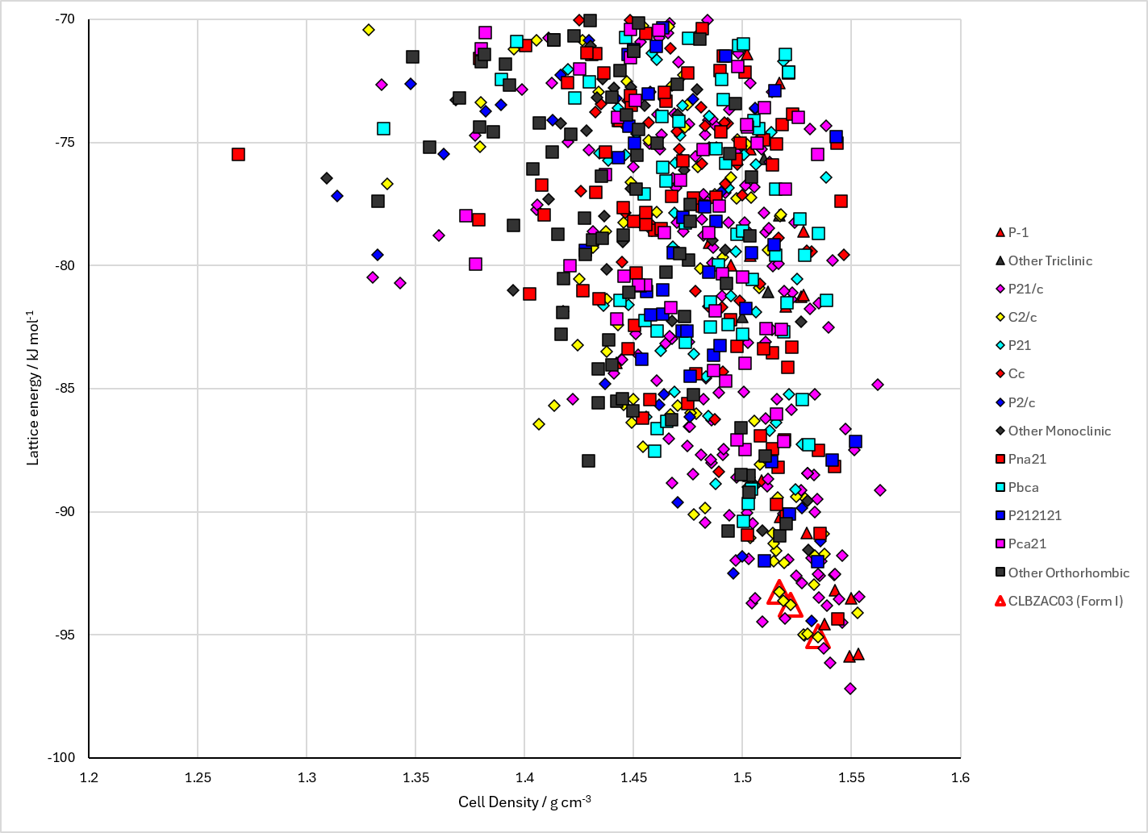
Figure 2. Crystal energy landscape of 2-Chlorobenzoic Acid from previous work.

CSD structures (CSD version 6.01 with Feb 2026 update)

Table 1. Crystallographic information for CSD entries for 2-Chlorobenzoic Acid. Different polymorphs are coloured differently.
REFCODE | space group | Z’ | a / Å | b / Å | c / Å | α / ° | β / ° | γ / ° | density / g cm⁻³ | Form
CLBZAC | C2/c | 1.0 | 14.73 | 3.9 | 25.5 | 90.0 | 112.67 | 90.0 | 1.5386 | None
CLBZAC01 | C2/c | 1.0 | 14.6382 | 3.8142 | 23.812 | 90.0 | 101.146 | 90.0 | 1.5944 | None
CLBZAC02 | C2/c | 1.0 | 14.6363 | 3.7907 | 23.786 | 90.0 | 101.003 | 90.0 | 1.6055 | None
CLBZAC03 | C2/c | 1.0 | 14.706 | 3.8955 | 23.968 | 90.0 | 101.413 | 90.0 | 1.5453 | None

Table 2. Experimental information for CSD entries for 2-Chlorobenzoic Acid.
REFCODE | space group | R factor | T / K | Year | Comments
CLBZAC | C2/c | 10.5 | None | 1961 | 10.1107/S0365110X61003673
CLBZAC01 | C2/c | 4.55 | at 150 K | 2008 | 10.1039/b811438b
CLBZAC02 | C2/c | 4.21 | 100 K | 2010 | None
CLBZAC03 | C2/c | 3.85 | 296 K | 2016 | 10.1021/jacs.6b05118

Make this table include whether polymorphs are solution-grown, sublimation grown, templated or otherwise. Add references.

Other notes

