3,8,9-Trinitro-5H-dibenzo(b,d)pyran-5-one
(Last updated June 2026)
Figure 1. The molecular diagram of 3,8,9-Trinitro-5H-dibenzo(b,d)pyran-5-one.

CSP studies
REFCODE | CIVTUW
Formula | C13 H5 N3 O8
Common Name
IUPAC Systematic Name | 3,8,9-Trinitro-5H-dibenzo(b,d)pyran-5-one
Other Names
CSD Refcodes | CIVTUW, CIVTUW01
Search Identifier | A
Scientist | Not sure
Date | pre-2010
Publication | No publication planned.
Energy model | 1
Study_ID | 0
Programs | MOLPAK, DMAREL (4.1.1)
Location on S Drive | \CHEMISTRY_CPOSS\0-EarlySearches\home\louise_price.eminerals\Trinitro-5H-dibenzo-bd-pyran-5-one
Potential Description | FIT
Intramolecular Description | MP2/6-31G(d,p)

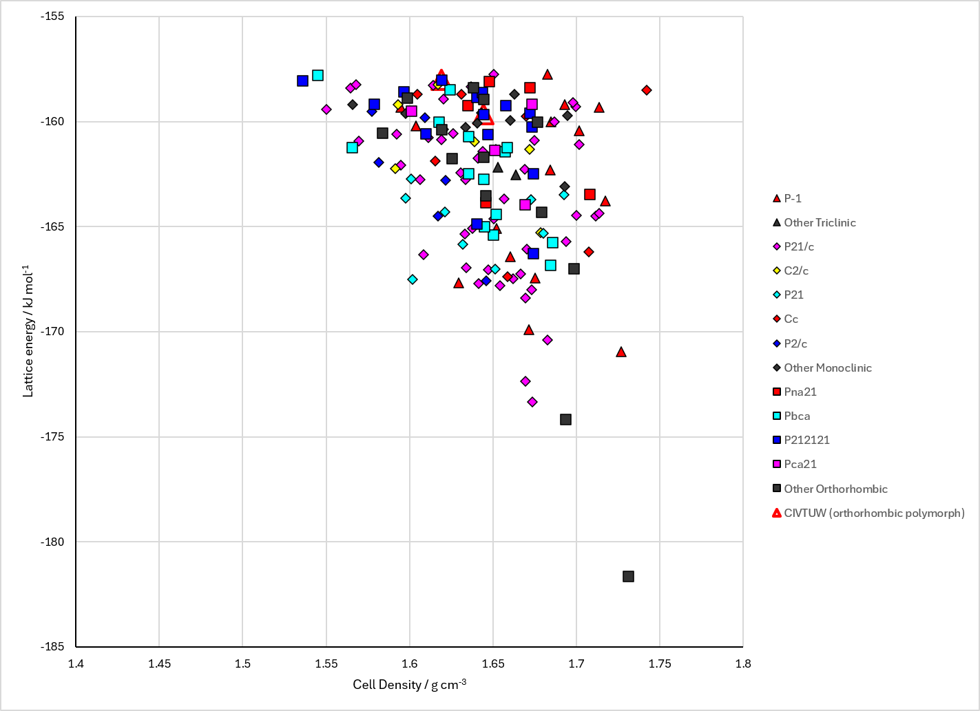
Figure 2. Crystal energy landscape of 3,8,9-Trinitro-5H-dibenzo(b,d)pyran-5-one from previous work.

CSD structures (CSD version 6.01 with Feb 2026 update)

Table 1. Crystallographic information for CSD entries for 3,8,9-Trinitro-5H-dibenzo(b,d)pyran-5-one. Different polymorphs are coloured differently.
REFCODE | space group | Z’ | a / Å | b / Å | c / Å | α / ° | β / ° | γ / ° | density / g cm⁻³ | Form
CIVTUW | P212121 | 1.0 | 5.027 | 10.379 | 24.756 | 90.0 | 90.0 | 90.0 | 1.7031 | orthorhombic polymorph
CIVTUW01 | P1121/n | 1.0 | 7.455 | 10.295 | 18.085 | 90.0 | 90.0 | 104.98 | 1.6406 | monoclinic polymorph

Table 2. Experimental information for CSD entries for 3,8,9-Trinitro-5H-dibenzo(b,d)pyran-5-one.
REFCODE | space group | R factor | T / K | Year | Comments
CIVTUW | P212121 | 2.9 | None | 1986 | None
CIVTUW01 | P1121/n | 3.2 | None | 1986 | None

Make this table include whether polymorphs are solution-grown, sublimation grown, templated or otherwise. Add references.

Other notes

