3-(4-(dibenzo[b,f][1,4]oxazepin-11-yl)piperazin-1-yl)-2,2-dimethylpropanoic acid (Eli-Lilly VII, LY2624803, Hypnion HY10275)
(Last updated March 2026)
Figure 1. The molecular diagram of Eli-Lilly LY2624803.

CSP studies
REFCODE | FOCWUR
Formula | C22 H25 N3 O3
Common Name | Eli-Lilly VII, LY2624803, Hypnion HY10275
IUPAC Systematic Name | 3-(4-dibenzo[b,f][1,4]oxepin-11-yl-piperazin-1-yl)-2,2-dimethylpropionic acid
Other Names
CSD Refcodes | FOCWUR, FOCWUR01
Search Identifier | A
Scientist | Doris Braun
Date | 2012
Publication | Braun DE, McMahon JA, Koztecki LH, Price SL, Reutzel-Edens SM, Crystal Growth & Design 2014, 14 (4), 2056-2072
Energy model | 3
Study_ID | 30
Programs | Study_ID=11, DMACRYS (2.0.4)
Location on S Drive | \CHEMISTRY_CPOSS\LY2624803\PCM
Potential Description | GDMA2.2(PCMdielectric3(PBE0/6-31G(d,p)) + FIT
Intramolecular Description | PBE0/6-31G(d,p)
Energy model | 2
Study_ID | 11
Programs | Study_ID=10, CrystalOptimizer, DMACRYS (2.0.4)
Location on S Drive | \CHEMISTRY_CPOSS\LY2624803\CrystOpt
Potential Description | CrystalOptimizer with PBE0/6-31G(d,p) intramolecular energy, DMA(PBE0/6-31G(d,p)) + FIT
Intramolecular Description | PBE0/6-31G(d,p)
Energy model | 1
Study_ID | 10
Programs | Flexible CrystalPredictor (1), DMAflex-Quick, DMACRYS (2.0.4)
Location on S Drive | \CHEMISTRY_CPOSS\LY2624803\DMAflex-Quick
Potential Description | Dmaflex-Quick, rotated charge densities from PBE0/6-31G(d,p) + FIT
Intramolecular Description | B3LYP/6-31G(d,p)

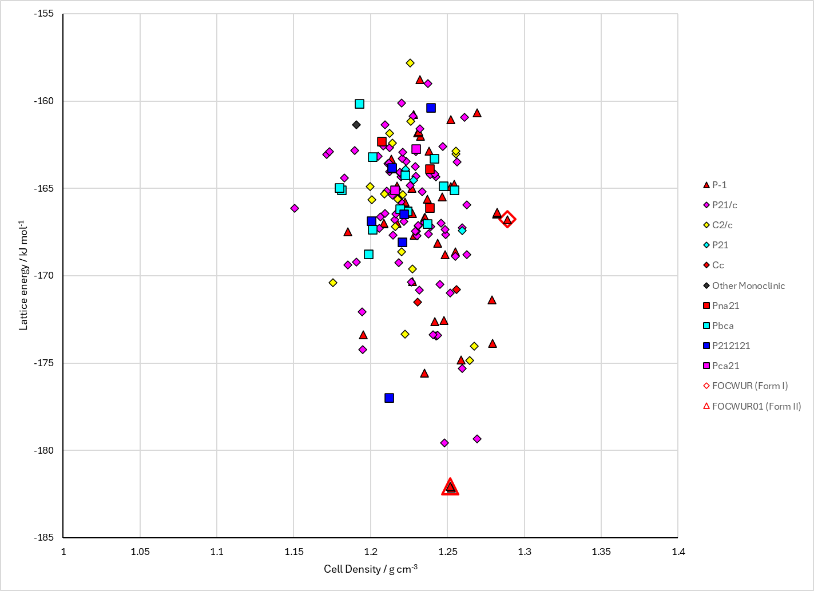
Figure 2. Crystal energy landscape of Eli-Lilly LY2624803 from previous work. Energy model A3.

CSD structures (CSD version 6.01)

Table 1. Crystallographic information for CSD entries for Eli-Lilly LY2624803. Different polymorphs are coloured differently.
REFCODE | space group | Z’ | a / Å | b / Å | c / Å | α / ° | β / ° | γ / ° | density / g cm⁻³ | Form
FOCWUR | P-1 | 1.0 | 9.397 | 10.8925 | 11.0095 | 65.728 | 67.321 | 77.584 | 1.3325 | form I
FOCWUR01 | P-1 | 1.0 | 9.27540 | 10.0504 | 11.858 | 106.01 | 108.236 | 99.895 | 1.3018 | form II

Table 2. Experimental information for CSD entries for Eli-Lilly LY2624803.
REFCODE | space group | R factor | T / K | Year | Comments
FOCWUR | P-1 | 4.38 | at 100 K | 2014 | 10.1021/cg500185h
FOCWUR01 | P-1 | 3.92 | at 100 K | 2014 | 10.1021/cg500185h

Make this table include whether polymorphs are solution-grown, sublimation grown, templated or otherwise. Add references.

Other notes

