Phenanthrenol
(Last updated May 2026)
Figure 1. The molecular diagram of Phenanthrenol.

CSP studies
REFCODE | CUTCAW
Formula | C14 H10 O1
Common Name | Phenanthrenol
IUPAC Systematic Name | Phenanthren-9-ol
Other Names
CSD Refcodes | CUTCAW
Search Identifier | A
Scientist | Panos Karamertzanis
Date | 2009
Publication | Friscic T, Lancaster RW, Fabian L, Karamertzanis PG PNAS 2010, 107 (30), 13216-13221
Energy model | 2
Study_ID | 10
Programs | Study_ID=20, CrystalOptimizer, DMACRYS (1.1.1)
Location on S Drive | \CHEMISTRY_CPOSS\0-EarlySearches\home\louise_price.eminerals\Steroids\phenanthrenol\dmaflex
Potential Description | CrystalOptimizer with 13 torsion and 1 bond angles optimised. FIT potential and B3LYP inter and intra levels.
Intramolecular Description | B3LYP
Energy model | 1
Study_ID | 20
Programs | Rigid CrystalPredictor, DMACRYS (1.1.1)
Location on S Drive | \CHEMISTRY_CPOSS\0-EarlySearches\home\louise_price.eminerals\Steroids\phenanthrenol\rigid
Potential Description | FIT potential and B3LYP6-31G(d,p) DMA.
Intramolecular Description | B3LYP/6-31Gd,p

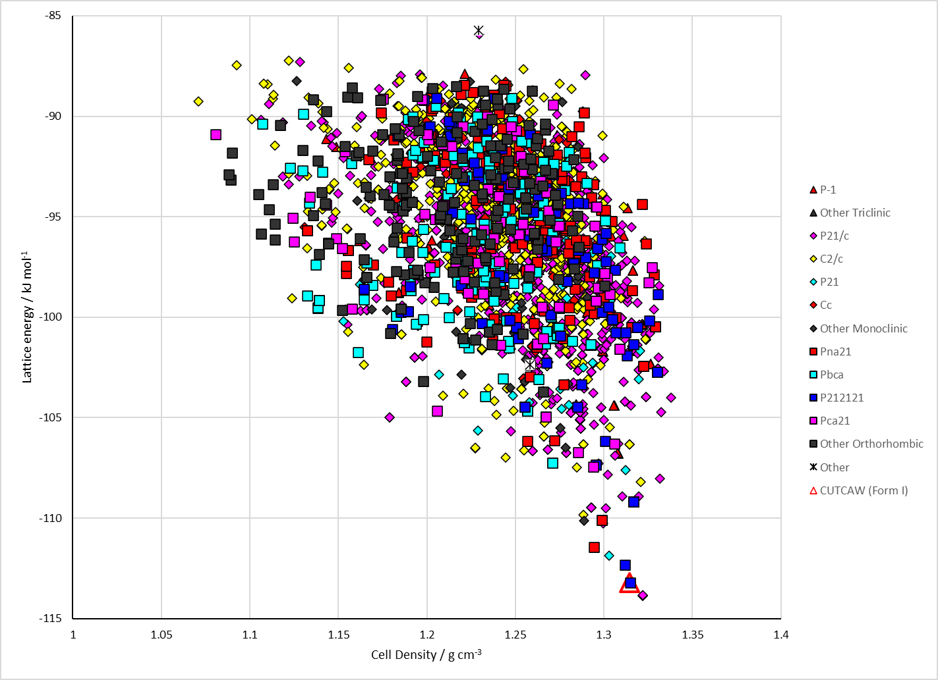
Figure 2. Crystal energy landscape of Phenanthrenol from previous work.

CSD structures (CSD version 6.01 with Feb 2026 update)

Table 1. Crystallographic information for CSD entries for Phenanthrenol. Different polymorphs are coloured differently.
REFCODE | space group | Z’ | a / Å | b / Å | c / Å | α / ° | β / ° | γ / ° | density / g cm⁻³ | Form
CUTCAW | P212121 | 1.0 | 4.68187 | 12.3504 | 16.7658 | 90.0 | 90.0 | 90.0 | 1.3307 | None

Table 2. Experimental information for CSD entries for Phenanthrenol.
REFCODE | space group | R factor | T / K | Year | Comments
CUTCAW | P212121 | 3.99 | at 298 K | 2010 | 10.1073/pnas.0915142107

Make this table include whether polymorphs are solution-grown, sublimation grown, templated or otherwise. Add references.

Other notes

