Pyrene
(Last updated May 2026)
Figure 1. The molecular diagram of Pyrene.

CSP studies
REFCODE | PYRENE
Formula | C16 H10
Common Name | Pyrene
IUPAC Systematic Name | Pyrene
Other Names
CSD Refcodes | PYRENE11, PYRENE06, PYRENE08, PYRENE24, PYRENE29
Search Identifier | A
Scientist | Panos Karamertzanis
Date | 2009
Publication | Friscic T, Lancaster RW, Fabian L, Karamertzanis PG PNAS 2010, 107 (30), 13216-13221
Energy model | 2
Study_ID | 10
Programs | Study_ID=20, CrystalOptimizer, DMACRYS (2.0.1)
Location on S Drive | \CHEMISTRY_CPOSS\0-EarlySearches\home\louise_price.eminerals\Steroids\pyrene\dmaflex
Potential Description | CrystalOptimizer with 13 torsion angles optimised. FIT potential and B3LYP inter and intra levels.
Intramolecular Description | B3LYP
Energy model | 1
Study_ID | 20
Programs | Rigid CrystalPredictor, DMACRYS (2.0.1)
Location on S Drive | \CHEMISTRY_CPOSS\0-EarlySearches\home\louise_price.eminerals\Steroids\pyrene\rigid
Potential Description | B3LYP DMA + FIT potential.
Intramolecular Description | B3LYP

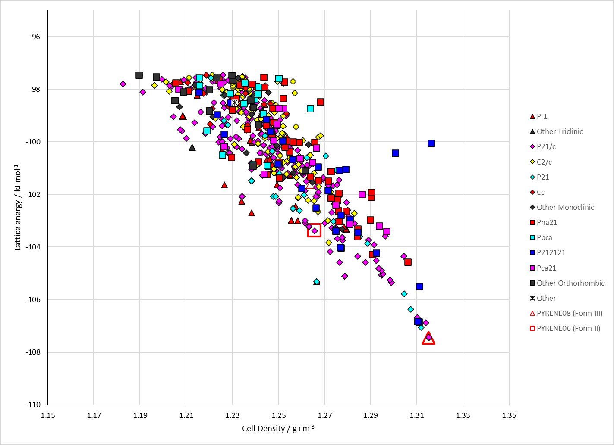
Figure 2. Crystal energy landscape of Pyrene from previous work.

CSD structures (CSD version 6.01 with Feb 2026 update)
Form I and II are very similar. They overlay with default options, so we don’t expect to see both in the search.
Table 1. Crystallographic information for CSD entries for Pyrene. Different polymorphs are coloured differently.
REFCODE | space group | Z’ | a / Å | b / Å | c / Å | α / ° | β / ° | γ / ° | density / g cm⁻³ | Form
DAFPOU | P21/c | 1 | 8.1431 | 9.8639 | 12.1136 | 90 | 96.484 | 90 | 1.39 | II
PYRENE | P21/a | 1 | 13.649 | 9.256 | 8.47 | 90 | 100.28 | 90 | 1.276 | I
PYRENE01 | P21/a | 1 | 13.649 | 9.253 | 8.47 | 90 | 100.28 | 90 | 1.276 | I
PYRENE02 | P21/a | 1 | 13.649 | 9.256 | 8.47 | 90 | 100.28 | 90 | 1.276 | I
PYRENE03 | P21/a | 1 | 13.532 | 9.159 | 8.387 | 90 | 100.25 | 90 | 1.313 | I
PYRENE04 | P21/a | 1 | 13.667 | 9.267 | 8.479 | 90 | 100.25 | 90 | 1.271 | I
PYRENE05 | P21/a | 1 | 13.644 | 9.255 | 8.469 | 90 | 100.27 | 90 | 1.277 | I
PYRENE06 | P21/a | 1.0 | 12.3026 | 9.98788 | 8.22064 | 90.0 | 96.4046 | 90.0 | 1.3382 | II
PYRENE07 | P21/a | 1 | 12.358 | 10.02 | 8.26 | 90 | 96.48 | 90 | 1.322 | II
PYRENE08 | P21/a | 0.5 | 15.35 | 3.852 | 8.65 | 90 | 103.3 | 90 | 1.35 | III
PYRENE09 | P21/a | 0.5 | 15.309 | 3.8375 | 8.3341 | 90 | 102.606 | 90 | 1.406 | III
PYRENE10 | P21/c | 1 | 8.374 | 9.144 | 13.502 | 90 | 100.245 | 90 | 1.32 | I
PYRENE11 | P21/c | 1 | 8.3726 | 9.1301 | 13.5283 | 90 | 100.281 | 90 | 1.32 | I
PYRENE12 | P21/c | 1 | 8.463 | 9.252 | 13.644 | 90 | 100.33 | 90 | 1.278 | I
PYRENE13 | P21/c | 1 | 8.3688 | 9.14 | 13.487 | 90 | 100.234 | 90 | 1.323 | I
PYRENE14 | P21/a | 1 | 13.651 | 9.257 | 8.472 | 90 | 100.292 | 90 | 1.275 | I
PYRENE15 | P21/c | 1 | 8.4032 | 9.1686 | 13.5345 | 90 | 100.317 | 90 | 1.309 | I
PYRENE16 | P21/c | 1 | 8.478 | 9.2652 | 13.655 | 90 | 100.31 | 90 | 1.273 | I
PYRENE17 | P21/c | 1 | 8.41463 | 9.17935 | 13.5575 | 90 | 100.3116 | 90 | 1.304 | I
PYRENE18 | P21/c | 1 | 8.4826 | 9.2796 | 13.638 | 90 | 100.473 | 90 | 1.273 | I
PYRENE19 | P21/c | 1 | 8.4679 | 9.2573 | 13.6511 | 90 | 100.256 | 90 | 1.276 | I
PYRENE20 | P21/c | 1 | 8.5 | 9.3 | 13.6 | 90 | 100.3 | 90 | 1.27 | I
PYRENE21 | P21/c | 1 | 7.0174 | 5.645 | 15.3477 | 90 | 100.363 | 90 | 2.246 | V
PYRENE22 | P21/c | 1 | 6.9711 | 5.541 | 15.2471 | 90 | 100.349 | 90 | 2.319 | V
PYRENE23 | P21/c | 1 | 8.0322 | 9.7422 | 11.8112 | 90 | 96.074 | 90 | 1.462 | II
PYRENE24 | P-1 | 2 | 7.593 | 10.223 | 11.192 | 92.536 | 95.04 | 91.21 | 1.554 | IV
PYRENE25 | P-1 | 2 | 7.477 | 10.07 | 10.879 | 92.434 | 94.73 | 90.86 | 1.647 | IV
PYRENE26 | P21/c | 1 | 7.45 | 6.4503 | 16.096 | 90 | 100.65 | 90 | 1.767 | V
PYRENE27 | P21/c | 1 | 7.345 | 6.2802 | 15.9325 | 90 | 100.57 | 90 | 1.859 | V
PYRENE28 | P21/c | 1 | 7.2292 | 6.0333 | 15.759 | 90 | 100.516 | 90 | 1.988 | V
PYRENE29 | P21/c | 1 | 7.155 | 5.8939 | 15.6277 | 90 | 100.467 | 90 | 2.073 | V
PYRENE30 | P21/c | 1 | 7.0634 | 5.7352 | 15.4503 | 90 | 100.395 | 90 | 2.182 | V

Table 2. Experimental information for CSD entries for Pyrene.
REFCODE | space group | R factor | T / K | Year | Comments
DAFPOU | P21/c | 6.82 | 293 | 2024 | synchrotron, 0.7 GPa, 10.1038/s42004-024-01294-0
PYRENE | P21/a | 11 | 295 | 1965 | 10.1107/S0365110X65001494
PYRENE01 | P21/a | 4.4 | 295 | 1970 | None
PYRENE02 | P21/a | 3.2 | 295 | 1972 | neutron, 10.1107/S0567740872007319
PYRENE03 | P21/a | 6.3 | 113 | 1978 | 10.1107/S0567740878005312
PYRENE04 | P21/a | 0 | 295 | 1978
PYRENE05 | P21/a | 0 | 295 | 1981
PYRENE06 | P21/a | 2.69 | at 4.2 K | 1996 | 10.1016/0009-2614(96)00670-7
PYRENE07 | P21/a | 5.15 | 93 | 2000 | 10.1016/S0022-2860(99)00280-X
PYRENE08 | P21/a | 11.82 | 298 | 2006 | 0.3 GPa, 10.1107/S0108768106026814
PYRENE09 | P21/a | 13.36 | 298 | 2006 | 0.5 GPa, 10.1107/S0108768106026814
PYRENE10 | P21/c | 4.13 | 90 | 2016 | 10.1002/chem.201602188
PYRENE11 | P21/c | 4.08 | 100 | 2020 | 10.1039/D0QM00229A
PYRENE12 | P21/c | 4.23 | 293 | 2018 | 10.1002/adom.201800198
PYRENE13 | P21/c | 4.6 | 110 | 2015 | 10.1021/acs.cgd.5b00844
PYRENE14 | P21/a | 0 | 0 | 2001
PYRENE15 | P21/c | 3.85 | 293 | 2023 | None
PYRENE16 | P21/c | 4.86 | 293 | 2024 | synchrotron, 10.1038/s42004-024-01294-0
PYRENE17 | P21/c | 3.77 | 170 | 2025 | 10.1002/anie.202417868
PYRENE18 | P21/c | 6.27 | 293 | 2025 | 10.1016/j.xinn.2025.100884
PYRENE19 | P21/c | 5.64 | 293 | 2025 | 10.1002/adma.202419981
PYRENE20 | P21/c | 24.33 | 298 | 2025 | electron diffraction, 10.1107/S1600576725009823
PYRENE21 | P21/c | 13.62 | 293 | 2024 | synchrotron, 10.1038/s42004-024-01294-0
PYRENE22 | P21/c | 16.55 | 293 | 2024 | synchrotron, 10.1038/s42004-024-01294-0
PYRENE23 | P21/c | 6.14 | 293 | 2024 | synchrotron, 1.4 GPa, 10.1038/s42004-024-01294-0
PYRENE24 | P-1 | 9.77 | 293 | 2024 | synchrotron, 2.7 GPa, 10.1038/s42004-024-01294-0
PYRENE25 | P-1 | 13.41 | 293 | 2024 | synchrotron, 4.3 GPa, 10.1038/s42004-024-01294-0
PYRENE26 | P21/c | 8.65 | 293 | 2024 | synchrotron, 7.3 GPa, 10.1038/s42004-024-01294-0
PYRENE27 | P21/c | 11.66 | 293 | 2024 | synchrotron, 9.5 GPa, 10.1038/s42004-024-01294-0
PYRENE28 | P21/c | 7.78 | 293 | 2024 | synchrotron, 15.4 GPa, 10.1038/s42004-024-01294-0
PYRENE29 | P21/c | 7.55 | 293 | 2024 | synchrotron, 20.2 GPa, 10.1038/s42004-024-01294-0
PYRENE30 | P21/c | 13.56 | 293 | 2024 | synchrotron, 25.2 GPa, 10.1038/s42004-024-01294-0

Make this table include whether polymorphs are solution-grown, sublimation grown, templated or otherwise. Add references.

Other notes

