Cyheptamide
(Last updated 22 February 2023)
Figure 1. The molecular diagram of Cyheptamide.

CSP studies
REFCODE | TEVSOD
Formula | C16 H15 N1 O1
Common Name | Cyheptamide
IUPAC Systematic Name | 10,11-dihydro-5H-dibenzocycloheptene-5-carboxamide
Other Names
CSD Refcodes | TEVSOD, TEVSOD01, TEVSOD02
Search Identifier | A
Scientist | Rui Guo
Date | 2013
Publication | Srirambhatla, V. K.; Guo, R.; Price, S. L.; Florence, A. J., Chemical Communications 2016, 52, 7384-7386.
Energy model | 1
Study_ID | 10
Programs | Flexible CrystalPredictor (1.6), CrystalOptimizer (2.3), DMACRYS (2.0.8RC1)
Location on S Drive | /CHEMISTRY_CPOSS\CarbamazepineSeries\Cyheptamide_CO
Potential Description | CrystalOptimizer with PBE0/6-31G(d,p) Intra and GDMA2.2(PBE0/6-31G(d,p)) + FIT
Energy model | 2
Study_ID | 30
Programs | Study_ID=10, DMACRYS (2.0.8RC1)
Location on S Drive | /CHEMISTRY_CPOSS\CarbamazepineSeries\Cyheptamide_PCM
Potential Description | GDMA2.2(PCMdielectric3(PBE0/6-31G(d,p)) + FIT
Search Identifier | B
Scientist | Louise Price
Date | 2010
Publication | No publication planned.
Energy model | 1
Study_ID | 0
Programs | MOLPAK, DMAREL (4.1.1)
Location on S Drive | \CHEMISTRY_CPOSS\0-EarlySearches\home\louise_price.eminerals\cyheptamide
Potential Description | DMA + FIT
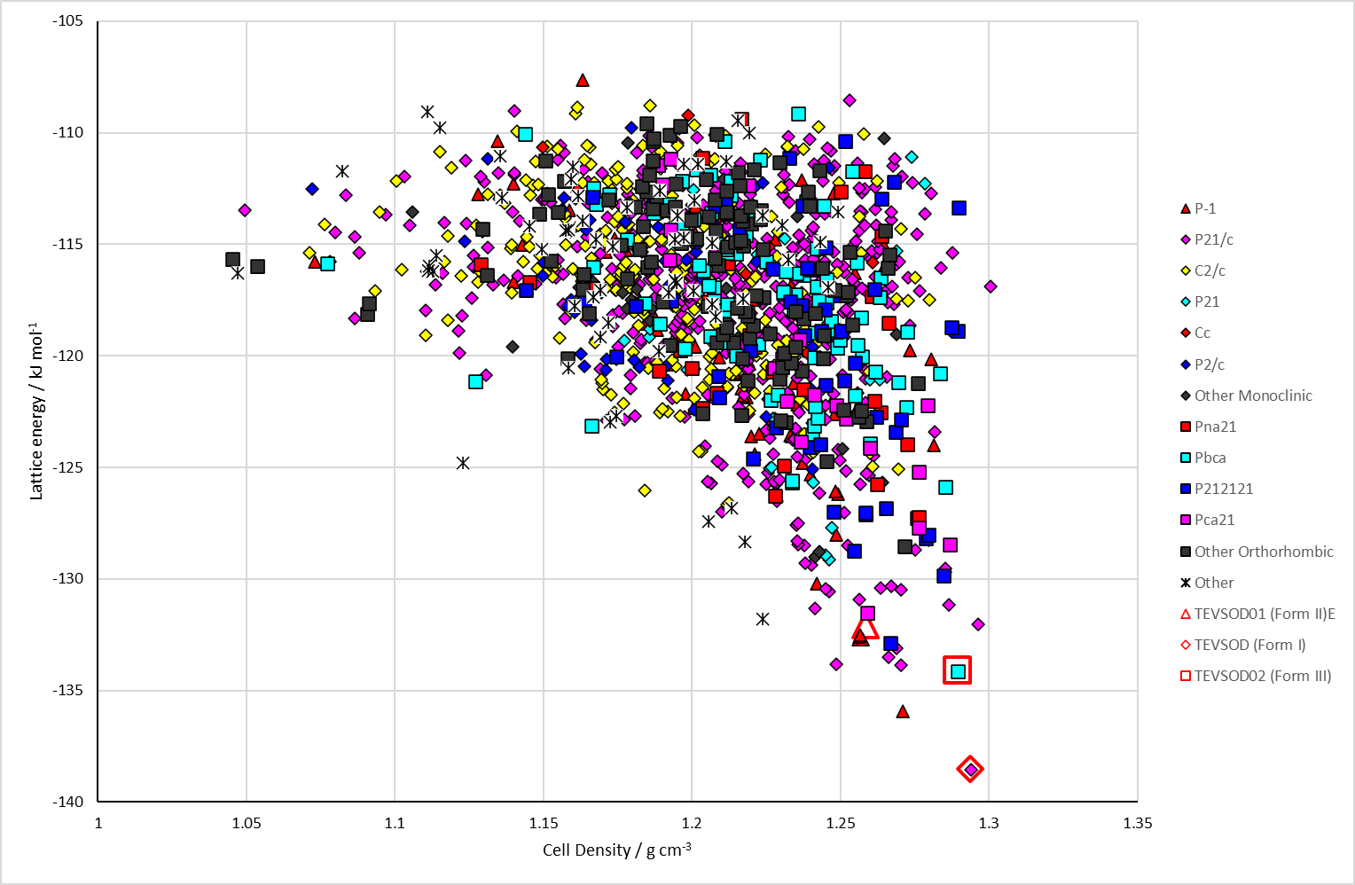
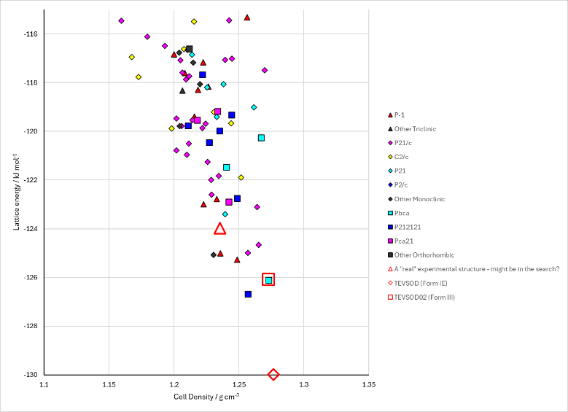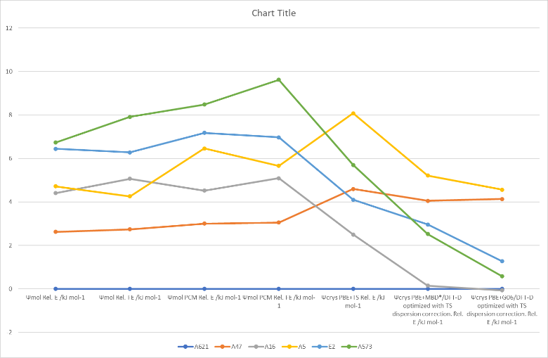
Figure 2. (Top) crystal energy landscape of Cyheptamide from Study_ID=10 (CrystalOptimizer). (Bottom left) crystal energy landscape of Cyheptamide from Study_ID=0 (MOLPAK). (Bottom right) relative energies by method of key structures.

CSD structures (version 5.43 with Mar, Jun, Sep and Nov 2022 updates)

Table 1. Crystallographic information for CSD entries for Cyheptamide. Different polymorphs are coloured differently.
REFCODE | space group | Z’ | a / Å | b / Å | c / Å | α / ° | β / ° | γ / ° | density / g cm⁻³ | Form
TEVSOD | P21/c | 1 | 5.6035 | 9.1716 | 23.579 | 90 | 96.752 | 90 | 1.31 | I
TEVSOD01 | P-1 | 4 | 5.6491 | 19.5639 | 22.0741 | 84.2178 | 88.4073 | 83.6001 | 1.307 | II
TEVSOD02 | Pbca | 1 | 9.0171 | 11.0071 | 23.9483 | 90 | 90 | 90 | 1.326 | III

Table 2. Experimental information for CSD entries for Cyheptamide.
REFCODE | space group | R factor | T / K | Year | Comments
TEVSOD | P21/c | 3.5 | 150 | 2007 | As supplied by Sigma-Aldrich¹
TEVSOD01 | P-1 | 4.2 | 100 | 2008 | Heating Form I to 458 K and then cooling to 100 K²
TEVSOD02 | Pbca | 4.41 | 123 | 2016 | Sublimation onto dihydrocarbmazepine form II³

Other notes
Form I (TEVSOD) is isostructural with dihydrocarbamazepine monoclinic form.
Form II (TEVSOD01) is isostructural with carbamazepine form I and cytenamide form II.
Form III (TEVSOD02) is isostructural with carbamazepine form V and dihydrocarbamazepine form II.

1. C. K. Leech, A. J. Florence, K. Shankland, N. Shankland and A. Johnston, Acta Crystallographica Section E - Structure Reports Online, 2007, 63, O205-O206.
2. A. J. Florence, K. Shankland, T. Gelbrich, M. B. Hursthouse, N. Shankland, A. Johnston, P. Fernandes and C. K. Leech, CrystEngComm, 2008, 10, 26-28.
3. V. K. Srirambhatla, R. Guo, S. L. Price and A. J. Florence, Chemical Communications, 2016, 52, 7384-7386.

