Caffeine
(Last updated May 2026)
Figure 1. The molecular diagram of Caffeine.

CSP studies
REFCODE | NIWFEE
Formula | C8 H10 N4 O2
Common Name | Caffeine
IUPAC Systematic Name | 1,3,7-trimethyl-2,6-dioxypurine
Other Names
CSD Refcodes | NIWFEE02, NIWFEE05
Search Identifier | A
Scientist | Matthew Habgood
Date | 2011
Publication | Habgood M 2011. Cryst Growth Des 11, 3600-3608.
Energy model | 1
Study_ID | 11
Programs | CrystalPredictor, CrystalOptimizer, DMACRYS (2.0.4)
Location on S Drive | \CHEMISTRY_CPOSS\Caffeine\Caffeine_disorder
Potential Description | DMA + FIT
Intramolecular Description | SCF
Search Identifier | B
Scientist | Nizar Issa
Date | pre-2010
Publication | No publication planned
Energy model | 2
Study_ID | 10
Programs | Study_ID=20, dmaflex, DMAREL (4.1.1)
Location on S Drive | \CHEMISTRY_CPOSS\0-EarlySearches\home\louise_price.eminerals\caffeine_dmaflex
Potential Description | DMAflex DMA + FIT
Intramolecular Description | MP2/6-31G(d,p)
Energy model | 1
Study_ID | 20
Programs | Rigid CrystalPredictor, DMAREL (4.1.1)
Location on S Drive | \CHEMISTRY_CPOSS\0-EarlySearches\home\louise_price.eminerals\caffeine
Potential Description | Crystal Predictor
Intramolecular Description | MP2/6-31G(d,p)
Search Identifier | C
Scientist | Louise Price
Date | July 2019
Publication | Possible Caffeine-Paracetamol cocrystal paper with Kreso
Energy model | 1
Study_ID | 60
Programs | Rigid CrystalPredictor, DFTB3-D3, DMACRYS (2.3.0)
Location on S Drive | \CHEMISTRY_CPOSS\Caffeine\Caffeine_DFTB
Potential Description | CrystalPredictor, followed by DFTB3-D3 refinement, followed by DMACRYS with GDMA2.2(PBE0/6-31G(d,p)) + FIT
Intramolecular Description | PBE0/6-31G(d,p)

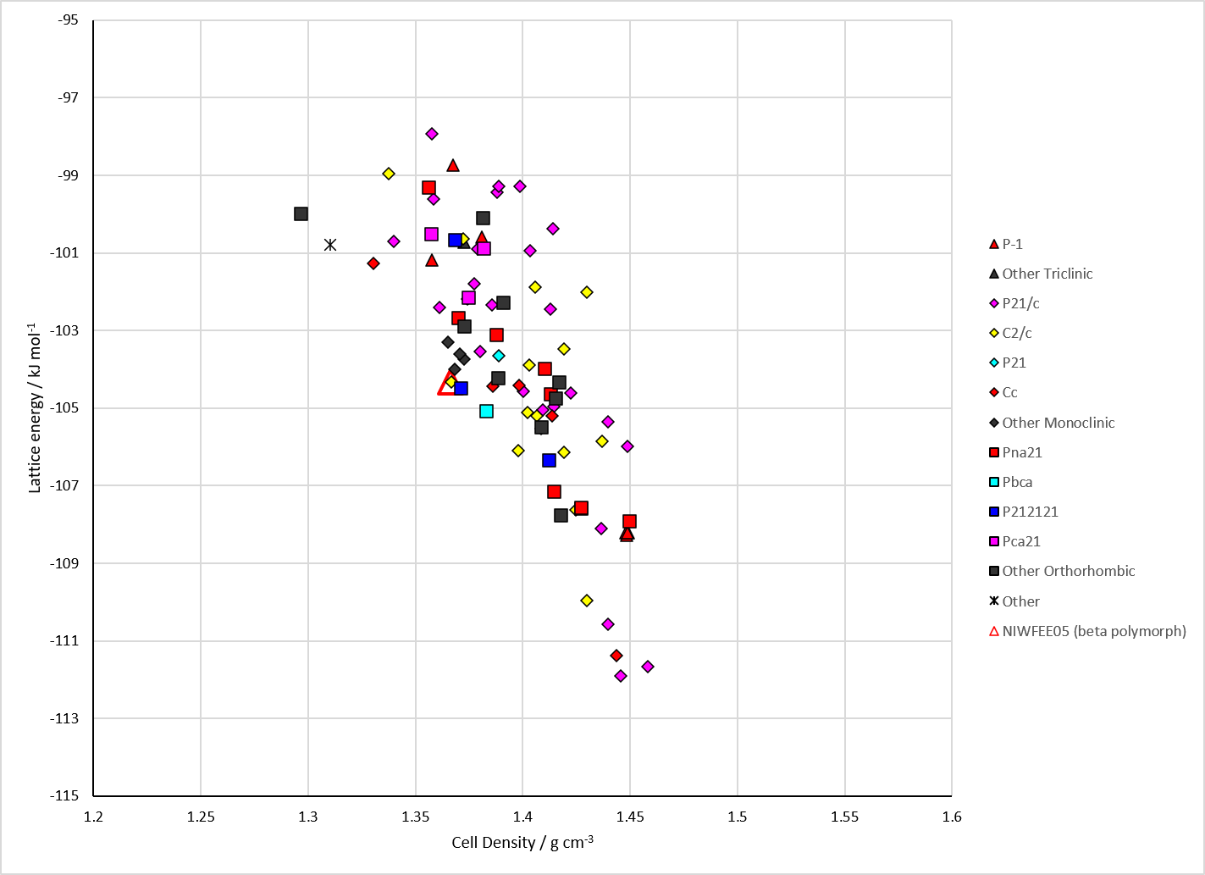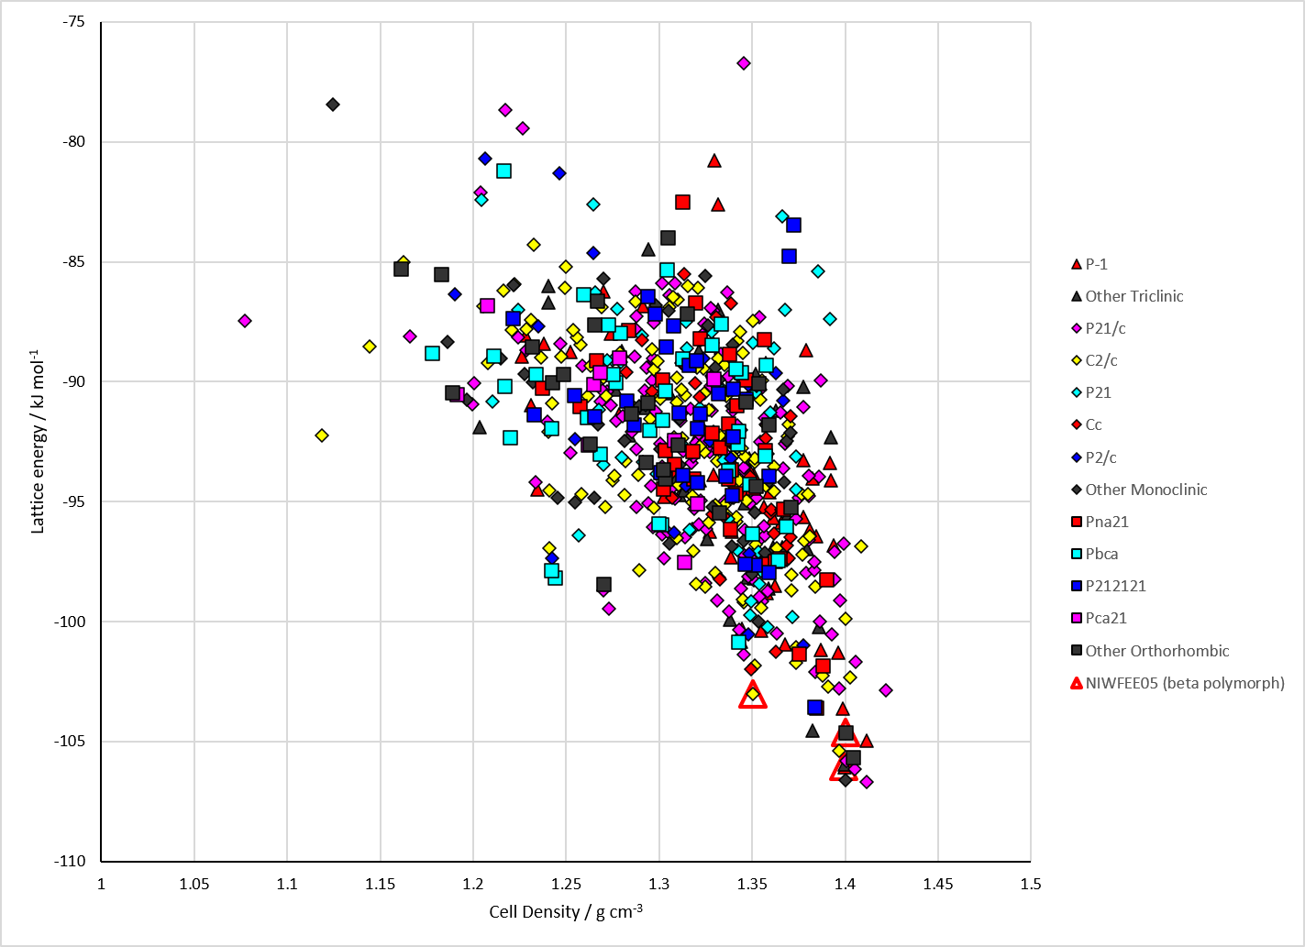
Figure 2. Crystal energy landscape of Caffeine from previous work. Left: Energy model A1. Right: Energy model C1.

CSD structures (CSD version 6.01 with Feb 2026 update)

Table 1. Crystallographic information for CSD entries for Caffeine. Different polymorphs are coloured differently.
REFCODE | space group | Z’ | a / Å | b / Å | c / Å | α / ° | β / ° | γ / ° | density / g cm⁻³ | Form
NIWFEE02 | R3c | 0.33 | 14.9372 | 14.9372 | 6.89800 | 90.0 | 90.0 | 119.99999 | 4.3546 | alpha polymorph
NIWFEE03 | Cc | 5.0 | 43.039 | 15.0675 | 6.95314 | 90.0 | 99.0274 | 90.0 | 1.4482 | beta polymorph
NIWFEE04 | R-3c | 0.17 | 14.831 | 14.831 | 6.7648 | 90.0 | 90.0 | 119.99999 | 1.5314 | alpha polymorph
NIWFEE05 | C2/c | 2.5 | 42.521 | 14.948 | 6.7923 | 90.0 | 97.825 | 90.0 | 1.2565 | beta polymorph
NIWFEE06 | C2/c | 2.5 | 42.6545 | 14.9676 | 6.81980 | 90.0 | 98.358 | 90.0 | 1.2475 | beta polymorph
The alpha polymorph has whole molecule disorder. Structure matching is not possible for our group.

Table 2. Experimental information for CSD entries for Caffeine.
REFCODE | space group | R factor | T / K | Year | Comments
NIWFEE02 | R3c | 2.25 | at 278 K | 2005 | dynamically orientationally disordered, powder data, 10.1107/S010876810500546X
NIWFEE03 | Cc | 4.33 | at 298 K | 2007 | powder data, 10.1002/chem.200600973
NIWFEE04 | R-3c | 5.69 | at 125 K | 2007 | disordered by symmetry, 10.1021/cg070291o
NIWFEE05 | C2/c | 5.84 | at 100 K | 2007 | disordered, 10.1021/cg070291o
NIWFEE06 | C2/c | 5.41 | 150 K | 2020 | disordered, 10.1016/j.chempr.2020.04.009

Make this table include whether polymorphs are solution-grown, sublimation grown, templated or otherwise. Add references.

Other notes

