Isocaffeine
(Last updated May 2026)
Figure 1. The molecular diagram of Isocaffeine.

CSP studies
REFCODE | ISCOFF
Formula | C8 H10 N4 O2
Common Name | Isocaffeine
IUPAC Systematic Name | 1,3,9-trimethyl-2,6-dioxypurine
Other Names
CSD Refcodes | ISCOFF
Search Identifier | A
Scientist | Matthew Habgood
Date | 2011
Publication | Habgood M 2011. Cryst Growth Des 11, 3600-3608.
Energy model | 1
Study_ID | 10
Programs | Rigid CrystalPredictor, CrystalOptimizer, DMACRYS (2.0.4)
Location on S Drive | \CHEMISTRY_CPOSS\Isocaffeine
Potential Description | DMA + FIT
Intramolecular Description | SCF

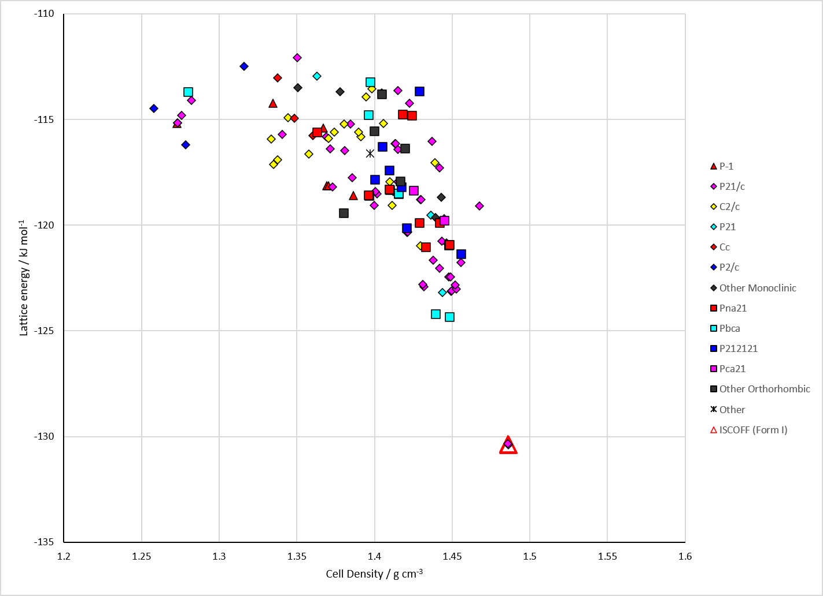
Figure 2. Crystal energy landscape of Isocaffeine from previous work.

CSD structures (CSD version 6.01 with Feb 2026 update)

Table 1. Crystallographic information for CSD entries for Isocaffeine. Different polymorphs are coloured differently.
REFCODE | space group | Z’ | a / Å | b / Å | c / Å | α / ° | β / ° | γ / ° | density / g cm⁻³ | Form
ISCOFF | P21/n | 1.0 | 7.71700 | 7.915 | 13.646 | 90.0 | 92.86 | 90.0 | 1.5494 | None

Table 2. Experimental information for CSD entries for Isocaffeine.
REFCODE | space group | R factor | T / K | Year | Comments
ISCOFF | P21/n | 3.9 | None | 1973 | 10.3891/acta.chem.scand.27-2757

Make this table include whether polymorphs are solution-grown, sublimation grown, templated or otherwise. Add references.

Other notes

