Oxcarbazepine
(Last updated 22 February 2023)
Figure 1. The molecular diagram of Oxcarbazepine.

CSP studies
REFCODE | CANDUR
Formula | C15 H12 N2 O2
Common Name | oxcarbazepine
IUPAC Systematic Name | 10-oxo-10,11-dihydro-5H-dibenzo(b,f)azepine-5-carboxamide
Other Names
CSD Refcodes | CANDUR01, CANDUR02, CANDUR03
Search Identifier | A
Scientist | Rui Guo
Date | 2017
Publication | Polyzois, H.; Guo, R.; Srirambhatla, V. K.; Warzecha, M.; Prasad, E.; Turner, A.; Halbert, G. W.; Keating, P.; Price, S. L.; Florence, A. J. Crystal Structure and Twisted Aggregates of Oxcarbazepine Form III. Crystal Growth & Design 2022. DOI 10.1021/acs.cgd.2c00152.
Energy model | 1
Study_ID | 10
Programs | flexible CrystalPredictor (2.1.01), CrystalOptimizer (2.2), DMACRYS (2.2.0.1)
Location on S Drive | \CHEMISTRY_CPOSS\CarbamazepineSeries\Oxcarbazepine_CO
Potential Description | CrystalOptimizer with GDMA2.2(PBE1PBE/6-31G(d,p)) + FIT
Energy model | 2
Study_ID | 30
Programs | Study_ID=10, DMACRYS (2.2.0.1)
Location on S Drive | \CHEMISTRY_CPOSS\CarbamazepineSeries\Oxcarbazepine_PCM
Potential Description | GDMA2.2(PCMdielectric3(PBE1PBE/6-31G(d,p))) + FIT

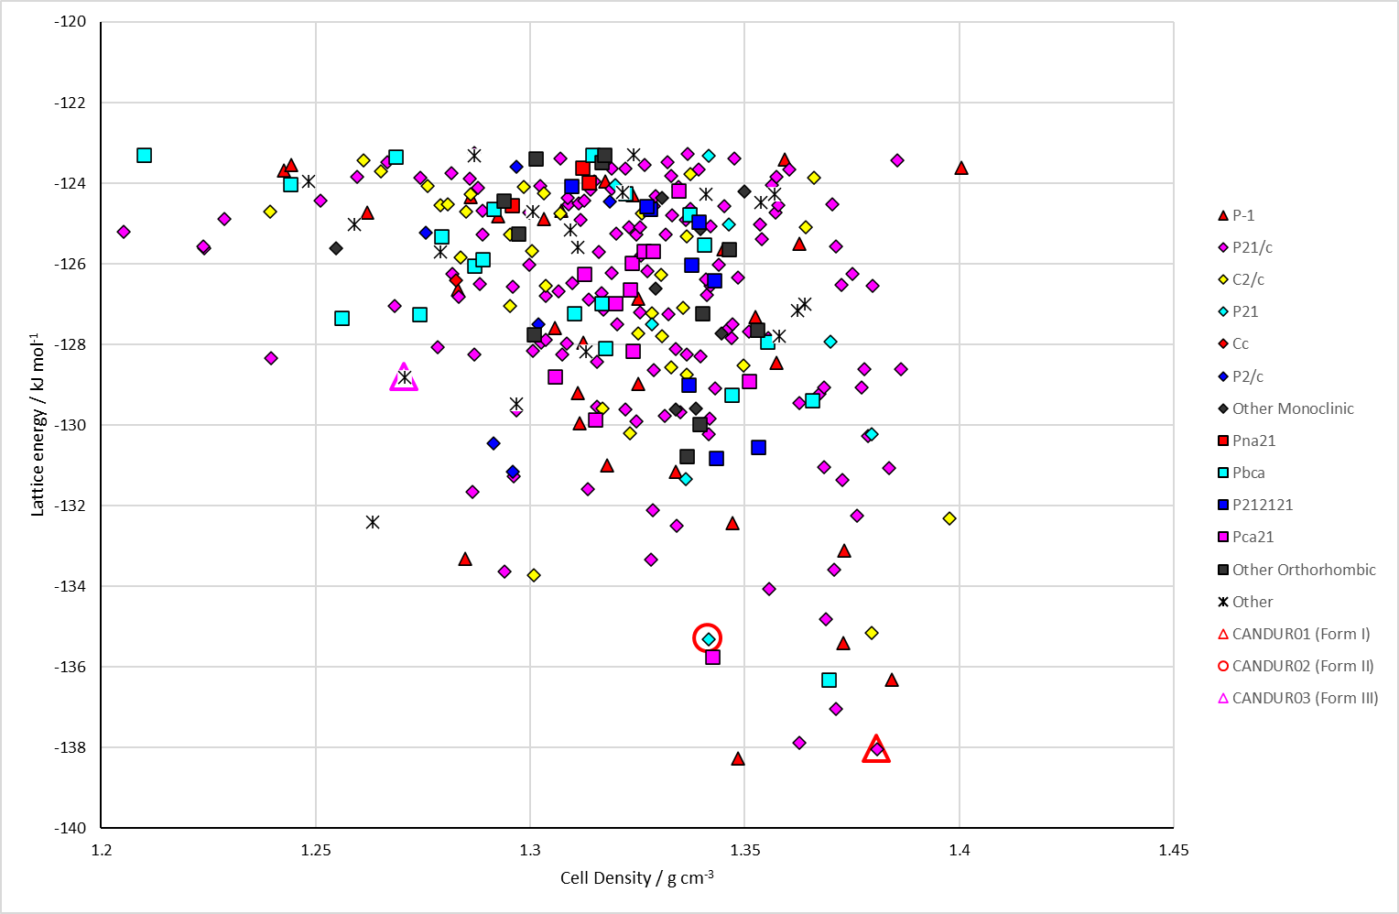
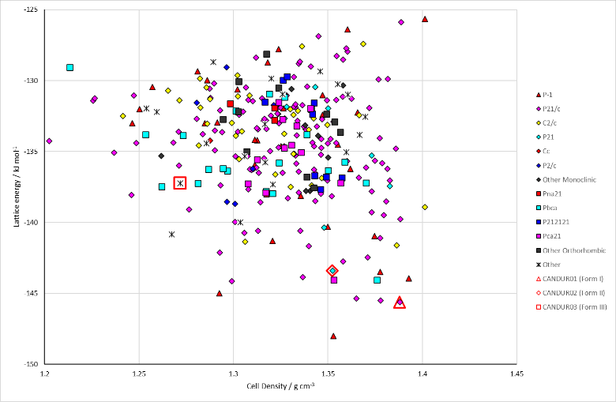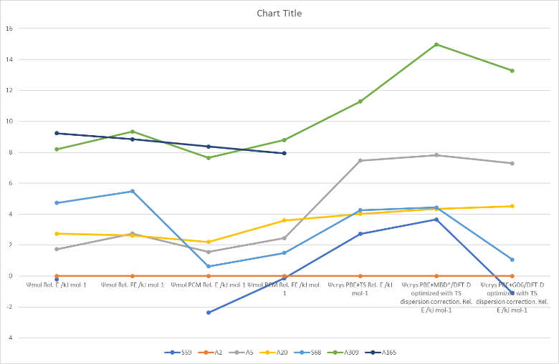
Figure 2. (Top) crystal energy landscape of Oxcarbazepine from Study_ID=10. (Bottom left) crystal energy landscape of Oxcarbazepine from Study_ID=30. (Bottom right) relative energies by method of key structures.

CSD structures (version 5.43 with Mar, Jun, Sep and Nov 2022 updates)

Table 1. Crystallographic information for CSD entries for Oxcarbazepine. Different polymorphs are coloured differently.
REFCODE | space group | Z’ | a / Å | b / Å | c / Å | α / ° | β / ° | γ / ° | density / g cm⁻³ | Form
CANDUR | P21/c | 1 | 5.276 | 9.307 | 24.841 | 90 | 95.64 | 90 | 1.38 | I
CANDUR01 | P21/c | 1 | 5.20194 | 9.2638 | 24.7989 | 90 | 95.234 | 90 | 1.408 | I
CANDUR02 | P21 | 1 | 5.1606 | 9.4057 | 12.5984 | 90 | 92.72 | 90 | 1.372 | II
CANDUR03 | R-3 | 1 | 35.975 | 35.975 | 5.291 | 90 | 90 | 120 | 1.271 | III

Table 2. Experimental information for CSD entries for Oxcarbazepine.
REFCODE | space group | R factor | T / K | Year | Comments
CANDUR | P21/c | 3.73 | 294 | 2005 | Dissolved in a 1:1 mixture of boiling distilled water and methanol and the solution allowed to stand for slow evaporation. Crystals grew in 14 days.¹
CANDUR01 | P21/c | 4.04 | 95 | 2010 | Directly from the bottle, or evaporation of methanol solution.²
CANDUR02 | P21 | 12.8 | 95 | 2010 | Dissolved in toluene, heated to 115°C, cooled to RT or placed in an ice bath²
A different Form III |  |  |  |  | Evaporation of methanol solutions (5 mg/mL) in the presence of ethylene/vinyl acetate copolymers or high-density polyethylene at room temperature.²
CANDUR03 | R-3 | 3.4 | 293 | 2022 | From the vapour phase (all substrates – Au, Ag and Cu foils; Ag-coated glass) or solution (binary solvent mixtures of ethanol and toluene). Determination from powder diffraction.³

Other notes
Form I (CANDUR01) is isostructural with dihydrocarbamazepine form I.

1. A. Hempel, N. Camerman, A. Camerman and D. Mastropaolo, Acta Crystallographica Section E, 2005, 61, o1313-o1315.
2. K. M. Lutker and A. J. Matzger, Journal of Pharmaceutical Sciences, 2010, 99, 794-803.
3. H. Polyzois, R. Guo, V. K. Srirambhatla, M. Warzecha, E. Prasad, A. Turner, G. W. Halbert, P. Keating, S. L. Price and A. J. Florence, Crystal Growth & Design, 2022.

