Benzophenanthrene
(Last updated April 2026)
Figure 1. The molecular diagram of Benzophenanthrene.

CSP studies
REFCODE | BZPHAN
Formula | C18 H12
Common Name | Benzophenanthrene
IUPAC Systematic Name | Benzo(c)phenanthrene
Other Names
CSD Refcodes | BZPHAN
Search Identifier | A
Scientist | Emiliana D'Oria
Date | pre-2010
Publication | D'Oria E, Karamertzanis PG, Price SL 2010. Cryst Growth Des 10, 1749-1756.
Energy model | 1
Study_ID | 1
Programs | MOLPAK, DMACRYS (1.0.1)
Location on S Drive | \CHEMISTRY_CPOSS\0-EarlySearches\home\louise_price.eminerals\BZPHAN_will01
Potential Description | DMA + WILL01
Intramolecular Description | MP2/6-31G(d,p)
Search Identifier | B
Scientist | Emiliana D'Oria
Date | pre-2010
Publication | See Study_ID=1
Energy model | 1
Study_ID | 0
Programs | MOLPAK, DMAREL (4.1.1)
Location on S Drive | \CHEMISTRY_CPOSS\0-EarlySearches\home\louise_price.eminerals\BZPHAN_fit
Potential Description | DMA + FIT
Intramolecular Description | MP2/6-31G(d,p)
Search Identifier | C
Scientist | Emiliana D'Oria
Date | pre-2010
Publication | See Study_ID=1
Energy model | 1
Study_ID | 10
Programs | MOLPAK, dmaflex (2), DMACRYS (1.1.1)
Location on S Drive | \CHEMISTRY_CPOSS\0-EarlySearches\home\louise_price.eminerals\BZPHAN_dmaflex
Potential Description | DMA + WILL01
Intramolecular Description | MP2/6-31G(d,p)

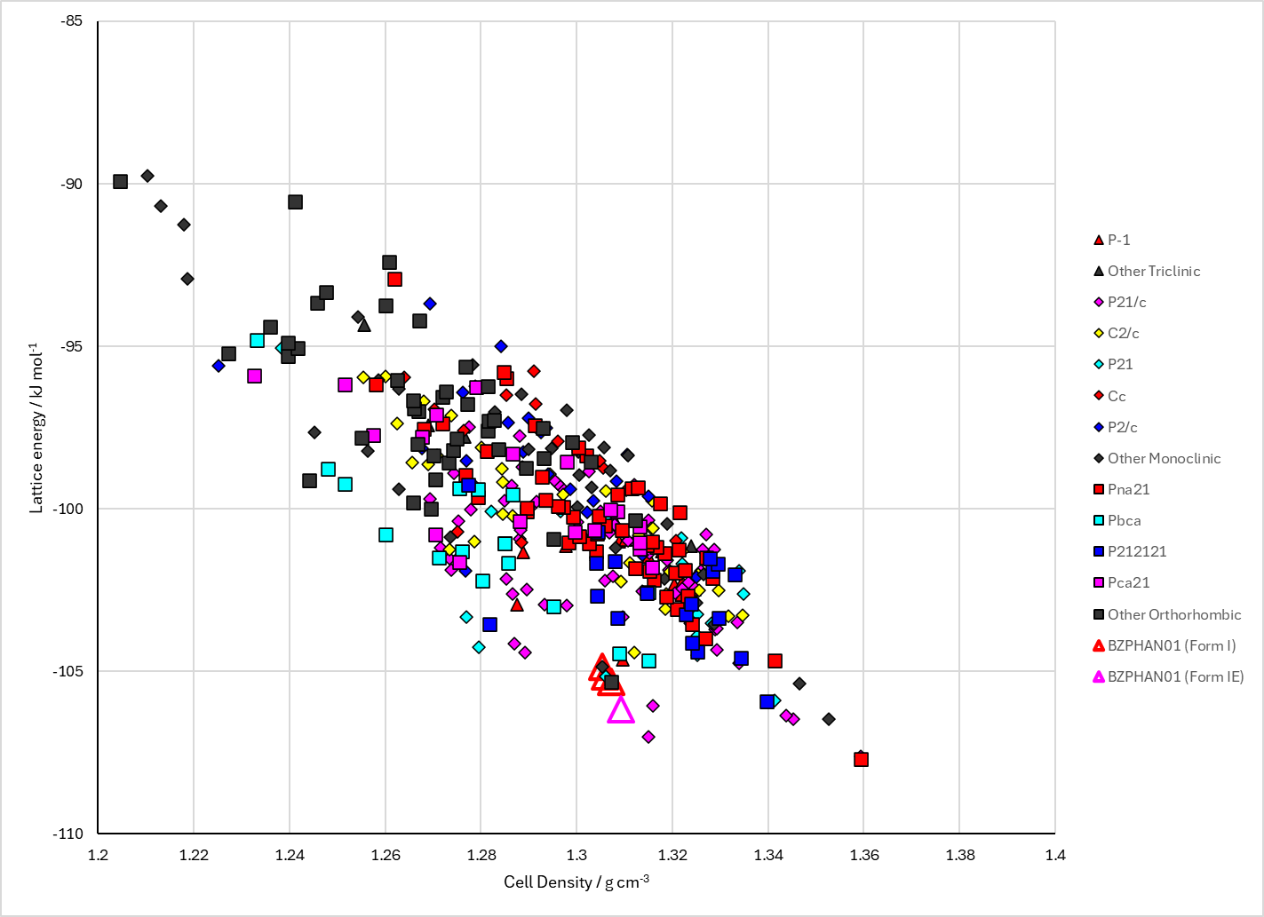
Figure 2. Crystal energy landscape of Benzophenanthrene from previous work.

CSD structures (CSD version 6.01 with Feb 2026 update)

Table 1. Crystallographic information for CSD entries for Benzophenanthrene. Different polymorphs are coloured differently.
REFCODE | space group | Z’ | a / Å | b / Å | c / Å | α / ° | β / ° | γ / ° | density / g cm⁻³ | Form
BZPHAN | P212121 | 1.0 | 14.66 | 14.157 | 5.785 | 90.0 | 90.0 | 90.0 | 1.2629 | None
BZPHAN01 | P212121 | 1.0 | 14.451 | 13.884 | 5.8 | 90.0 | 90.0 | 90.0 | 1.3030 | None

Table 2. Experimental information for CSD entries for Benzophenanthrene.
REFCODE | space group | R factor | T / K | Year | Comments
BZPHAN | P212121 | 9.0 | None | 1963 | 10.1039/JR9630002108
BZPHAN01 | P212121 | 4.8 | at 120 K | 2000 | 10.1021/ja002072w

Make this table include whether polymorphs are solution-grown, sublimation grown, templated or otherwise. Add references.

Other notes

