Sulfadiazine
(Last updated January 2026)
Figure 1. The molecular diagram of Sulfadiazine.

CSP studies
REFCODE | SULDAZ
Formula | C10 H10 N4 O2 S1
Common Name | Sulfadiazine
IUPAC Systematic Name | 4-Amino-N-(2-pyrimidinyl)-benzenesulfonamide
Other Names
CSD Refcodes | SULDAZ03
Search Identifier | A
Scientist | William Wood
Date | March 2023
Publication | In preparation
Energy model | 2
Study_ID | 10
Programs | Study_ID=20, CrystalOptimizer (2.4.7.1), DMACRYS (2.3.1.1)
Location on S Drive | \CHEMISTRY_CPOSS\Sulfadiazine\CrystOpt\
Potential Description | CrystalOptimizer with GDMA2.2(PBE0/6-31G(d,p)) + FIT + Scheraga SO2
Intramolecular Description | PBE0/6-31G(d,p)
Energy model | 1
Study_ID | 20
Programs | CrystalPredictor (2.4.3), DMACRYS (2.3.1.1)
Location on S Drive | \CHEMISTRY_CPOSS\Sulfadiazine\CrystPred\
Potential Description | CrystalPredictor2.4.3.2(torsion groups) + DMACRYS with GDMA2.2(PBE0/6-31G(d,p)) + FIT + Scheraga SO2
Intramolecular Description | PBE0/6-31G(d,p)

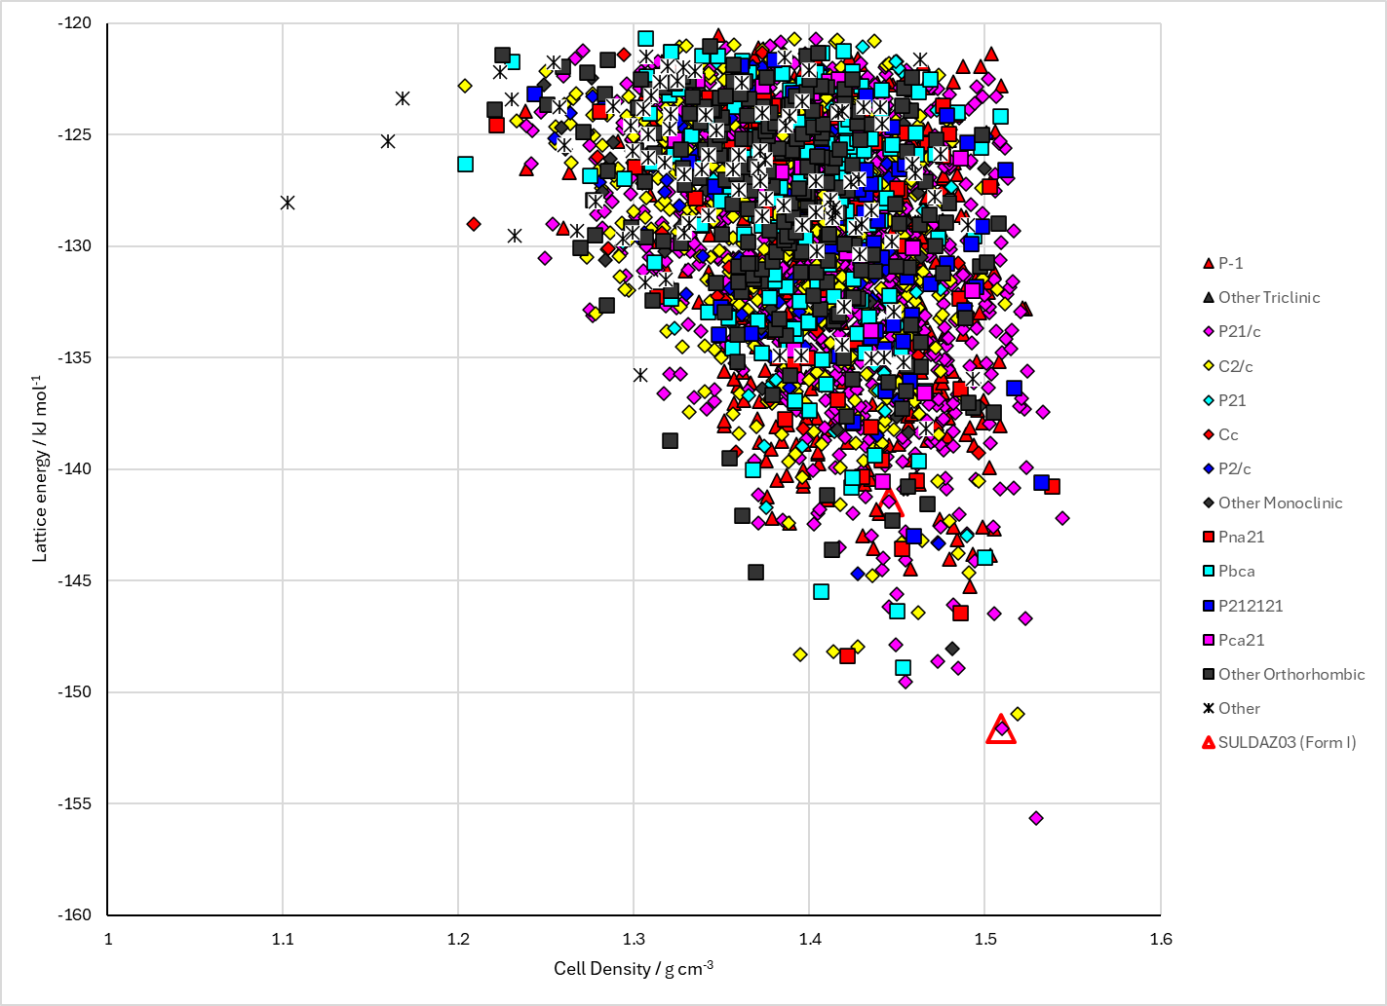 | 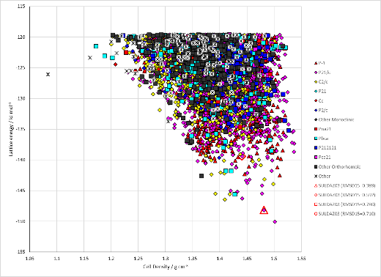
 | 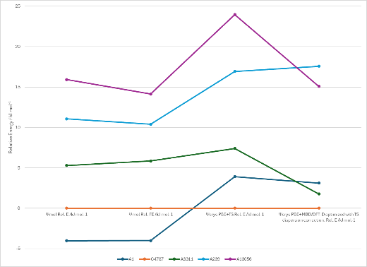
Figure 2. Crystal energy landscape of Sulfadiazine from previous work. Left: Following CrystalOptimizer refinement, Top Right: Following CrystalPredictor (Study_ID=20), Bottom Right: Energy comparisons with DFT.

CSD structures (CSD version 6.01)
Table 1. Crystallographic information for CSD entries for Sulfadiazine. Different polymorphs are coloured differently.
REFCODE | space group | Z’ | a / Å | b / Å | c / Å | α / ° | β / ° | γ / ° | density / g cm⁻³ | Form
SULDAZ | P21/c | 1.0 | 13.71 | 5.84 | 15.11 | 90.0 | 115.0 | 90.0 | 1.5161 | I
SULDAZ01 | P21/c | 1.0 | 13.71 | 5.84 | 15.11 | 90.0 | 115.0 | 90.0 | 1.5161 | I
SULDAZ02 | P21/c | 1.0 | 13.613 | 5.91900 | 14.988 | 90.0 | 114.563 | 90.0 | 1.5134 | I
SULDAZ03 | P21/c | 1.0 | 13.683 | 5.819 | 14.795 | 90.0 | 115.03700 | 90.0 | 1.5575 | I
SULDAZ05 | P21/c | 1.0 | 13.6948 | 5.8197 | 14.8245 | 90.0 | 115.09140 | 90.0 | 1.5536 | I
SULDAZ06 | P21/c | 1.0 | 13.6948 | 5.8197 | 14.8245 | 90.0 | 115.09100 | 90.0 | 1.5536 | I
SULDAZ07 | P21/c | 1.0 | 13.6810 | 5.8449 | 14.859 | 90.0 | 114.97 | 90.0 | 1.5433 | I
SULDAZ08 | P21/c | 1.0 | 13.657 | 5.9307 | 15.0140 | 90.0 | 114.61999 | 90.0 | 1.5037 | I
SULDAZ09 | P21/c | 1.0 | 13.621 | 5.92500 | 14.9910 | 90.0 | 114.574 | 90.0 | 1.5108 | I
SULDAZ11 | P21/c | 1.0 | 13.6953 | 5.8207 | 14.8243 | 90.0 | 115.07200 | 90.0 | 1.5530 | I

Table 2. Experimental information for CSD entries for Sulfadiazine.
REFCODE | space group | R factor | T / K | Year | Comments
SULDAZ | P21/c | 15.0 | None | 1974 | Paper not accessible
SULDAZ01 | P21/c | 7.9 | None | 1983 | Paper not accessible
SULDAZ02 | P21/c | 6.4 | None | 1995 | Crystallization method not specified, 10.1107/S0108270193014180
SULDAZ03 | P21/c | 4.03 | at 100 K | 2006 | From a solution of methanol, 10.1016/j.ica.2006.03.030
SULDAZ05 | P21/c | 5.310 | at 100 K | 2013 | Attempted recrystallization of diamminebis(sulfadiazine)zinc, 10.1039/c2ce26633d
SULDAZ06 | P21/c | 4.2 | at 100 K | 2013 | Attempted recrystallization of diamminebis(sulfadiazine)zinc, 10.1039/c2ce26633d
SULDAZ07 | P21/c | 3.89 | at 150 K | 2000 | Crystallization method not specified, 10.5258/ecrystals/186
SULDAZ08 | P21/c | 4.8 | 293 K | 2018 | Solution crystallization from acetone or ethyl acetate, 10.1016/j.xphs.2018.06.026
SULDAZ09 | P21/c | 2.81 | 293 K | 2018 | Paper not accessible
SULDAZ11 | P21/c | 5.86 | 100 K | 2024 | Paper not accessible

Make this table include whether polymorphs are solution-grown, sublimation grown, templated or otherwise. Add references.

Other notes

