Glucose
(Last updated February 2026)
Figure 1. The molecular diagram of beta-d-Glucose.

CSP studies
REFCODE | GLUCSE
Formula | C6 H12 O6
Common Name | beta-D-glucose
IUPAC Systematic Name | (2R,3R,4S,5S,6R)-6-(hydroxymethyl)oxane-2,3,4,5-tetrol
Other Names
CSD Refcodes | GLUCSE02
Search Identifier | A
Scientist | Isaac Sugden
Date | 2019
Publication | Imperial College work
Energy model | 1
Study_ID | 30
Programs | CrystalPredictor (?), CrystalOptimizer (?), DMACRYS (2.2.1.1)
Location on S Drive | \CHEMISTRY_CPOSS\Imperial\Glucose
Potential Description | CrystalOptimizer with PCMdielectric7(HF/6-31G(d,p)) Intra and GDMA2.2(PCMdielectric7(HF/6-31G(d,p))) + FIT with Beyer polar hydrogens.
Intramolecular Description | PCMdielectric7(HF/6-31G(d,p))

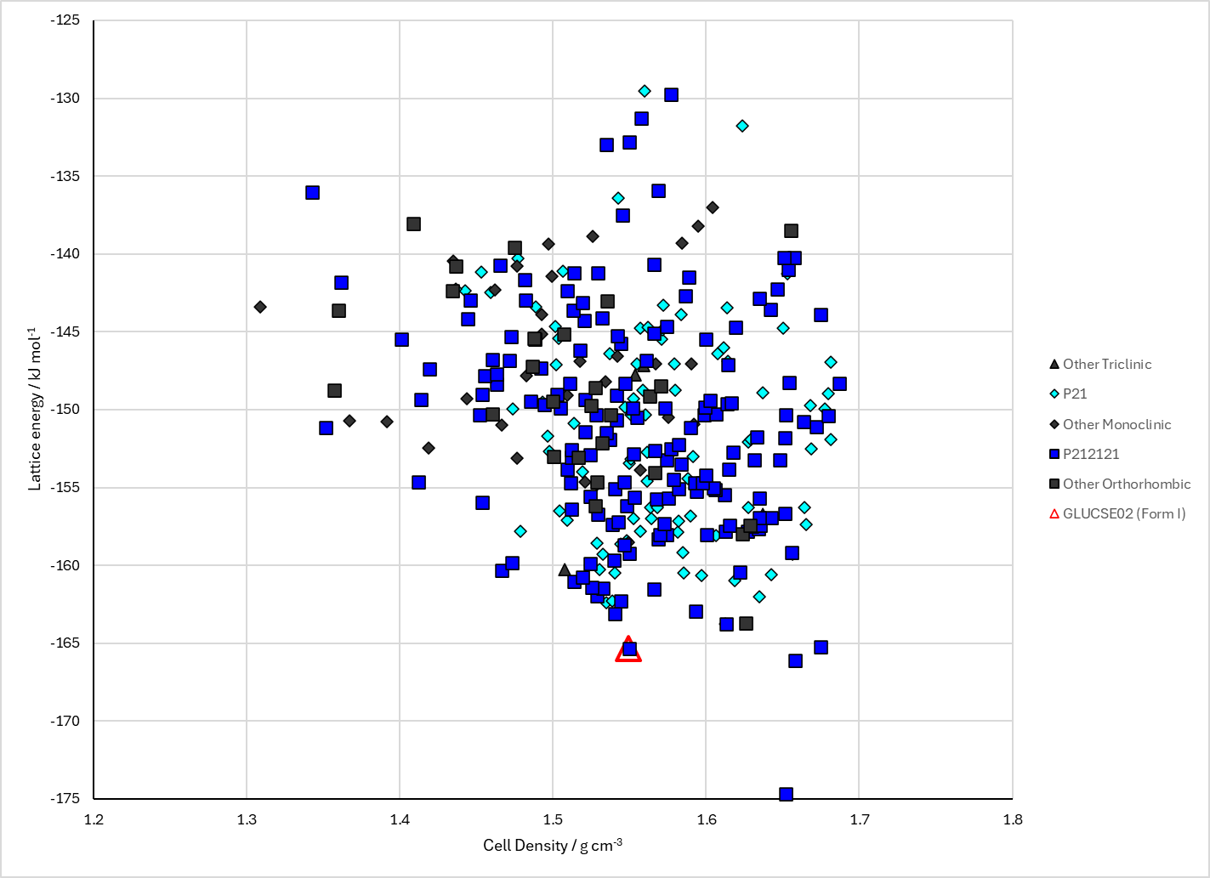
Figure 2. Crystal energy landscape of beta-d-Glucose from previous work.

CSD structures (CSD version 6.01)

Table 1. Crystallographic information for CSD entries for beta-d-Glucose. Different polymorphs are coloured differently.
REFCODE | space group | Z’ | a / Å | b / Å | c / Å | α / ° | β / ° | γ / ° | density / g cm⁻³ | Form
GLUCSE | P212121 | 1.0 | 9.29000 | 12.65 | 6.7 | 90.0 | 90.0 | 90.0 | 1.5197 | None
GLUCSE01 | P212121 | 1.0 | 9.205 | 12.64 | 6.654 | 90.0 | 90.0 | 90.0 | 1.5456 | None
GLUCSE02 | P212121 | 1.0 | 6.5949 | 9.014 | 12.72 | 90.0 | 90.0 | 90.0 | 1.5824 | None

Table 2. Experimental information for CSD entries for beta-d-Glucose.
REFCODE | space group | R factor | T / K | Year | Comments
GLUCSE | P212121 | 11.0 | None | 1963 | 10.1107/S0365110X63002693
GLUCSE01 | P212121 | None | None | 1968 | 10.1107/S0567740868003250
GLUCSE02 | P212121 | 4.76 | at 95 K | 1995 | 10.1107/S0108768194011262

Make this table include whether polymorphs are solution-grown, sublimation grown, templated or otherwise. Add references.

Other notes

