Indomethacin
(Last updated May 2026)
Figure 1. The molecular diagram of Indomethacin.

CSP studies
REFCODE | INDMET
Formula | C19 H16 N1 O4 Cl1
Common Name | Indomethacin
IUPAC Systematic Name | 1-(p-Chlorobenzoyl)-5-methoxy-2-methylindole-3-acetic acid
Other Names
CSD Refcodes | INDMET05, INDMET02, INDMET07, INDMET09, INDMET10
Search Identifier | A
Scientist | Doris Braun
Date | 2013
Publication | An experimental paper - DOI 10.1039/c5cp03880d
Energy model | 3
Study_ID | 30
Programs | Study_ID=10, DMACRYS (2.0.4)
Location on S Drive | \CHEMISTRY_CPOSS\Indomethacin\PCM
Potential Description | GDMA2.2(PCMdielectric3(PBE0/6-31G(d,p))) + FIT
Intramolecular Description | PBE0/6-31G(d,p), epsilon=3
Energy model | 2
Study_ID | 10
Programs | Study_ID=20, CrystalOptimizer, DMACRYS (2.0.4)
Location on S Drive | \CHEMISTRY_CPOSS\Indomethacin\CrystalOptimizer
Potential Description | GDMA2.2(PBE0/6-31G(d,p)) + FIT
Intramolecular Description | PBE0/6-31G(d,p)
Energy model | 1
Study_ID | 20
Programs | CrystalPredictor (1), DMAflex-Q, DMACRYS (2.0.4)
Location on S Drive | \CHEMISTRY_CPOSS\Indomethacin\DMAflex-Q
Potential Description | DMAflex-Quick, rotated charge densities from PBE0/6-31G(d,p) + FIT
Intramolecular Description | B3LYP/6-31G(d,p)

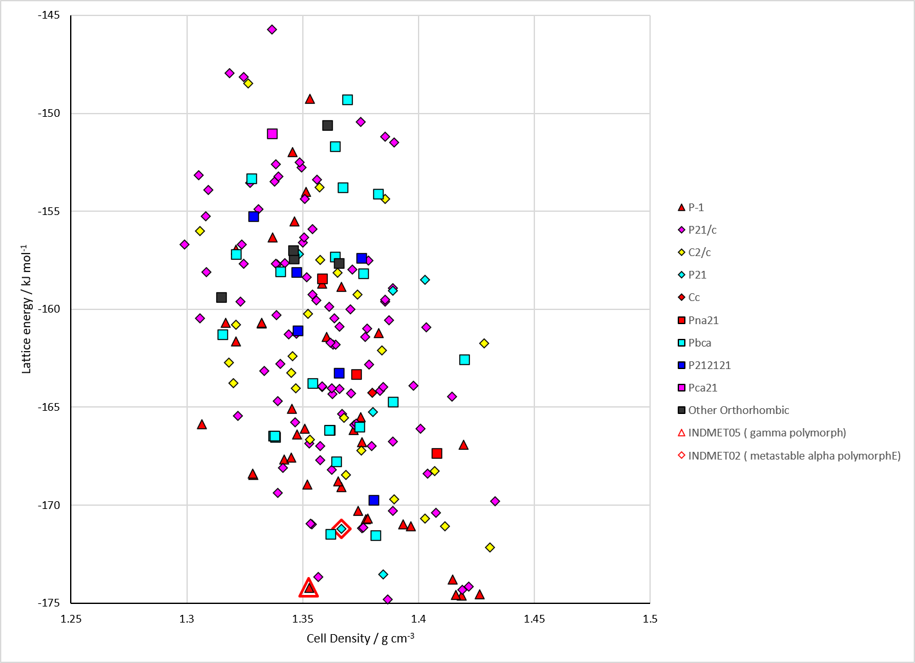
Figure 2. Crystal energy landscape of Indomethacin from previous work.

CSD structures (CSD version 6.01 with Feb 2026 update)

Table 1. Crystallographic information for CSD entries for Indomethacin. Different polymorphs are coloured differently.
REFCODE | space group | Z’ | a / Å | b / Å | c / Å | α / ° | β / ° | γ / ° | density / g cm⁻³ | Form
INDMET | P-1 | 1.0 | 9.295 | 10.969 | 9.742 | 69.38 | 110.79 | 92.78 | 1.3724 | gamma polymorph
INDMET01 | P-1 | 1.0 | 9.31 | 10.81 | 11.0 | 105.77 | 93.0 | 122.48 | 1.3634 | gamma polymorph
INDMET02 | P21 | 3.0 | 5.46160 | 25.3100 | 18.152 | 90.0 | 94.38 | 90.0 | 1.4248 | metastable alpha polymorph
INDMET03 | P-1 | 1.0 | 9.236 | 9.62000 | 10.887 | 69.897 | 87.328 | 69.501 | 1.4014 | gamma polymorph
INDMET04 | P21 | 3.0 | 5.46090 | 25.2285 | 18.1402 | 90.0 | 94.361 | 90.0 | 1.4304 | alpha polymorph
INDMET05 | P-1 | 1.0 | 9.21730 | 9.606 | 10.8436 | 69.959 | 87.197 | 69.501 | 1.4110 | gamma polymorph
INDMET06 | P-1 | 1.0 | 9.23800 | 9.62460 | 10.8767 | 69.854 | 87.248 | 69.465 | 1.4023 | gamma polymorph
INDMET07 | P21 | 2.0 | 18.3195 | 5.09993 | 18.5386 | 90.0 | 95.771 | 90.0 | 1.3790 | delta polymorph
INDMET08 | P21 | 2.0 | 18.3 | 5.12 | 18.56 | 90.0 | 95.8 | 90.0 | 1.3736 | delta polymorph
INDMET09 | Cc | 2.0 | 4.79 | 57.0 | 12.91 | 90.0 | 99.57 | 90.0 | 1.3674 | theta polymorph
INDMET10 | C2/c | 2.0 | 43.7 | 5.19 | 33.43 | 90.0 | 100.73 | 90.0 | 1.2760 | sigma polymorph
INDMET11 | P-1 | 1.0 | 9.24110 | 9.62600 | 10.8794 | 69.803 | 87.297 | 69.512 | 1.4015 | gamma polymorph
INDMET12 | P-1 | 1.0 | 9.2369 | 9.6311 | 10.8758 | 69.863 | 87.254 | 69.441 | 1.4018 | gamma polymorph
INDMET13 | P-1 | 1.0 | 9.24880 | 9.62450 | 10.877 | 69.829 | 87.251 | 69.42 | 1.4014 | gamma polymorph

Table 2. Experimental information for CSD entries for Indomethacin.
REFCODE | space group | R factor | T / K | Year | Comments
INDMET | P-1 | 5.9 | None | 1972 | 10.1021/ja00759a047
INDMET01 | P-1 | 11.1 | None | 1976 | None
INDMET02 | P21 | 5.4 | at 203 K | 2002 | 10.1021/ja017662o
INDMET03 | P-1 | 4.43 | at 120 K | 2003 | 10.1107/S160053680301290X
INDMET04 | P21 | 6.49 | at 193 K | 2011 | 10.1021/ml100292y
INDMET05 | P-1 | 3.300 | 100.0 K | 2020 | 10.1039/D0CC03157G
INDMET06 | P-1 | 2.989 | 150 K | 2021 | None
INDMET07 | P21 | 3.56 | 295 K | 2021 | powder, 10.1016/j.ijpharm.2021.121067
INDMET08 | P21 | 17.15 | 293 K | 2022 | electron diffraction, 10.1002/anie.202114985
INDMET09 | Cc | 19.13 | 293 K | 2022 | electron diffraction, 10.1002/anie.202114985
INDMET10 | C2/c | 28.22 | 87 K | 2024 | electron powder diffraction, 10.1107/S2052252524008121
INDMET11 | P-1 | 2.92 | 150 K | 2024 | 10.1021/acs.jchemed.4c00797
INDMET12 | P-1 | 3.209 | 150 K | 2024 | 10.1021/acs.jchemed.4c00797
INDMET13 | P-1 | 3.070 | 150 K | 2024 | 10.1021/acs.jchemed.4c00797

Make this table include whether polymorphs are solution-grown, sublimation grown, templated or otherwise. Add references.

Other notes

