Amantadine Hydrochloride
(Last updated May 2026)
Figure 1. The molecular diagram of Amantadine Hydrochloride.

CSP studies
REFCODE | FINVAZ
Formula | C10 H18 N1 + Cl1 -
Common Name | Amantadine hydrochloride
IUPAC Systematic Name | Amantadine hydrochloride
Other Names
CSD Refcodes | FINVAZ01
Search Identifier | A
Scientist | Sharmarke Mohamed
Date | pre-2010
Publication | No publication planned.
Energy model | 1
Study_ID | 20
Programs | Rigid CrystalPredictor, DMACRYS (2.0.2)
Location on S Drive | \CHEMISTRY_CPOSS\0-EarlySearches\home\louise_price.eminerals\amantadine_hydrochloride
Potential Description | DMA(MP2 6-31(d,p)) + WILL01 + Hejczyk chlorine parameters
Intramolecular Description | MP2/6-31G(d,p)

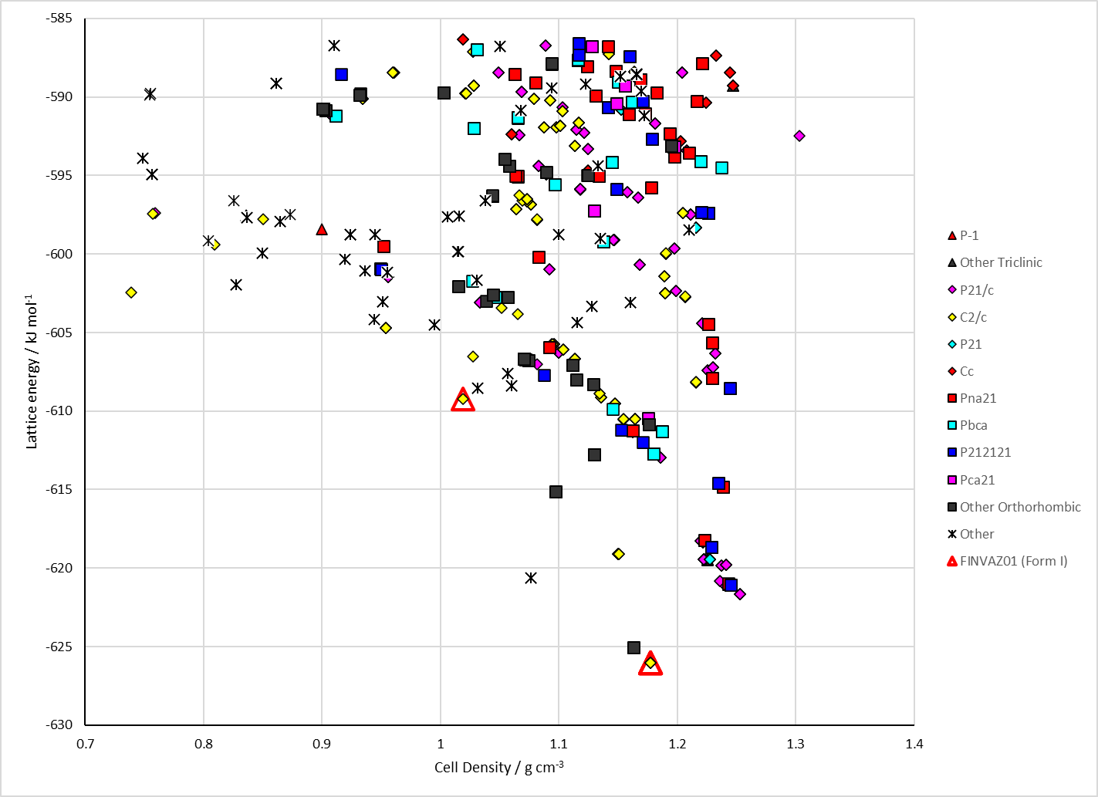
Figure 2. Crystal energy landscape of Amantadine Hydrochloride from previous work.

CSD structures (CSD version 6.01 with Feb 2026 update)

Table 1. Crystallographic information for CSD entries for Amantadine Hydrochloride. Different polymorphs are coloured differently.
REFCODE | space group | Z’ | a / Å | b / Å | c / Å | α / ° | β / ° | γ / ° | density / g cm⁻³ | Form
FINVAZ | C2/c | 1.0 | 20.549 | 11.138 | 9.658 | 90.0 | 108.81 | 90.0 | 1.1917 | None
FINVAZ01 | C2/c | 1.0 | 20.7095 | 11.1664 | 9.7217 | 90.0 | 109.021 | 90.0 | 1.1732 | None

Table 2. Experimental information for CSD entries for Amantadine Hydrochloride.
REFCODE | space group | R factor | T / K | Year | Comments
FINVAZ | C2/c | 6.5 | at 143 K | 1987 | 10.1107/S010827018709423X
FINVAZ01 | C2/c | 4.52 | 100 K | 2022 | 10.1016/j.cherd.2022.09.049

Make this table include whether polymorphs are solution-grown, sublimation grown, templated or otherwise. Add references.

Other notes

