(S)-(+)-5-Hydroxymethyl-2-oxazolidinone
(Last updated April 2026)
Figure 1. The molecular diagram of (S)-(+)-5-Hydroxymethyl-2-oxazolidinone.

CSP studies
REFCODE | EXEVUY
Formula | C4 H7 N1 O3
Common Name | (S)-(+)-5-Hydroxymethyl-2-oxazolidinone
IUPAC Systematic Name | (S)-(+)-5-Hydroxymethyl-2-oxazolidinone
Other Names
CSD Refcodes | EXEVUY
Search Identifier | A
Scientist | Emiliana D'Oria
Date | pre-2010
Publication | No publication planned.
Energy model | 2
Study_ID | 10
Programs | Study_ID=0, dmaflex (2), DMACRYS (1.1.1)
Location on S Drive | \CHEMISTRY_CPOSS\0-EarlySearches\home\louise_price.eminerals\Hydroxymethyloxazolidinone\dmaflex
Potential Description | DMA + FIT
Intramolecular Description | HF/6-31G(d,p)
Energy model | 1
Study_ID | 0
Programs | MOLPAK, DMAREL (4.1.1)
Location on S Drive | \CHEMISTRY_CPOSS\0-EarlySearches\home\louise_price.eminerals\Hydroxymethyloxazolidinone\ConOpt
Potential Description | DMA + FIT
Intramolecular Description | MP2/6-31G(d,p)

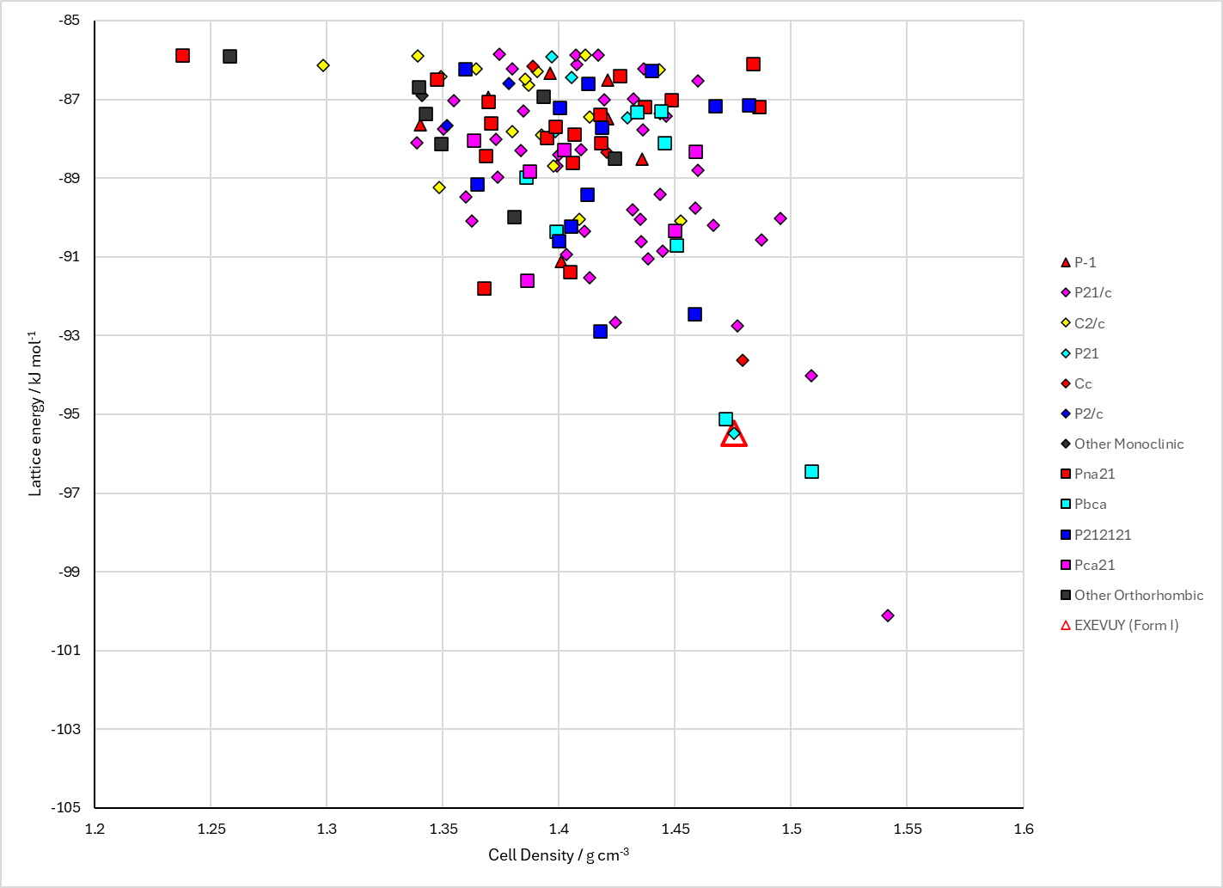
Figure 2. Crystal energy landscape of (S)-(+)-5-Hydroxymethyl-2-oxazolidinone from previous work.

CSD structures (CSD version 6.01 with Feb 2026 update)

Table 1. Crystallographic information for CSD entries for (S)-(+)-5-Hydroxymethyl-2-oxazolidinone. Different polymorphs are coloured differently.
REFCODE | space group | Z’ | a / Å | b / Å | c / Å | α / ° | β / ° | γ / ° | density / g cm⁻³ | Form
EXEVUY | P21 | 1.0 | 5.566 | 7.90020 | 6.2428 | 90.0 | 104.98 | 90.0 | 1.4665 | None

Table 2. Experimental information for CSD entries for (S)-(+)-5-Hydroxymethyl-2-oxazolidinone.
REFCODE | space group | R factor | T / K | Year | Comments
EXEVUY | P21 | 3.04 | at 293 K | 2004 | 10.1016/j.tetasy.2004.03.038

Make this table include whether polymorphs are solution-grown, sublimation grown, templated or otherwise. Add references.

Other notes

