Progesterone
(Last updated April 2026)
Figure 1. The molecular diagram of Progesterone.

CSP studies
REFCODE | PROGST
Formula | C21 H30 O2
Common Name | Progesterone
IUPAC Systematic Name | Progesterone
Other Names
CSD Refcodes | PROGST12, PROGST13, EWACUA, KESBEQ
Search Identifier | A
Scientist | Panos Karamertzanis
Date | 2005
Publication | Lancaster RW, Karamertzanis PG, Hulme AT, Tocher DA, Covey DF, Price SL Chem. Commun 2006, (47), 4921-4923.
Energy model | 2
Study_ID | 10
Programs | Study_ID=0, dmaflex, DMAREL (4.1.1)
Location on S Drive | \CHEMISTRY_CPOSS\0-EarlySearches\home\louise_price.eminerals\progesterone_dmaflex
Potential Description | FIT
Intramolecular Description | MP2/6-31G(d,p)
Energy model | 1
Study_ID | 0
Programs | MOLPAK, DMAREL (4.1.1)
Location on S Drive | \CHEMISTRY_CPOSS\0-EarlySearches\home\louise_price.eminerals\progesterone
Potential Description | FIT
Intramolecular Description | MP2/6-31G(d,p)
Search Identifier | B
Scientist | Panos Karamertzanis
Date | 2009
Publication | Friscic T, Lancaster RW, Fabian L, Karamertzanis PG PNAS 2010, 107 (30), 13216-13221
Energy model | 2
Study_ID | 11
Programs | Study_ID=20, CrystalOptimizer, DMACRYS (1.1.1)
Location on S Drive | \CHEMISTRY_CPOSS\0-EarlySearches\home\louise_price.eminerals\Steroids\progesterone\dmaflex
Potential Description | CrystalOptimizer with 23 torsion angles and 1 bond angle optimised. FIT potential and B3LYP inter and intra levels.
Intramolecular Description | B3LYP
Energy model | 1
Study_ID | 20
Programs | Rigid CrystalPredictor, DMACRYS (1.1.1)
Location on S Drive | \CHEMISTRY_CPOSS\0-EarlySearches\home\louise_price.eminerals\Steroids\progesterone\rigid
Potential Description | FIT potential and B3LYP6-31G(d,p) DMA.
Intramolecular Description | B3LYP/6-31Gd,p

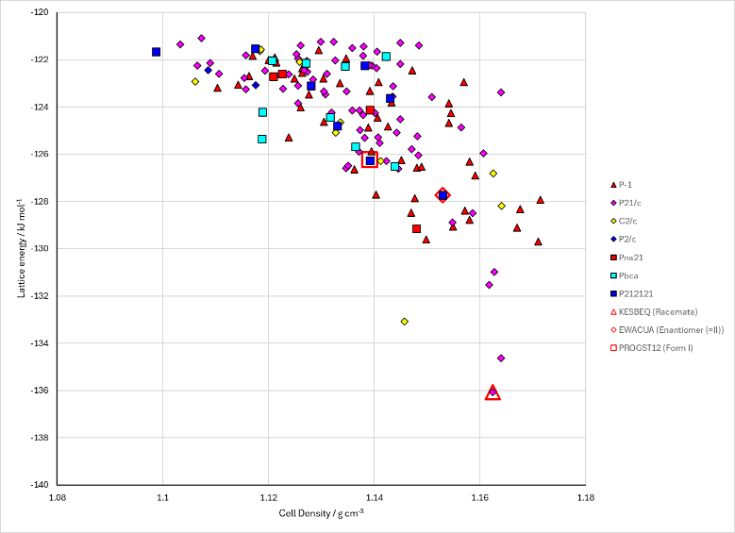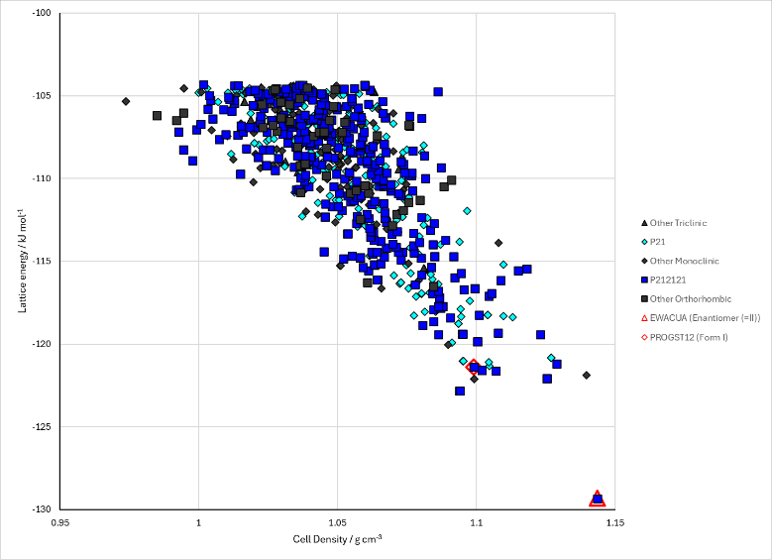
Figure 2. Crystal energy landscape of Progesterone from previous work. Left: Energy model A1. Right: Energy model B1.
Note that the right hand plot on Figure 2 only search the non-centrosymmetric space groups.

CSD structures (CSD version 6.01 with Feb 2026 update)

Table 1. Crystallographic information for CSD entries for Progesterone. Different polymorphs are coloured differently.
REFCODE | space group | Z’ | a / Å | b / Å | c / Å | α / ° | β / ° | γ / ° | density / g cm⁻³ | Form
EWACUA | P212121 | 1.0 | 6.22190 | 12.6094 | 22.2869 | 90.0 | 90.0 | 90.0 | 1.1945 | Enantiomer (=Form II)
KESBEQ | P21/c | 1.0 | 10.9219 | 7.44 | 21.034 | 90.0 | 93.362000 | 90.0 | 1.2241 | Racemate
PROGST01 | P212121 | 1.0 | 6.252 | 12.592 | 22.488 | 90.0 | 90.0 | 90.0 | 1.1798 | Form II
PROGST10 | P212121 | 1.0 | 12.5590 | 13.798 | 10.34 | 90.0 | 90.0 | 90.0 | 1.1656 | Form I
PROGST11 | P212121 | 1.0 | 10.287 | 12.5240 | 13.701 | 90.0 | 90.0 | 90.0 | 1.1832 | Form I
PROGST12 | P212121 | 1.0 | 10.2496 | 12.483 | 13.6406 | 90.0 | 90.0 | 90.0 | 1.1967 | Form I
PROGST13 | P212121 | 1.0 | 6.2089 | 12.5804 | 22.188 | 90.0 | 90.0 | 90.0 | 1.2051 | Form II
PROGST14 | P212121 | 1.0 | 6.2062 | 12.573 | 22.12 | 90.0 | 90.0 | 90.0 | 1.2101 | Form II
PROGST15 | P212121 | 1.0 | 10.38 | 12.81 | 13.89 | 90.0 | 90.0 | 90.0 | 1.1309 | Form I
PROGST16 | P212121 | 1.0 | 10.2770 | 12.554 | 13.504 | 90.0 | 90.0 | 90.0 | 1.1988 | Form I
PROGST15 has incorrect orientation of COMe group, but same packing.
Table 2. Experimental information for CSD entries for Progesterone.
REFCODE | space group | R factor | T / K | Year | Comments
EWACUA | P212121 | 4.2 | at 180 K | 2003 | 10.1016/S0003-9861(02)00491-5
KESBEQ | P21/c | 8.86 | at 150 K | 2006 | 10.1039/B611599C
PROGST01 | P212121 | 12.3 | None | 1975 | None
PROGST10 | P212121 | 4.7 | None | 1972 | 10.1107/S0567740872007393
PROGST11 | P212121 | 5.5 | at 173.2 K | 2004 | 10.1016/j.tet.2004.02.030
PROGST12 | P212121 | 3.87 | at 150 K | 2007 | 10.1002/jps.20983
PROGST13 | P212121 | 4.54 | at 150 K | 2007 | 10.1002/jps.20983
PROGST14 | P212121 | 4.979 | 110 K | 2014 | 10.1021/cg5006727
PROGST15 | P212121 | 17.65 | 293 K | 2018 | 10.1021/acscentsci.8b00760
PROGST16 | P212121 | 11.81 | 80.2 K | 2021 | 10.3389/fmolb.2021.648603

Make this table include whether polymorphs are solution-grown, sublimation grown, templated or otherwise. Add references.

Other notes

