Naphthalene
(Last updated May 2026)
Figure 1. The molecular diagram of Naphthalene.

CSP studies
REFCODE | NAPHTA
Formula | C8 H10
Common Name | Naphthalene
IUPAC Systematic Name | Naphthalene
Other Names
CSD Refcodes | NAPHTA32
Search Identifier | A
Scientist | Not sure
Date | pre-2010
Publication | No publication planned.
Energy model | 1
Study_ID | 0
Programs | MOLPAK, DMAREL (4.1.1)
Location on S Drive | \CHEMISTRY_CPOSS\0-EarlySearches\home\louise_price.eminerals\Naphthalene1
Potential Description | MP2 6-31G(d,p) DMA + fit.pots
Intramolecular Description | MP2 6-31G(d,p)
Search Identifier | B
Scientist | Not sure
Date | pre-2010
Publication | No publication planned.
Energy model | 1
Study_ID | 1
Programs | MOLPAK, DMAREL (4.1.1)
Location on S Drive | \CHEMISTRY_CPOSS\0-EarlySearches\home\louise_price.eminerals\Naphthalene2
Potential Description | Old Williams charge 0.153e on C-H + fit.pots
Intramolecular Description | MP2 6-31G(d,p)

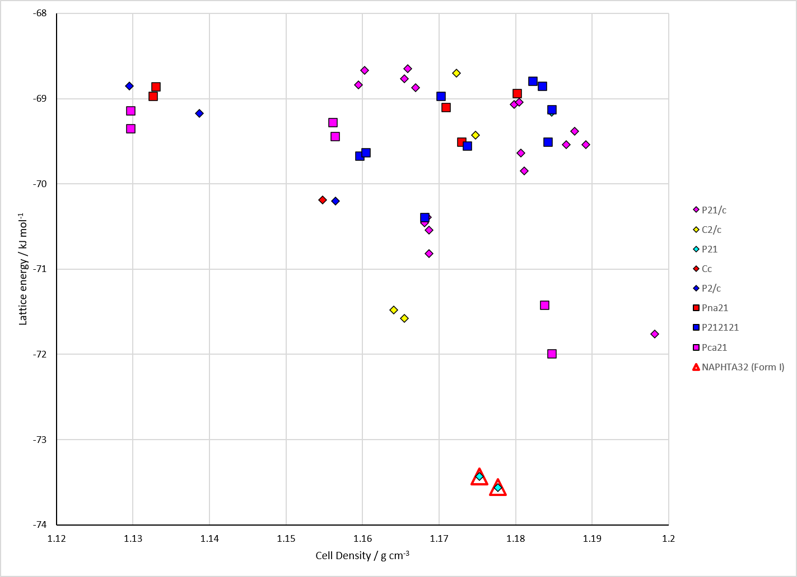
Figure 2. Crystal energy landscape of Naphthalene from previous work.

CSD structures (CSD version 6.01 with Feb 2026 update)

Table 1. Crystallographic information for CSD entries for Naphthalene. Different polymorphs are coloured differently.
REFCODE | space group | Z’ | a / Å | b / Å | c / Å | α / ° | β / ° | γ / ° | density / g cm⁻³ | Form
NAPHTA | P21/a | 0.5 | 8.235 | 6.003 | 8.658 | 90.0 | 122.92000 | 90.0 | 1.1847 | None
NAPHTA04 | P21/a | 0.5 | 8.098 | 5.953 | 8.65200 | 90.0 | 124.39999 | 90.0 | 1.2368 | None
NAPHTA11 | P21/a | 0.5 | 8.235 | 6.003 | 8.658 | 90.0 | 122.92000 | 90.0 | 1.1847 | None
NAPHTA12 | P21/a | 0.5 | 8.01 | 5.884 | 8.536 | 90.0 | 123.45 | 90.0 | 1.2680 | None
NAPHTA15 | P21/c | 0.5 | 7.82480 | 5.9349 | 8.0997 | 90.0 | 114.441 | 90.0 | 1.2430 | None
NAPHTA16 | P21/c | 0.5 | 7.8612 | 5.9413 | 8.1224 | 90.0 | 114.528 | 90.0 | 1.2333 | None
NAPHTA17 | P21/c | 0.5 | 7.89260 | 5.94260 | 8.13830 | 90.0 | 114.764 | 90.0 | 1.2280 | None
NAPHTA18 | P21/c | 0.5 | 7.9435 | 5.9534 | 8.1645 | 90.0 | 114.998 | 90.0 | 1.2164 | None
NAPHTA19 | P21/a | 0.5 | 8.0348 | 5.8899 | 8.565 | 90.0 | 123.59 | 90.0 | 1.2606 | None
NAPHTA20 | P21/a | 0.5 | 7.99480 | 5.8726 | 8.542 | 90.0 | 123.677 | 90.0 | 1.2754 | None
NAPHTA21 | P21/a | 0.5 | 7.85230 | 5.8106 | 8.474 | 90.0 | 124.02700 | 90.0 | 1.3283 | None
NAPHTA22 | P21/a | 0.5 | 7.6778 | 5.721 | 8.395 | 90.0 | 124.54999 | 90.0 | 1.4015 | None
NAPHTA23 | P21/a | 0.5 | 8.0846 | 5.9375 | 8.6335 | 90.0 | 124.67300 | 90.0 | 1.2488 | None
NAPHTA24 | P21/a | 0.5 | 8.0847 | 5.93840 | 8.6343 | 90.0 | 124.64599 | 90.0 | 1.2481 | None
NAPHTA25 | P21/a | 0.5 | 8.09260 | 5.9404 | 8.6353 | 90.0 | 124.521 | 90.0 | 1.2445 | None
NAPHTA26 | P21/a | 0.5 | 8.1125 | 5.9398 | 8.64900 | 90.0 | 124.47200 | 90.0 | 1.2388 | None
NAPHTA27 | P21/a | 0.5 | 8.1275 | 5.94490 | 8.6595 | 90.0 | 124.345 | 90.0 | 1.2321 | None
NAPHTA28 | P21/a | 0.5 | 8.14510 | 5.9499 | 8.66490 | 90.0 | 124.18900 | 90.0 | 1.2254 | None
NAPHTA29 | P21/a | 0.5 | 8.1651 | 5.9547 | 8.6697 | 90.0 | 124.0 | 90.0 | 1.2180 | None
NAPHTA30 | P21/a | 0.5 | 8.1941 | 5.9599 | 8.6754 | 90.0 | 123.686 | 90.0 | 1.2074 | None
NAPHTA31 | P21/a | 0.5 | 8.08 | 5.933 | 8.632 | 90.0 | 124.65 | 90.0 | 1.2504 | None
NAPHTA32 | P21/a | 0.5 | 8.0815 | 5.93340 | 8.63440 | 90.0 | 124.62 | 90.0 | 1.2493 | None
NAPHTA33 | P21/a | 0.5 | 8.102 | 5.9404 | 8.646 | 90.0 | 124.463 | 90.0 | 1.2406 | None
NAPHTA34 | P21/a | 0.5 | 8.145 | 5.9542 | 8.659 | 90.0 | 124.08900 | 90.0 | 1.2239 | None
NAPHTA35 | P21/a | 0.5 | 8.194 | 5.968 | 8.669 | 90.0 | 123.57 | 90.0 | 1.2050 | None
NAPHTA36 | P21/a | 0.5 | 8.256 | 5.98300 | 8.677 | 90.0 | 122.72899 | 90.0 | 1.1805 | None
NAPHTA37 | P21 | 1.0 | 8.6869 | 6.01230 | 8.29380 | 90.0 | 122.59710 | 90.0 | 1.1664 | None
NAPHTA39 | P21/a | 0.5 | 7.44940 | 5.6208 | 8.2917 | 90.0 | 125.494 | 90.0 | 1.5058 | None
NAPHTA40 | P21/a | 0.5 | 7.5578 | 5.6554 | 8.3443 | 90.0 | 125.21200 | 90.0 | 1.4607 | None
NAPHTA41 | P21/a | 0.5 | 7.64720 | 5.684 | 8.38900 | 90.0 | 125.02800 | 90.0 | 1.4255 | None
NAPHTA42 | P21/a | 0.5 | 7.7152 | 5.70970 | 8.4166 | 90.0 | 124.816 | 90.0 | 1.3983 | None
NAPHTA43 | P21/a | 0.5 | 7.80310 | 5.75970 | 8.4596 | 90.0 | 124.507 | 90.0 | 1.3586 | None
NAPHTA44 | P21/a | 0.5 | 7.87130 | 5.788 | 8.4908 | 90.0 | 124.07600 | 90.0 | 1.3284 | None
NAPHTA45 | P21/a | 0.5 | 7.99170 | 5.85640 | 8.5502 | 90.0 | 123.777 | 90.0 | 1.2797 | None
NAPHTA46 | P21/a | 0.5 | 8.084 | 5.9051 | 8.5731 | 90.0 | 123.48400 | 90.0 | 1.2470 | None
NAPHTA47 | P21/a | 0.5 | 8.2592 | 5.98351 | 8.6755 | 90.0 | 122.65099 | 90.0 | 1.1791 | None
NAPHTA48 | P21/a | 0.5 | 7.3886 | 5.61450 | 8.2776 | 90.0 | 125.706 | 90.0 | 1.5265 | None
NAPHTA49 | P21/c | 0.5 | 7.873 | 5.965 | 8.15200 | 90.0 | 114.34 | 90.0 | 1.2203 | None
NAPHTA50 | P21/a | 0.5 | 8.1433 | 5.9512 | 8.6594 | 90.0 | 124.128 | 90.0 | 1.2253 | None
NAPHTA51 | P21/a | 0.5 | 8.1686 | 5.9617 | 8.6654 | 90.0 | 123.86 | 90.0 | 1.2147 | None
NAPHTA52 | P21/a | 0.5 | 8.2128 | 5.97270 | 8.6745 | 90.0 | 123.38800 | 90.0 | 1.1980 | None
NAPHTA53 | P21/a | 0.5 | 8.108 | 5.9397 | 8.6472 | 90.0 | 124.37900 | 90.0 | 1.2384 | None
NAPHTA54 | P21/a | 0.5 | 8.1224 | 5.94300 | 8.6525 | 90.0 | 124.322 | 90.0 | 1.2340 | None

Table 2. Experimental information for CSD entries for Naphthalene.
REFCODE | space group | R factor | T / K | Year | Comments
NAPHTA | P21/a | 16.8 | None | 1949 | 10.1107/S0365110X49000618
NAPHTA04 | P21/a | 4.7 | 123 K | 1976 | None
NAPHTA11 | P21/a | None | None | 1957 | 10.1107/S0365110X57001826
NAPHTA12 | P21/a | 3.1 | None | 1982 | 0.51 GPa, 10.1107/S056774088200942X
NAPHTA15 | P21/c | 1.77 | at 100.0 K | 2004 | 10.1021/jp036186g
NAPHTA16 | P21/c | 2.030 | at 135.0 K | 2004 | 10.1021/jp036186g
NAPHTA17 | P21/c | 2.87 | at 170.0 K | 2004 | 10.1021/jp036186g
NAPHTA18 | P21/c | 3.64 | at 205.0 K | 2004 | 10.1021/jp036186g
NAPHTA19 | P21/a | 7.07 | at 298 K | 2006 | 0.4 GPa, 10.1107/S0108768106026814
NAPHTA20 | P21/a | 6.24 | at 298 K | 2006 | 0.6 GPa, 10.1107/S0108768106026814
NAPHTA21 | P21/a | 9.63 | at 298 K | 2006 | 1.0 GPa, 10.1107/S0108768106026814
NAPHTA22 | P21/a | 12.04 | at 298 K | 2006 | 2.1 GPa, 10.1107/S0108768106026814
NAPHTA23 | P21/a | 4.0 | at 10 K | 2006 | synchrotron, 10.1021/jp062953a
NAPHTA24 | P21/a | 3.37 | at 30 K | 2006 | synchrotron, 10.1021/jp062953a
NAPHTA25 | P21/a | 3.73 | at 60 K | 2006 | synchrotron, 10.1021/jp062953a
NAPHTA26 | P21/a | 3.5 | at 90 K | 2006 | synchrotron, 10.1021/jp062953a
NAPHTA27 | P21/a | 4.01 | at 120 K | 2006 | synchrotron, 10.1021/jp062953a
NAPHTA28 | P21/a | 3.66 | at 150 K | 2006 | synchrotron, 10.1021/jp062953a
NAPHTA29 | P21/a | 4.05 | at 180 K | 2006 | synchrotron, 10.1021/jp062953a
NAPHTA30 | P21/a | 5.13 | at 220 K | 2006 | neutron, 10.1021/jp062953a
NAPHTA31 | P21/a | 2.34 | at 5 K | 2006 | neutron, 10.1021/jp062953a
NAPHTA32 | P21/a | 1.74 | at 30 K | 2006 | neutron, 10.1021/jp062953a
NAPHTA33 | P21/a | 3.2 | at 80 K | 2006 | neutron, 10.1021/jp062953a
NAPHTA34 | P21/a | 2.530 | at 150 K | 2006 | neutron, 10.1021/jp062953a
NAPHTA35 | P21/a | 2.52 | at 220 K | 2006 | neutron, 10.1021/jp062953a
NAPHTA36 | P21/a | 2.81 | at 295 K | 2006 | neutron, 10.1021/jp062953a
NAPHTA37 | P21 | 12.18 | at 298 K | 2007 | powder, 10.1021/cg0605943
NAPHTA39 | P21/a | 0.54 | ? | 2014 | synchrotron, powder, 4.85 GPa, 10.1107/S1600576714005937
NAPHTA40 | P21/a | 0.49 | ? | 2014 | synchrotron, powder, 3.7 GPa, 10.1107/S1600576714005937
NAPHTA41 | P21/a | 0.48 | ? | 2014 | synchrotron, powder, 3.1 GPa, 10.1107/S1600576714005937
NAPHTA42 | P21/a | 0.449 | ? | 2014 | synchrotron, powder, 2.65 GPa, 10.1107/S1600576714005937
NAPHTA43 | P21/a | 0.470 | ? | 2014 | synchrotron, powder, 1.9 GPa, 10.1107/S1600576714005937
NAPHTA44 | P21/a | 0.51 | ? | 2014 | synchrotron, powder, 1.31 GPa, 10.1107/S1600576714005937
NAPHTA45 | P21/a | 0.6 | ? | 2014 | synchrotron, powder, 0.78 GPa, 10.1107/S1600576714005937
NAPHTA46 | P21/a | 0.52 | ? | 2014 | synchrotron, powder, 0.41 GPa, 10.1107/S1600576714005937
NAPHTA47 | P21/a | 0.410 | ? | 2014 | synchrotron, powder, 10.1107/S1600576714005937
NAPHTA48 | P21/a | 0.48 | ? | 2014 | synchrotron, powder, 5.6 GPa, 10.1107/S1600576714005937
NAPHTA49 | P21/c | 5.83 | 90 K | 2016 | 10.1002/chem.201602188
NAPHTA50 | P21/a | 3.8 | 143 K | 1982 | 10.1107/S0567740882008358
NAPHTA51 | P21/a | 3.8 | 184 K | 1982 | 10.1107/S0567740882008358
NAPHTA52 | P21/a | 3.500 | 239 K | 1982 | 10.1107/S0567740882008358
NAPHTA53 | P21/a | 3.8 | 92 K | 1982 | 10.1107/S0567740882008358
NAPHTA54 | P21/a | 4.0 | 109 K | 1982 | 10.1107/S0567740882008358

Make this table include whether polymorphs are solution-grown, sublimation grown, templated or otherwise. Add references.

Other notes

