Pyridine
(Last updated May 2026)
Figure 1. The molecular diagram of Pyridine.

CSP studies
A single CrystalPredictor search was run, but then the structures were optimized by the three methods starting from the search output. The structures were not optimized by one method, then another.
REFCODE | PYRDNA
Formula | C5 H5 N1
Common Name | Pyridine
IUPAC Systematic Name | Pyridine
Other Names | Pyridine
CSD Refcodes | PYRDNA04, PYRDNA05, PYRDNA08
Search Identifier | A
Scientist | Alex Aina
Date | November 2016
Publication | Aina AA; Misquitta AJ; Price SL, J Chem Phys 2017, 147, (16), 161722.
Energy model | 1
Study_ID | 2
Programs | Rigid CrystalPredictor, DMACRYS (2.2.1.0)
Location on S Drive | \CHEMISTRY_CPOSS\Pyridine\DIFF
Potential Description | ISA(PBE0/AC/d-aug-cc-pVTZ Dunning) + non-empirical potential with anisotropic repulsion and a C10 damped isotropic dispersion, and rank 1 anisotropic polarization model.
Intramolecular Description | PBE0/6-31G(d,p)
Energy model | 2
Study_ID | 1
Programs | Rigid CrystalPredictor, DMACRYS (2.2.1.0)
Location on S Drive | \CHEMISTRY_CPOSS\Pyridine\DIFF_ISO
Potential Description | ISA(PBE0/AC/d-aug-cc-pVTZ Dunning) + non-empirical potential with isotropic repulsion and a C10 damped isotropic dispersion, and rank 1 anisotropic polarization model.
Intramolecular Description | PBE0/6-31G(d,p)
Energy model | 3
Study_ID | 0
Programs | Rigid CrystalPredictor, DMACRYS (2.2.1.1)
Location on S Drive | \CHEMISTRY_CPOSS\Pyridine\FITGDMA
Potential Description | GDMA(PBE0/6-31g(d,p)) + FIT
Intramolecular Description | PBE0/6-31G(d,p)

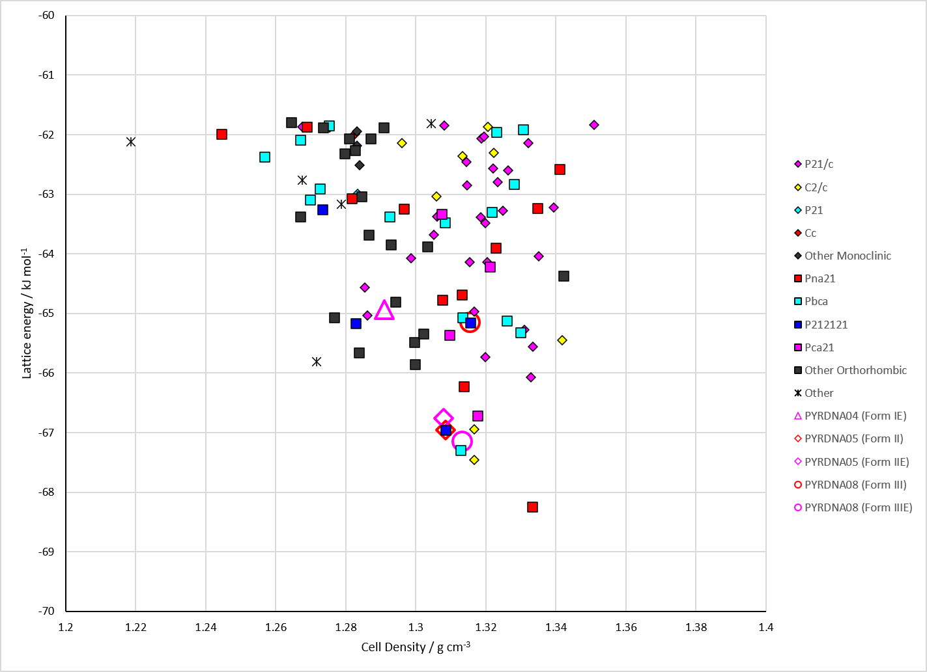
Figure 2. Crystal energy landscape of Pyridine from previous work. Energy model A1.

CSD structures (CSD version 6.01 with Feb 2026 update)

Table 1. Crystallographic information for CSD entries for Pyridine. Different polymorphs are coloured differently.
REFCODE | space group | Z’ | a / Å | b / Å | c / Å | α / ° | β / ° | γ / ° | density / g cm⁻³ | Form
PYRDNA01 | Pna21 | 4.0 | 17.524 | 8.969 | 11.352 | 90.0 | 90.0 | 90.0 | 1.1778 | polymorph I
PYRDNA02 | P212121 | 1.0 | 5.596 | 6.961 | 11.493 | 90.0 | 90.0 | 90.0 | 1.1735 | polymorph II
PYRDNA03 | P212121 | 1.0 | 5.41360 | 6.80010 | 11.2450 | 90.0 | 90.0 | 90.0 | 1.2691 | polymorph II
PYRDNA04 | Pna21 | 4.0 | 17.2429 | 8.88178 | 11.2228 | 90.0 | 90.0 | 90.0 | 1.2227 | polymorph I
PYRDNA05 | P212121 | 1.0 | 5.64729 | 6.9801 | 11.4650 | 90.0 | 90.0 | 90.0 | 1.1625 | polymorph II
PYRDNA06 | Pna21 | 4.0 | 17.267 | 8.76400 | 11.006 | 90.0 | 90.0 | 90.0 | 1.2618 | polymorph I
PYRDNA07 | P212121 | 1.0 | 5.392 | 6.806 | 11.2610 | 90.0 | 90.0 | 90.0 | 1.2713 | polymorph II
PYRDNA08 | P41212 | 0.5 | 5.4053 | 5.4053 | 13.4853 | 90.0 | 90.0 | 90.0 | 1.3334 | polymorph III

Table 2. Experimental information for CSD entries for Pyridine.
REFCODE | space group | R factor | T / K | Year | Comments
PYRDNA01 | Pna21 | 4.4 | at 153 K | 1981 | 10.1063/1.442204
PYRDNA02 | P212121 | 6.26 | at 158 K | 2009 | 10.1002/anie.200803589
PYRDNA03 | P212121 | 6.78 | at 293 K | 2009 | 1.1 GPa, 10.1002/anie.200803589
PYRDNA04 | Pna21 | 2.42 | at 2 K | 2009 | neutron, powder, 10.1002/anie.200803589
PYRDNA05 | P212121 | 1.660 | at 195 K | 2009 | neutron, powder, 10.1002/anie.200803589
PYRDNA06 | Pna21 | 9.97 | at 295 K | 2010 | 1.23 GPa, 10.1039/c001153c
PYRDNA07 | P212121 | 2.900 | 293 K | 2020 | synchrotron, 1.09 GPa, 10.1107/S2052252519015616
PYRDNA08 | P41212 | 7.55 | 293 K | 2020 | synchrotron, 1.69 GPa, 10.1107/S2052252519015616

Make this table include whether polymorphs are solution-grown, sublimation grown, templated or otherwise. Add references.

Other notes

