Hydroxyazabenzotriazole
(Last updated June 2026)
Figure 1. The molecular diagram of Hydroxyazabenzotriazole.

CSP studies
REFCODE | BELBUP
Formula | C5 H4 N4 O1
Common Name | Hydroxyazabenzotriazole
IUPAC Systematic Name | 1-Hydroxy-7-Azabenzotriazole
Other Names | 3H-[1,2,3]triazolo[4,5-b]pyridin-3-ol
CSD Refcodes | BELBUP01, BELBUP02, BELBUP06
Search Identifier | A
Scientist | Not sure
Date | pre-2010
Publication | No publication planned.
Energy model | 1
Study_ID | 0
Programs | MOLPAK, DMAREL (4.1.1)
Location on S Drive | \CHEMISTRY_CPOSS\0-EarlySearches\home\louise_price.eminerals\hydroxyazabenzotriazole
Potential Description | DMA + FIT
Intramolecular Description | MP2/6-31G(d,p)

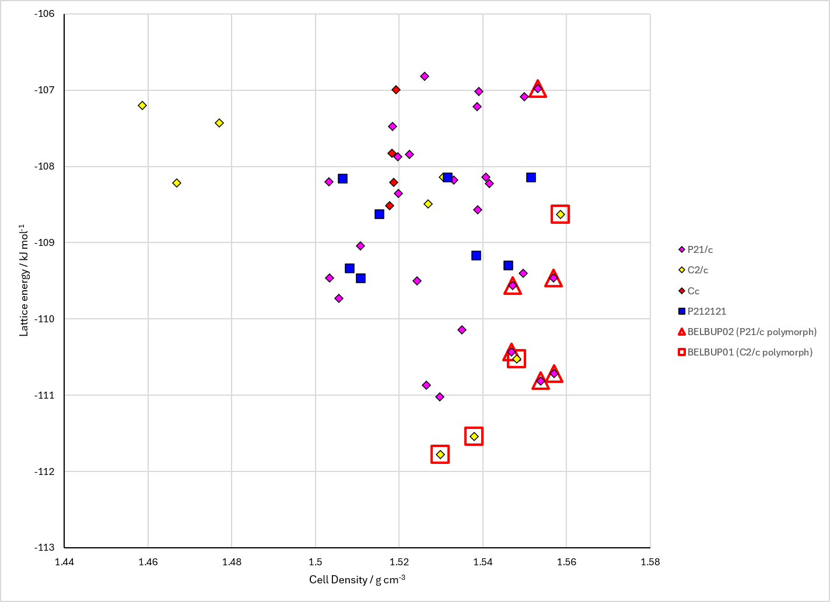
Figure 2. Crystal energy landscape of Hydroxyazabenzotriazole from previous work.

CSD structures (CSD version 6.01 with Feb 2026 update)

Table 1. Crystallographic information for CSD entries for Hydroxyazabenzotriazole. Different polymorphs are coloured differently.
REFCODE | space group | Z’ | a / Å | b / Å | c / Å | α / ° | β / ° | γ / ° | density / g cm⁻³ | Form
BELBUP | C2/c | 1.0 | 22.091 | 3.994 | 14.294 | 90.0 | 114.83000 | 90.0 | 1.5797 | C2/c polymorph
BELBUP01 | C2/c | 1.0 | 22.0427 | 3.93110 | 14.234 | 90.0 | 114.885 | 90.0 | 1.6160 | C2/c polymorph
BELBUP02 | P21/c | 1.0 | 3.74870 | 20.8881 | 7.0982 | 90.0 | 96.257000 | 90.0 | 1.6363 | P21/c polymorph
BELBUP03 | Pca21 | 1.0 | 20.2593 | 4.0782 | 6.82780 | 90.0 | 90.0 | 90.0 | 1.6026 | Pca21 polymorph
BELBUP04 | C2/c | 1.0 | 22.0384 | 3.9291 | 14.2255 | 90.0 | 114.82600 | 90.0 | 1.6173 | C2/c polymorph
BELBUP05 | P21/c | 1.0 | 3.8281 | 20.8300 | 7.1313 | 90.0 | 96.359000 | 90.0 | 1.5997 | P21/c polymorph
BELBUP06 | Pca21 | 1.0 | 20.2281 | 4.0014 | 6.81260 | 90.0 | 90.0 | 90.0 | 1.6395 | Pca21 polymorph

Table 2. Experimental information for CSD entries for Hydroxyazabenzotriazole.
REFCODE | space group | R factor | T / K | Year | Comments
BELBUP | C2/c | 3.81 | None | 1999 | 10.1016/S0022-2860(98)00582-1
BELBUP01 | C2/c | 2.96 | at 123.0 K | 2006 | 10.1107/S0108768106012584
BELBUP02 | P21/c | 3.27 | at 123.0 K | 2006 | 10.1107/S0108768106012584
BELBUP03 | Pca21 | 4.95 | at 294 K | 2010 | 10.1016/j.poly.2010.07.004
BELBUP04 | C2/c | 3.09 | 123 K | 2018 | None
BELBUP05 | P21/c | 3.53 | 294 K | 2021 | None
BELBUP06 | Pca21 | 2.949 | 150 K | 2023 | None

Make this table include whether polymorphs are solution-grown, sublimation grown, templated or otherwise. Add references.

Other notes

