Substituted nitro benzoic acids
(Last updated March 2026)
Figure 1. The molecular diagram of substituted nitro benzoic acids.

CSP studies
REFCODE | VOLZEC
Formula | C7 H4 N1 O4 Cl1
Common Name | 2-chloro-4-nitrobenzoic acid
IUPAC Systematic Name | 2-chloro-4-nitrobenzoic acid
Other Names
CSD Refcodes | VOLZEC, VOLZEC01
Search Identifier | A
Scientist | Agris Berzins
Date | 2018
Publication | Berzins A, Kons A, Sarsuns K, Belyakov S, Actins A, Crystal Growth & Design 2020, 20 (9), 5767-5784
Energy model | 1
Study_ID | 10
Programs | CrystalPredictor, CrystalOptimizer, DMACRYS (2.3.0)
Location on S Drive | \CHEMISTRY_CPOSS\Agris\2chloro_4nitro_benzoicacid
Potential Description | CrystalOptimizer MO62X/6-31G(d,p) intramolecular + GDMA2.2(MO62X/6-31G(d,p)) DMA + FIT
Intramolecular Description | M062X/6-31G(d,p)
REFCODE | IKEXOM
Formula | C7 H4 N1 O4 Cl1 - H2 O1
Common Name | 2-chloro-4-nitrobenzoic acid monohydrate
IUPAC Systematic Name | 2-chloro-4-nitrobenzoic acid monohydrate
Other Names
CSD Refcodes | IKEXOM
Search Identifier | A
Scientist | Agris Berzins
Date | 2018
Publication | Berzins A, Kons A, Sarsuns K, Belyakov S, Actins A, Crystal Growth & Design 2020, 20 (9), 5767-5784
Energy model | 1
Study_ID | 10
Programs | CrystalPredictor, CrystalOptimizer, DMACRYS (2.3.0)
Location on S Drive | \CHEMISTRY_CPOSS\Agris\2chloro_4nitro_benzoicacid_monohydrate
Potential Description | CrystalOptimizer MO62X/6-31G(d,p) intramolecular + GDMA2.2(MO62X/6-31G(d,p)) DMA + FIT
Intramolecular Description | M062X/6-31G(d,p)
REFCODE | CLNBZA
Formula | C7 H4 N1 O4 Cl1
Common Name | 2-chloro-5-nitrobenzoic acid
IUPAC Systematic Name | 2-chloro-5-nitrobenzoic acid
Other Names
CSD Refcodes | CLNBZA
Search Identifier | A
Scientist | Agris Berzins
Date | 2018
Publication | Berzins A, Kons A, Sarsuns K, Belyakov S, Actins A, Crystal Growth & Design 2020, 20 (9), 5767-5784
Energy model | 1
Study_ID | 10
Programs | CrystalPredictor, CrystalOptimizer, DMACRYS (2.3.0)
Location on S Drive | \CHEMISTRY_CPOSS\Agris\2chloro_5nitro_benzoicacid
Potential Description | CrystalOptimizer MO62X/6-31G(d,p) intramolecular + GDMA2.2(MO62X/6-31G(d,p)) DMA + FIT
Intramolecular Description | M062X/6-31G(d,p)
REFCODE | CLNBAM
Formula | C7 H4 N1 O4 Cl1 - H2 O1
Common Name | 2-chloro-5-nitrobenzoic acid monohydrate
IUPAC Systematic Name | 2-chloro-5-nitrobenzoic acid monohydrate
Other Names
CSD Refcodes
Search Identifier | A
Scientist | Agris Berzins
Date | 2018
Publication | Berzins A, Kons A, Sarsuns K, Belyakov S, Actins A, Crystal Growth & Design 2020, 20 (9), 5767-5784
Energy model | 1
Study_ID | 10
Programs | CrystalPredictor, CrystalOptimizer, DMACRYS (2.3.0)
Location on S Drive | \CHEMISTRY_CPOSS\Agris\2chloro_5nitro_benzoicacid_monohydrate
Potential Description | CrystalOptimizer MO62X/6-31G(d,p) intramolecular + GDMA2.2(MO62X/6-31G(d,p)) DMA + FIT
Intramolecular Description | M062X/6-31G(d,p)
REFCODE | QUPSEC
Formula | C7 H5 N1 O5
Common Name | 2-hydroxy-4-nitrobenzoic acid
IUPAC Systematic Name | 2-hydroxy-4-nitrobenzoic acid
Other Names
CSD Refcodes | QUPSEC
Search Identifier | A
Scientist | Agris Berzins
Date | 2018
Publication | Berzins A, Kons A, Sarsuns K, Belyakov S, Actins A, Crystal Growth & Design 2020, 20 (9), 5767-5784
Energy model | 1
Study_ID | 10
Programs | CrystalPredictor, CrystalOptimizer, DMACRYS (2.3.0)
Location on S Drive | \CHEMISTRY_CPOSS\Agris\2hydroxy_4nitro_benzoicacid
Potential Description | CrystalOptimizer MO62X/6-31G(d,p) intramolecular + GDMA2.2(MO62X/6-31G(d,p)) DMA + FIT
Intramolecular Description | M062X/6-31G(d,p)
REFCODE | OHNBMH
Formula | C7 H5 N1 O5 - H2 O1
Common Name | 2-hydroxy-4-nitrobenzoic acid monohydrate
IUPAC Systematic Name | 2-hydroxy-4-nitrobenzoic acid monohydrate
Other Names
CSD Refcodes
Search Identifier | A
Scientist | Agris Berzins
Date | 2018
Publication | Berzins A, Kons A, Sarsuns K, Belyakov S, Actins A, Crystal Growth & Design 2020, 20 (9), 5767-5784
Energy model | 1
Study_ID | 10
Programs | CrystalPredictor, CrystalOptimizer, DMACRYS (2.3.0)
Location on S Drive | \CHEMISTRY_CPOSS\Agris\2hydroxy_4nitro_benzoicacid_monohydrate
Potential Description | CrystalOptimizer MO62X/6-31G(d,p) intramolecular + GDMA2.2(MO62X/6-31G(d,p)) DMA + FIT
Intramolecular Description | M062X/6-31G(d,p)
REFCODE | QUPROL
Formula | C8 H7 N1 O4
Common Name | 2-methyl-4-nitrobenzoic acid
IUPAC Systematic Name | 2-methyl-4-nitrobenzoic acid
Other Names
CSD Refcodes | QUPROL, QUPROL01
Search Identifier | A
Scientist | Agris Berzins
Date | 2018
Publication | Berzins A, Kons A, Sarsuns K, Belyakov S, Actins A, Crystal Growth & Design 2020, 20 (9), 5767-5784
Energy model | 1
Study_ID | 10
Programs | CrystalPredictor, CrystalOptimizer, DMACRYS (2.3.0)
Location on S Drive | \CHEMISTRY_CPOSS\Agris\2methyl_4nitro_benzoicacid
Potential Description | CrystalOptimizer MO62X/6-31G(d,p) intramolecular + GDMA2.2(MO62X/6-31G(d,p)) DMA + FIT
Intramolecular Description | M062X/6-31G(d,p)
REFCODE | MENBZM
Formula | C8 H7 N1 O4 - H2 O1
Common Name | 2-methyl-4-nitrobenzoic acid monohydrate
IUPAC Systematic Name | 2-methyl-4-nitrobenzoic acid monohydrate
Other Names
CSD Refcodes
Search Identifier | A
Scientist | Agris Berzins
Date | 2018
Publication | Berzins A, Kons A, Sarsuns K, Belyakov S, Actins A, Crystal Growth & Design 2020, 20 (9), 5767-5784
Energy model | 1
Study_ID | 10
Programs | CrystalPredictor, CrystalOptimizer, DMACRYS (2.3.0)
Location on S Drive | \CHEMISTRY_CPOSS\Agris\2methyl_4nitro_benzoicacid_monohydrate
Potential Description | CrystalOptimizer MO62X/6-31G(d,p) intramolecular + GDMA2.2(MO62X/6-31G(d,p)) DMA + FIT
Intramolecular Description | M062X/6-31G(d,p)
REFCODE | CLNBAA
Formula | C7 H4 N1 O4 Cl1
Common Name | 4-chloro-2-nitrobenzoic acid
IUPAC Systematic Name | 4-chloro-2-nitrobenzoic acid
Other Names
CSD Refcodes | Not on CSD yet
Search Identifier | A
Scientist | Agris Berzins
Date | 2018
Publication | Berzins A, Kons A, Sarsuns K, Belyakov S, Actins A, Crystal Growth & Design 2020, 20 (9), 5767-5784
Energy model | 1
Study_ID | 10
Programs | CrystalPredictor, CrystalOptimizer, DMACRYS (2.3.0)
Location on S Drive | \CHEMISTRY_CPOSS\Agris\4chloro_2nitro_benzoicacid
Potential Description | CrystalOptimizer MO62X/6-31G(d,p) intramolecular + GDMA2.2(MO62X/6-31G(d,p)) DMA + FIT
Intramolecular Description | M062X/6-31G(d,p)
REFCODE | CLNBZM
Formula | C7 H4 N1 O4 Cl1 - H2 O1
Common Name | 4-chloro-2-nitrobenzoic acid monohydrate
IUPAC Systematic Name | 4-chloro-2-nitrobenzoic acid monohydrate
Other Names
CSD Refcodes
Search Identifier | A
Scientist | Agris Berzins
Date | 2018
Publication | Berzins A, Kons A, Sarsuns K, Belyakov S, Actins A, Crystal Growth & Design 2020, 20 (9), 5767-5784
Energy model | 1
Study_ID | 10
Programs | CrystalPredictor, CrystalOptimizer, DMACRYS (2.3.0)
Location on S Drive | \CHEMISTRY_CPOSS\Agris\4chloro_2nitro_benzoicacid_monohydrate
Potential Description | CrystalOptimizer MO62X/6-31G(d,p) intramolecular + GDMA2.2(MO62X/6-31G(d,p)) DMA + FIT
Intramolecular Description | M062X/6-31G(d,p)
REFCODE | QUPSUS
Formula | C7 H4 N1 O4 Cl1
Common Name | 5-chloro-2-nitrobenzoic acid
IUPAC Systematic Name | 5-chloro-2-nitrobenzoic acid
Other Names
CSD Refcodes | QUPSUS
Search Identifier | A
Scientist | Agris Berzins
Date | 2018
Publication | Berzins A, Kons A, Sarsuns K, Belyakov S, Actins A, Crystal Growth & Design 2020, 20 (9), 5767-5784
Energy model | 1
Study_ID | 10
Programs | CrystalPredictor, CrystalOptimizer, DMACRYS (2.3.0)
Location on S Drive | \CHEMISTRY_CPOSS\Agris\5chloro_2nitro_benzoicacid
Potential Description | CrystalOptimizer MO62X/6-31G(d,p) intramolecular + GDMA2.2(MO62X/6-31G(d,p)) DMA + FIT
Intramolecular Description | M062X/6-31G(d,p)

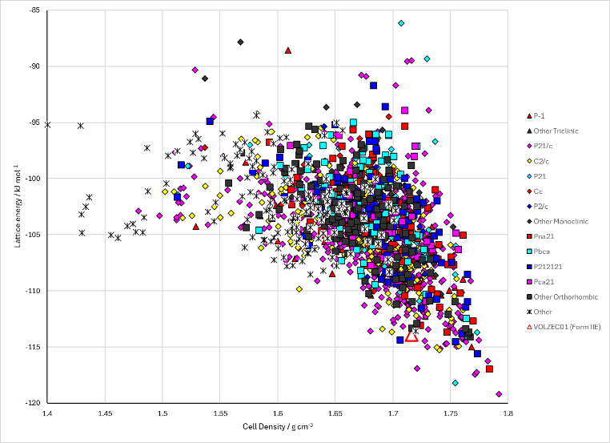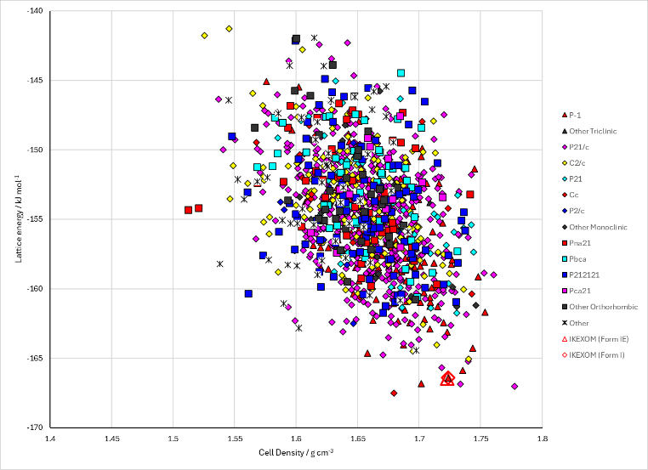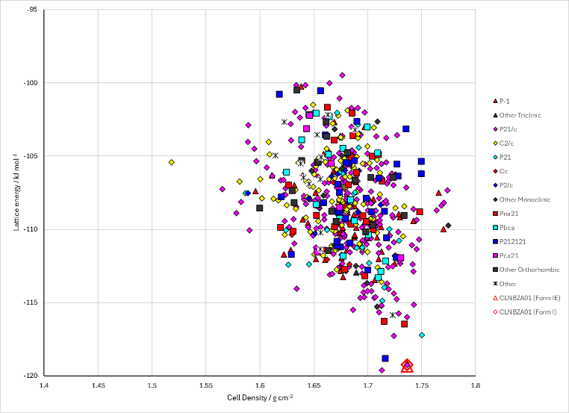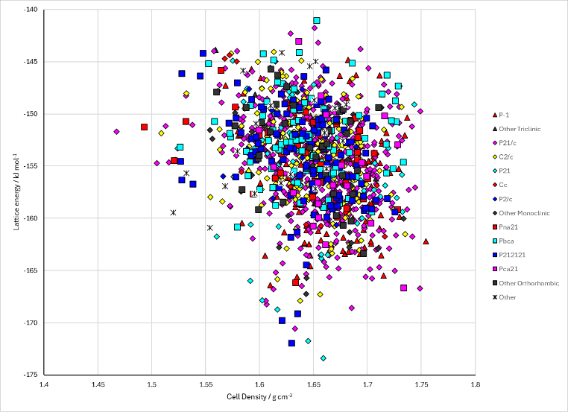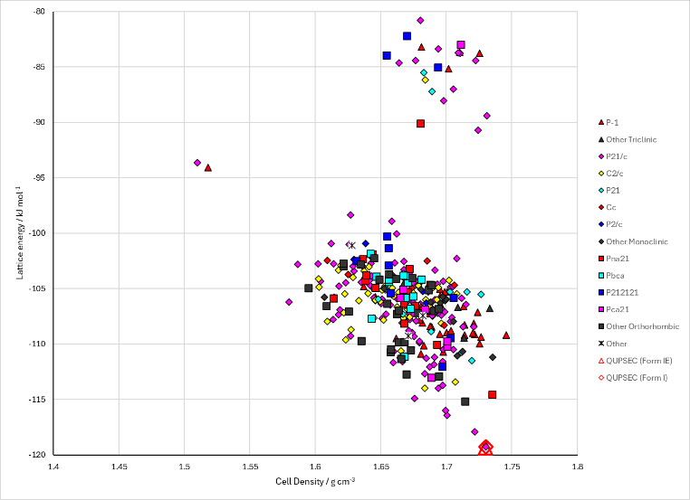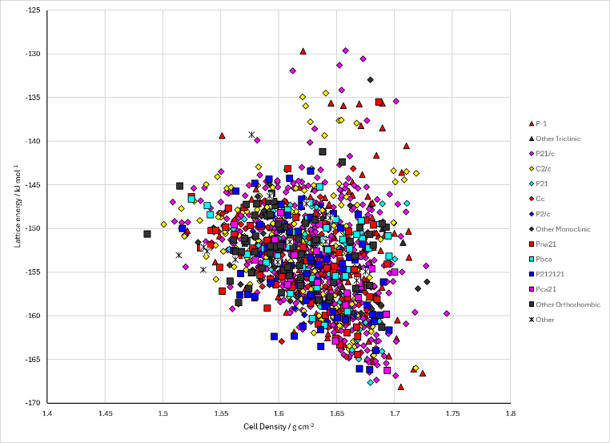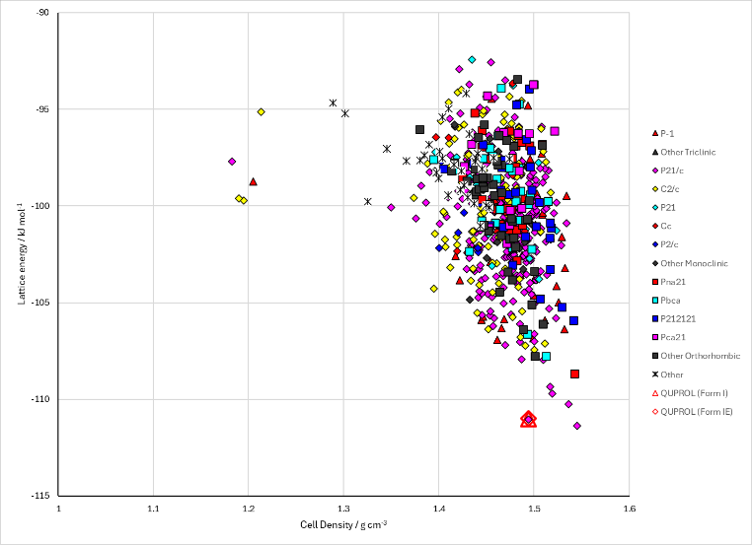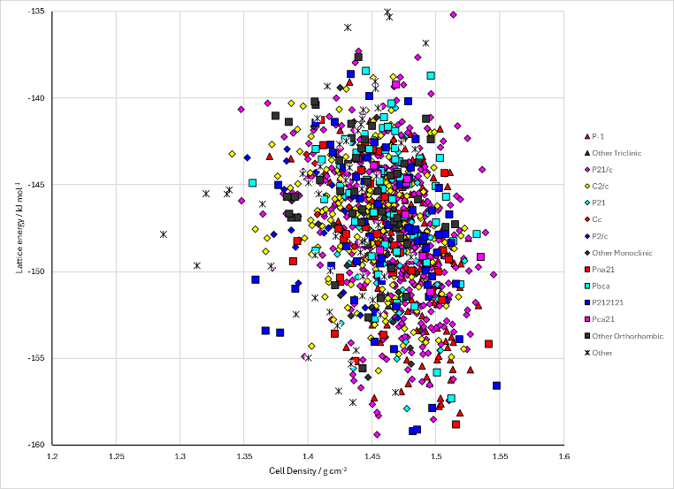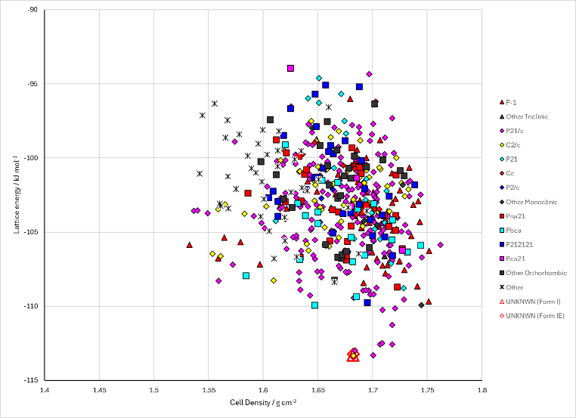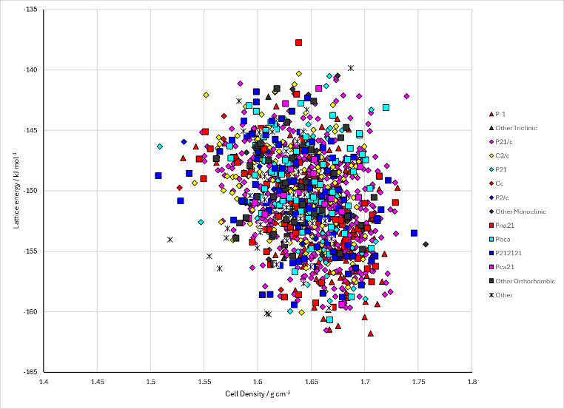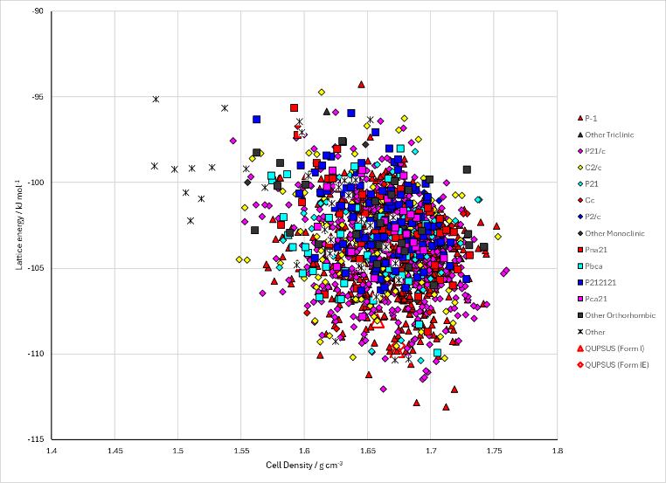
Figure 2. Crystal energy landscape of substituted nitro benzoic acids from previous work. Left: anhydrous systems. Right: monohydrates. From top to bottom, 2C4NBA, 2C5NBA, 2H4NBA, 2M4NBA, 4C2NBA, 5C2NBA.

CSD structures (CSD version 6.01)

Table 1. Crystallographic information for CSD entries for substituted nitro benzoic acids. Different polymorphs are coloured differently.
REFCODE | space group | Z’ | a / Å | b / Å | c / Å | α / ° | β / ° | γ / ° | density / g cm⁻³ | Form
IKEXOM | P-1 | 1.0 | 7.28710 | 7.93950 | 8.5516 | 117.58 | 95.8 | 93.48 | 1.6839 | None
VOLZEC | P21/c | 1.0 | 10.833 | 5.8573 | 13.497 | 90.0 | 105.734 | 90.0 | 1.6241 | Form I
VOLZEC01 | P21/c | 4.0 | 14.209 | 29.43 | 7.735 | 90.0 | 93.619 | 90.0 | 1.6589 | Form II
CLNBZA | P21/c | 1.0 | 5.86 | 5.13 | 26.6500 | 90.0 | 97.98 | 90.0 | 1.6874 | Form I
CLNBZA01 | P21/c | 1.0 | 5.8681 | 5.1261 | 26.8664 | 90.0 | 98.4857 | 90.0 | 1.6749 | Form I
QUPSEC | P21/c | 1.0 | 3.80150 | 11.6936 | 16.2761 | 90.0 | 94.506 | 90.0 | 1.6862 | Form I
QUPROL | P21/c | 1.0 | 4.9248 | 11.8428 | 13.6012 | 90.0 | 92.036 | 90.0 | 1.5177 | Form I
QUPROL01 | P-1 | 1.0 | 3.86630 | 8.41110 | 12.4646 | 95.797 | 90.296 | 94.661 | 1.4968 | Form II
QUPSUS | P-1 | 2.0 | 8.1232 | 9.43250 | 10.8858 | 97.051 | 97.933 | 90.026 | 1.6332 | Form I

Table 2. Experimental information for CSD entries for substituted nitro benzoic acids.
REFCODE | space group | R factor | T / K | Year | Comments
IKEXOM | P-1 | 2.87 | at 118 K | 2011 | 10.1039/c0ce00361a
VOLZEC | P21/c | 4.65 | at 297 K | 2008 | 10.1039/b812017j
VOLZEC01 | P21/c | 4.72 | at 298 K | 2008 | 10.1039/b812017j
CLNBZA | P21/c | 9.0 | None | 1962 | 10.1039/JR9620001767
CLNBZA01 | P21/c | 5.64 | 293 K | 2020 | 10.1021/acs.cgd.0c00331
QUPSEC | P21/c | 4.88 | 290 K | 2020 | 10.1021/acs.cgd.0c00331
QUPROL | P21/c | 3.61 | 293 K | 2020 | 10.1021/acs.cgd.0c00331
QUPROL01 | P-1 | 5.28 | 290 K | 2020 | 10.1021/acs.cgd.0c00331
QUPSUS | P-1 | 4.29 | 290 K | 2020 | 10.1021/acs.cgd.0c00331

Make this table include whether polymorphs are solution-grown, sublimation grown, templated or otherwise. Add references.

Other notes

