2-Bromobenzamide
(Last updated December 2025)
Figure 1. The molecular diagrams of 2-bromobenzamide.

CSP studies
REFCODE | BRBZAO
Formula | C7 H6 N1 O1 Br1
Common Name | o-bromobenzamide
IUPAC Systematic Name | 2-bromobenzamide
Other Names | 2-bromobenzamide
CSD Refcodes | BRBZAO01
Search Identifier | A
Scientist | Anastasia Ntantou
Date | pre-2010
Publication | Masters thesis
Energy model | 1
Study_ID | 0
Programs | MOLPAK, DMAREL (4.1.1)
Location on S Drive | \CHEMISTRY_CPOSS\0-EarlySearches\home\louise_price.eminerals\2-bromobenzamide
Potential Description | DMA + FIT + isotropic BR from blind test
Intramolecular Description | MP2/6-31G(d,p)

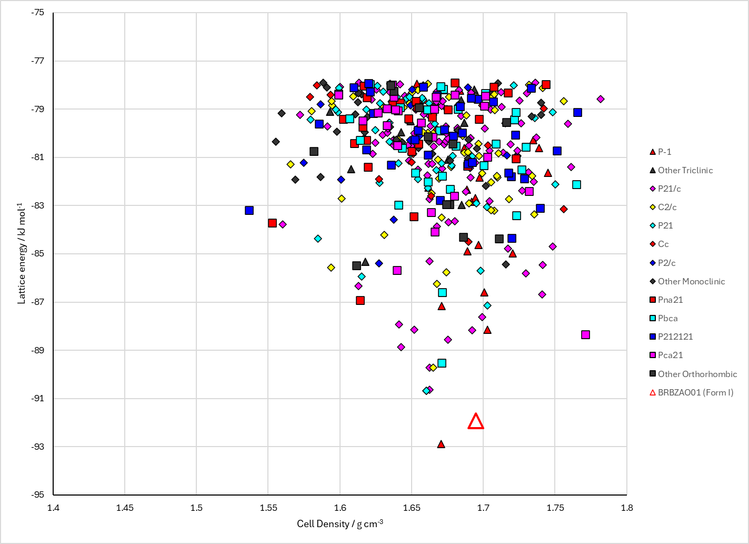
Figure 2. Crystal energy landscape of 2-bromobenzamide from previous work. Study_ID=0.

CSD structures (CSD version 6.01)
Table 1. Crystallographic information for CSD entries for 2-bromobenzamide. Different polymorphs are coloured differently.
REFCODE | space group | Z’ | a / Å | b / Å | c / Å | α / ° | β / ° | γ / ° | density / g cm⁻³ | Form
BRBZAO | P21/a | 1.0 | 13.92 | 11.43 | 5.02000 | 90.0 | 107.0 | 90.0 | 1.7394 | None
BRBZAO01 | P21/n | 1.0 | 5.0263 | 10.9683 | 13.3113 | 90.0 | 93.465 | 90.0 | 1.8138 | None
BRBZAO02 | P21/n | 1.o | 5.024(<1) | 11.402(1) | 13.313(1) | 90 | 93.76(<1) | 90 | 1.746 | None

Table 2. Experimental information for CSD entries for XXX.
REFCODE | space group | R factor | T / K | Year | Comments
BRBZAO | P21/a | 16.0 | None | 1972 | None
BRBZAO01 | P21/n | 1.97 | 100 K | 2015 | 10.1039/C5CY00627A
BRBZAO02 | p21/N | 2.69 | 296 k | 2021 | 10.1021/acs.cgd.0c01119

Make this table include whether polymorphs are solution-grown, sublimation grown, templated or otherwise. Add references.

Other notes

