2-Chlorobenzamide
(Last updated December 2025)
Figure 1. The molecular diagram of 2-chlorobenzamide.

CSP studies
REFCODE | CLBZAM
Formula | C7 H6 N1 O1 Cl1
Common Name | 2-Chlorobenzamide
IUPAC Systematic Name | 2-Chlorobenzamide
Other Names | 2-Chlorobenzamide
CSD Refcodes | CLBZAM12, CLBZAM11, CLBZAM13
Search Identifier | A
Scientist | Louise Price
Date | 2011
Publication | Cockcroft JK; Buanz ABM; Ntantou A; Price LS; Tocher DA; Vickers M; Lancaster RW, Crystal Growth & Design 2016, 16(11), 6144-6147
Energy model | 1
Study_ID | 10
Programs | Flexible CrystalPredictor (1.x), CrystalOptimizer (x), DMACRYS (2.0.4)
Location on S Drive | \CHEMISTRY_CPOSS\2-chlorobenzamide_CPCO
Potential Description | CrystalOptimizer, GDMA2.2 (MP2/6-31G(d,p)) multipoles, MP2/6-31G(d,p) intra, FIT
Intramolecular Description | MP2/6-31G(d,p)
Search Identifier | B
Scientist | Anastasia Ntantou
Date | pre-2010
Publication | Masters thesis only
Energy model | 1
Study_ID | 0
Programs | MOLPAK, DMAREL (4.1.1)
Location on S Drive | \CHEMISTRY_CPOSS\0-EarlySearches\home\louise_price.eminerals\2-chlorobenzamide
Potential Description | DMA + FIT + CL (DAY & PRICE 2003)
Intramolecular Description | MP2/6-31G(d,p)
Search Identifier | C
Scientist | Bob Lancaster
Date | pre-2010
Publication | No publication planned
Energy model | 1
Study_ID | 2
Programs | MOLPAK, DMACRYS (1.1.1)
Location on S Drive | \CHEMISTRY_CPOSS\0-EarlySearches\home\louise_price.eminerals\2-chlorobenzamide_BOB
Potential Description | DMA + FIT
Intramolecular Description | MP2/6-31G(d,p)

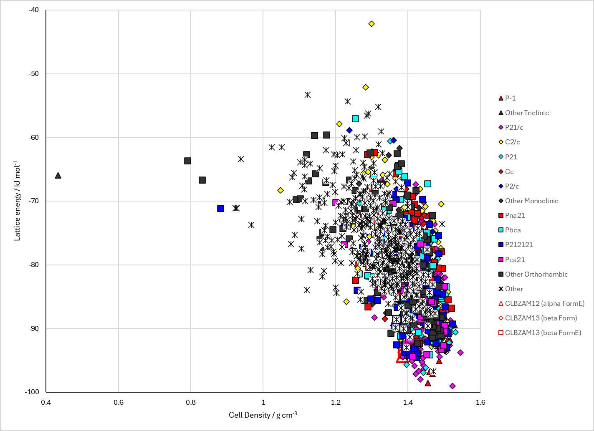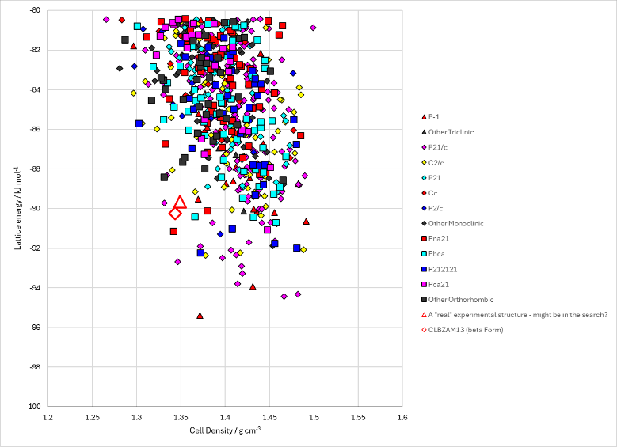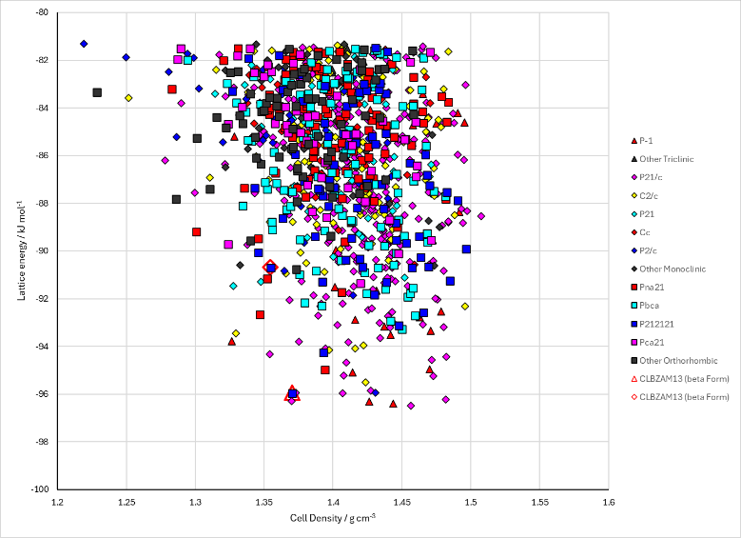
Figure 2. Crystal energy landscape of 2-chlorobenzamide from previous work. Top: from Study_ID=10. Bottom left: from Study_ID=0. Bottom right: from Study_ID=2.

CSD structures (CSD version 6.01)
Table 1. Crystallographic information for CSD entries for 2-chlorobenzamide. Different polymorphs are coloured differently.
REFCODE | space group | Z’ | a / Å | b / Å | c / Å | α / ° | β / ° | γ / ° | density / g cm⁻³ | Form
CLBZAM10 | P21/n | 1.0 | 14.127 | 10.683 | 5.051 | 90.0 | 90.2 | 90.0 | 1.3556 | alpha form
CLBZAM11 | P212121 | 1.0 | 14.0300 | 10.599 | 5.064 | 90.0 | 90.0 | 90.0 | 1.3723 | beta form
CLBZAM12 | P21/n | 1.0 | 5.05934 | 10.3235 | 14.2631 | 90.0 | 92.187 | 90.0 | 1.3881 | alpha form
CLBZAM13 | P212121 | 1.0 | 5.06073 | 10.3791 | 13.9351 | 90.0 | 90.0 | 90.0 | 1.4118 | beta form

CLBZAM11 and CLBZAM13 are notionally the same form. However Louise can’t overlay them in Mercury and they have different structure matches. The are possibly enantiomers (needs more investigation, which I don’t have time for!).
Two other polymorphs of 2-chlorobenzamide are reported, CLBZAM02 gamma and CLBZMA03 delta. Neither have space groups or full structures.
Table 2. Experimental information for CSD entries for XXX.
REFCODE | space group | R factor | T / K | Year | Comments
CLBZAM10 | P21/n | 9.700 | None | 1974 | 10.1107/S0567740874007801
CLBZAM11 | P212121 | 6.5 | None | 1974 | 10.1107/S0567740874007801
CLBZAM12 | P21/n | 3.0 | 150 K | 2016 | 10.1021/acs.cgd.6b00973
CLBZAM13 | P212121 | 2.2 | 150 K | 2016 | 10.1021/acs.cgd.6b00973

Make this table include whether polymorphs are solution-grown, sublimation grown, templated or otherwise. Add references.

Other notes
There was no .pot file for CLBZAM Study_ID = 10. The pote.dat files were compared for Bob’s search and Louise’s search, and differed only in the H_F2 ClF1 cross term.
Bob’s search
BUCK |  | H_F2 |  | H_F2 |  | 52.12899 |  | 0.214592 |  | 0.222819 |  | 0 |  | 70
BUCK |  | ClF1 |  | ClF1 |  | 9583.58 |  | 0.2849 |  | 80.22445 |  | 0 |  | 70
BUCK |  | ClF1 |  | H_F2 |  | 446.9519 |  | 0.214592 |  | 2.373693 |  | 0 |  | 70
Louise’s search
BUCK |  | H_F2 |  | H_F2 |  | 52.12899 |  | 0.214592 |  | 0.222819 |  | 0 |  | 70
BUCK |  | ClF1 |  | ClF1 |  | 9583.58 |  | 0.2849 |  | 80.22445 |  | 0 |  | 70
BUCK |  | ClF1 |  | H_F2 |  | 706.8114 |  | 0.244798 |  | 4.227947 |  | 0 |  | 70
Anastasia’s search
BUCK | HP |  | CODA |  | HP |  | CODA | 52.12899 | 0.214592 |  | 0.222819 |  | 0 |  | 70
BUCK | CL |  | CODA |  | CL |  | CODA | 5905.001 | 0.299159 |  | 86.7168 |  | 0 |  | 70
BUCK | CL |  | CODA |  | HP |  | CODA | 554.8123 | 0.256857 |  | 4.395825 |  | 0 |  | 70
Cross potential from crosspot
BUCK |  | H_F2 |  | ClF1 |  | 706.8114 |  | 0.244798 |  | 4.227947 |  | 0 |  | 70
Anastasia’s cross potential from crosspot
BUCK |  | H_F2 |  | ClF1 |  | 554.8168 |  | 0.249915 |  | 4.395697 |  | 0 |  | 70

The chlorine potential was different in the case of Anastasia’s search. The cross term was consistent (within rounding errors in Excel). The cross potential used by Bob’s search was wrong.

