2-Fluorobenzamide
(Last updated December 2025)
Figure 1. The molecular diagrams of the 2-fluorobenzamide.

CSP studies
REFCODE | BIGSUF
Formula | C7 H6 N1 O1 F1
Common Name | 2-Fluorobenzamide
IUPAC Systematic Name | 2-Fluorobenzamide
Other Names | 2-Fluorobenzamide
CSD Refcodes | BIGSUF01
Search Identifier | A
Scientist | Anastasia Ntantou
Date | pre-2010
Publication | Masters thesis
Energy model | 1
Study_ID | 0
Programs | MOLPAK, DMAREL (4.1.1)
Location on S Drive | CHEMISTRY_CPOSS\0-EarlySearches\home\louise_price.eminerals\2-fluorobenzamide\opt
Potential Description | DMA + FIT
Intramolecular Description | MP2/6-31G(d,p)
Search Identifier | B
Scientist | Anastasia Ntantou
Date | pre-2010
Publication | Masters thesis
Energy model | 1
Study_ID | 1
Programs | MOLPAK, DMAREL (4.1.1)
Location on S Drive | CHEMISTRY_CPOSS\0-EarlySearches\home\louise_price.eminerals\2-fluorobenzamide\con_opt
Potential Description | DMA + FIT
Intramolecular Description | MP2/6-31G(d,p)

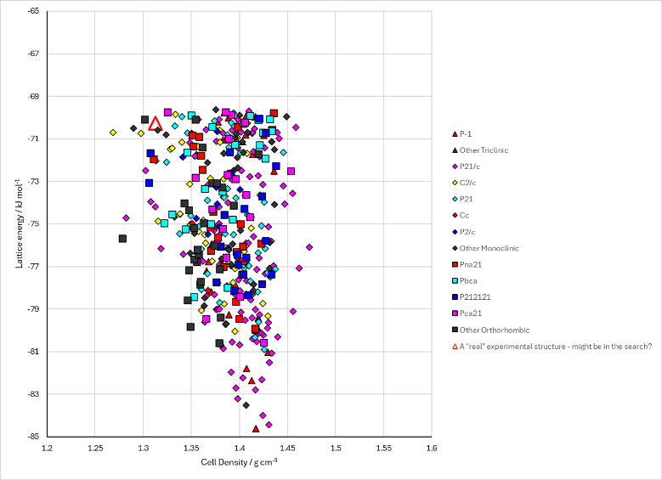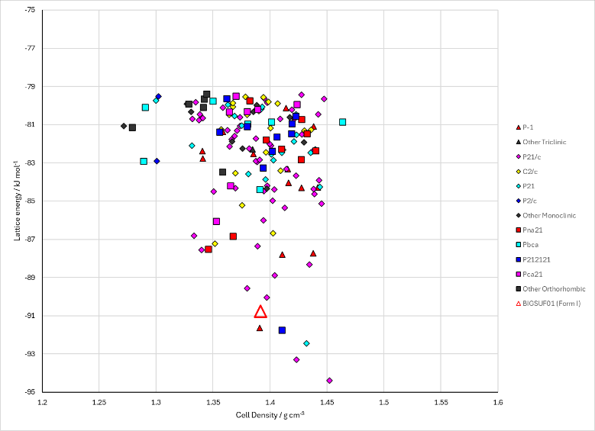
Figure 2. Crystal energy landscape of 2-fluorobenzamide from previous work. Left: from Study_ID=1. Right: from Study_ID=1.

CSD structures (CSD version 6.01)
Table 1. Crystallographic information for CSD entries for 2-fluorobenzamide. Different polymorphs are coloured differently.
REFCODE | space group | Z’ | a / Å | b / Å | c / Å | α / ° | β / ° | γ / ° | density / g cm⁻³ | Form
BIGSUF | P21/a | 2.0 | 12.695 | 20.534 | 5.133 | 90.0 | 97.8 | 90.0 | 1.3941 | None
BIGSUF01 | P21/c | 2 | 5.126(<1) | 20.368(1) | 12.322(1) | 90 | 96.69(<1) | 90 | 1.447 | None

Table 2. Experimental information for CSD entries for 2-fluorobenzamide.
REFCODE | space group | R factor | T / K | Year | Comments
BIGSUF | P21/a | 7.60 | None | 1982 | 10.1246/bcsj.55.1643
BIGSUF01 | P21/c | 4.39 | 100 | 2024 | 10.1021/acs.cgd.4c00517

Make this table include whether polymorphs are solution-grown, sublimation grown, templated or otherwise. Add references.

Other notes

