3-Aminobenzamide
(Last updated January 2026)
Figure 1. The molecular diagrams of 3-aminobenzamide.

CSP studies
REFCODE | UCLANA
Formula | C7 H8 N2 O1
Common Name | 3-aminobenzamide
IUPAC Systematic Name | 3-aminobenzamide
Other Names | 3-aminobenzamide
CSD Refcodes
Search Identifier | A
Scientist | Anastasia Ntantou
Date | pre-2010
Publication | Masters thesis
Energy model | 1
Study_ID | 0
Programs | MOLPAK, DMAREL (4.1.1)
Location on S Drive | \CHEMISTRY_CPOSS\0-EarlySearches\home\louise_price.eminerals\3-aminobenzamide
Potential Description | DMA + FIT
Intramolecular Description | MP2/6-31G(d,p)

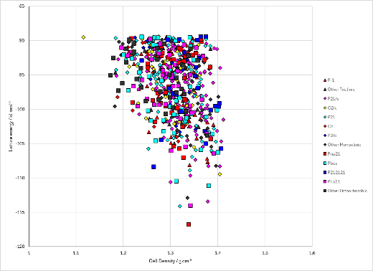
Figure 2. Crystal energy landscapes of 3-aminobenzamide from previous work.

CSD structures (CSD version 6.01)
Table 1. Crystallographic information for CSD entries for 3-aminobenzamide.
REFCODE | space group | Z’ | a / Å | b / Å | c / Å | α / ° | β / ° | γ / ° | density / g cm⁻³ | Form

Table 2. Experimental information for CSD entries for 3-aminobenzamide.
REFCODE | space group | R factor | T / K | Year | Comments

Other notes

