4-Aminobenzamide
(Last updated January 2026)
Figure 1. The molecular diagrams of 4-aminobenzamide.

CSP studies
REFCODE | AMBZAM
Formula | C7 H8 N2 O1
Common Name | 4-aminobenzamide
IUPAC Systematic Name | 4-aminobenzamide
Other Names | 4-aminobenzamide
CSD Refcodes | AMBZAM11
Search Identifier | A
Scientist | Anastasia Ntantou
Date | pre-2010
Publication | Masters thesis
Energy model | 1
Study_ID | 0
Programs | MOLPAK, DMAREL (4.1.1)
Location on S Drive | \CHEMISTRY_CPOSS\0-EarlySearches\home\louise_price.eminerals\4-aminobenzamide
Potential Description | DMA + FIT
Intramolecular Description | MP2/6-31G(d,p)

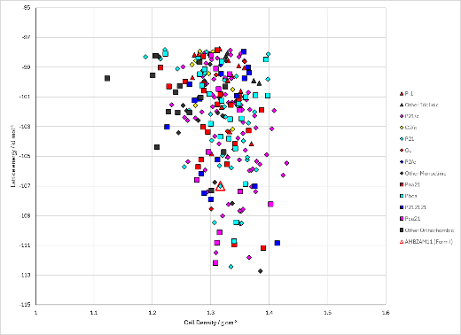
Figure 2. Crystal energy landscapes of 4-aminobenzamide from previous work.

CSD structures (CSD version 6.01)
Table 1. Crystallographic information for CSD entries for 4-aminobenzamide.
REFCODE | space group | Z’ | a / Å | b / Å | c / Å | α / ° | β / ° | γ / ° | density / g cm⁻³ | Form
AMBZAM10 | P21 | 1.0 | 8.42 | 5.29 | 7.91 | 90.0 | 108.0 | 90.0 | 1.3494 | None
AMBZAM11 | P21 | 1.0 | 7.81330 | 5.2554 | 8.4547 | 90.0 | 108.798 | 90.0 | 1.3758 | None
AMBZAM12 | P21 | 1.0 | 7.80110 | 5.2423 | 8.4445 | 90.0 | 108.784 | 90.0 | 1.3829 | None

Table 2. Experimental information for CSD entries for 4-aminobenzamide.
REFCODE | space group | R factor | T / K | Year | Comments
AMBZAM10 | P21 | 7.600 | None | 1967 | None
AMBZAM11 | P21 | 3.16 | 120 K | 2018 | 10.1021/acs.cgd.8b00711
AMBZAM12 | P21 | 6.0 | 100.0 K | 2018 | 10.1021/acs.cgd.8b01214

Other notes

