2-Bromo-5-AminoBenzoic Acid
(Last updated June 2026)
Figure 1. The molecular diagram of 2-Bromo-5-AminoBenzoic Acid.

CSP studies
REFCODE | TONIBR
Formula | C7 H6 N1 O2 Br1
Common Name | 2-Amino-5-bromo benzoic acid
IUPAC Systematic Name | 2-Amino-5-bromo benzoic acid
Other Names | 5-Bromoanthranilic acid
CSD Refcodes
Search Identifier | A
Scientist | Sally Price
Date | pre-2010
Publication | No publication planned.
Energy model | 1
Study_ID | 0
Programs | MOLPAK, DMAREL (4.1.1)
Location on S Drive | \CHEMISTRY_CPOSS\0-EarlySearches\home\louise_price.eminerals\2-amino-5-bromobenzoic_acid
Potential Description | DMA + FIT + isotropic BR from blind test
Intramolecular Description | MP2 6-31G(d,p)

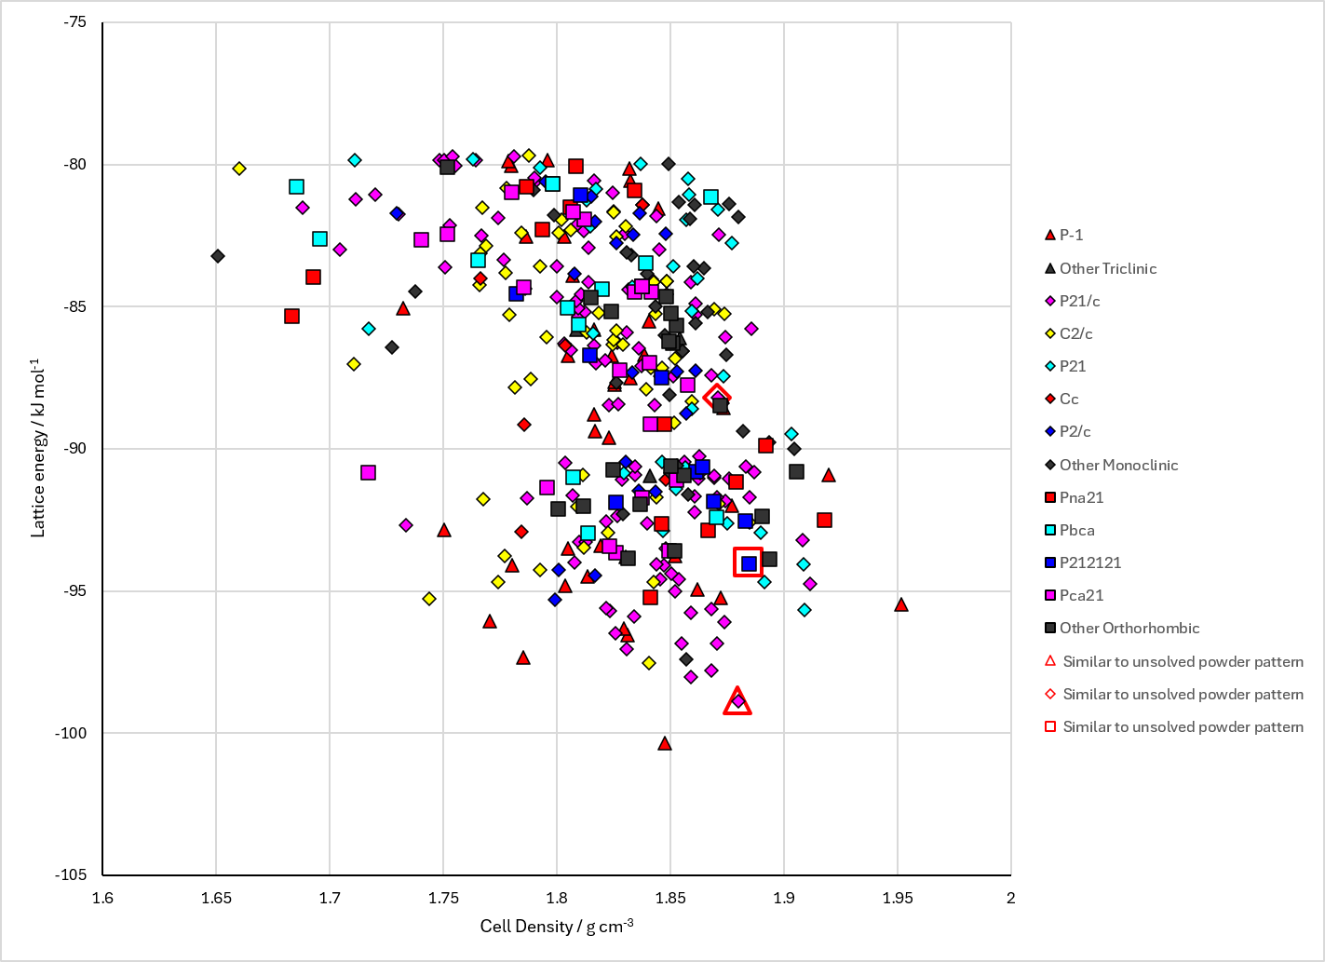
Figure 2. Crystal energy landscape of 2-Bromo-5-AminoBenzoic Acid from previous work.

CSD structures (CSD version 6.01 with Feb 2026 update)

Table 1. Crystallographic information for CSD entries for 2-Bromo-5-AminoBenzoic Acid. Different polymorphs are coloured differently.
REFCODE | space group | Z’ | a / Å | b / Å | c / Å | α / ° | β / ° | γ / ° | density / g cm⁻³ | Form

Table 2. Experimental information for CSD entries for 2-Bromo-5-AminoBenzoic Acid.
REFCODE | space group | R factor | T / K | Year | Comments

Make this table include whether polymorphs are solution-grown, sublimation grown, templated or otherwise. Add references.

Other notes

