Dihydro Dibenzo Cycloheptenyl Ethanone
(Last updated June 2026)
Figure 1. The molecular diagram of Dihydro Dibenzo Cycloheptenyl Ethanone.

CSP studies
REFCODE | UCLLPA
Formula | C17 H16 O1
Common Name | DihydroDibenzocycloheptenylethanone
IUPAC Systematic Name | 1-(10,11-Dihydro-5H-Dibenzo[a,d]cyclohepten-5-yl)-ethanone
Other Names
CSD Refcodes
Search Identifier | A
Scientist | Louise Price
Date | pre-2010
Publication | No publication planned.
Energy model | 1
Study_ID | 0
Programs | MOLPAK, DMAREL (4.1.1)
Location on S Drive | \CHEMISTRY_CPOSS\0-EarlySearches\home\louise_price.eminerals\Dihydrodibenzocycloheptenyl-ethanone
Potential Description | DMA + FIT
Intramolecular Description | MP2/6-31G(d,p)

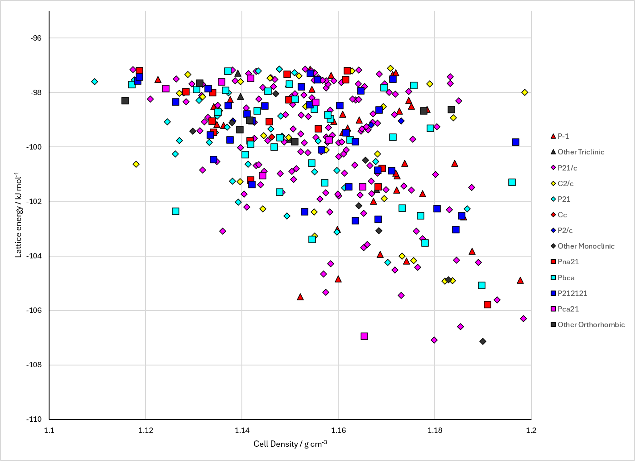
Figure 2. Crystal energy landscape of Dihydro Dibenzo Cycloheptenyl Ethanone from previous work.

CSD structures (CSD version 6.01 with Feb 2026 update)

Table 1. Crystallographic information for CSD entries for Dihydro Dibenzo Cycloheptenyl Ethanone. Different polymorphs are coloured differently.
REFCODE | space group | Z’ | a / Å | b / Å | c / Å | α / ° | β / ° | γ / ° | density / g cm⁻³ | Form

Table 2. Experimental information for CSD entries for Dihydro Dibenzo Cycloheptenyl Ethanone.
REFCODE | space group | R factor | T / K | Year | Comments

Make this table include whether polymorphs are solution-grown, sublimation grown, templated or otherwise. Add references.

Other notes

