Memantine Hydrochloride
(Last updated June 2026)

Figure 1. The molecular diagram of Memantine Hydrochloride.

CSP studies
REFCODE | UCLSMA
Formula | C12 H22 N1 Cl1
Common Name | Memantine hydrochloride
IUPAC Systematic Name | Memantine hydrochloride
Other Names
CSD Refcodes
Search Identifier | A
Scientist | Sharmarke Mohamed
Date | pre-2010
Publication | No publication planned.
Energy model | 1
Study_ID | 0
Programs | Rigid CrystalPredictor, DMACRYS (2.0.2)
Location on S Drive | \CHEMISTRY_CPOSS\0-EarlySearches\home\louise_price.eminerals\memantine_hydrochloride
Potential Description | DMA(MP2 6-31(d,p)) + WILL01 + Hejczyk chlorine parameters
Intramolecular Description | MP2/6-31G(d,p)

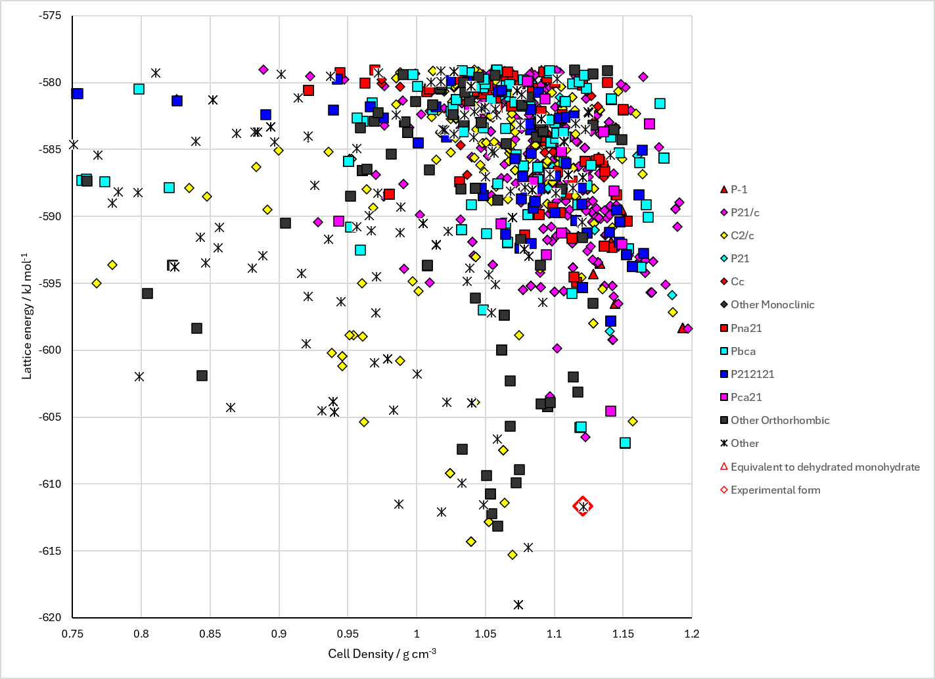
Figure 2. Crystal energy landscape of Memantine Hydrochloride from previous work.

CSD structures (CSD version 6.01 with Feb 2026 update)

Table 1. Crystallographic information for CSD entries for Memantine Hydrochloride. Different polymorphs are coloured differently.
REFCODE | space group | Z’ | a / Å | b / Å | c / Å | α / ° | β / ° | γ / ° | density / g cm⁻³ | Form

Table 2. Experimental information for CSD entries for Memantine Hydrochloride.
REFCODE | space group | R factor | T / K | Year | Comments

Make this table include whether polymorphs are solution-grown, sublimation grown, templated or otherwise. Add references.

Other notes
I have no idea what the “Experimental form” is.

