Pentachloronitrobenzene
(Last updated June 2026)
Figure 1. The molecular diagram of Pentachloronitrobenzene.

CSP studies
REFCODE | PCLNBZ
Formula | C6 N1 O2 Cl5
Common Name | Pentachloronitrobenzene
IUPAC Systematic Name | 1,2,3,4,5-pentachloro-6-nitrobenzene
Other Names
CSD Refcodes | PCLNBZ
Search Identifier | A
Scientist | Not sure
Date | pre-2010
Publication | No publication planned.
Energy model | 1
Study_ID | 0
Programs | MOLPAK, DMAREL (4.1.1)
Location on S Drive | \CHEMISTRY_CPOSS\0-EarlySearches\home\louise_price.eminerals\pentachloronitrobenzene
Potential Description | Isotropic RiceDay potential. All parameters taken from the Rice potential. Isotropic chlorine parameters from Day potential added.
Intramolecular Description | MP2/6-31G(d,p)

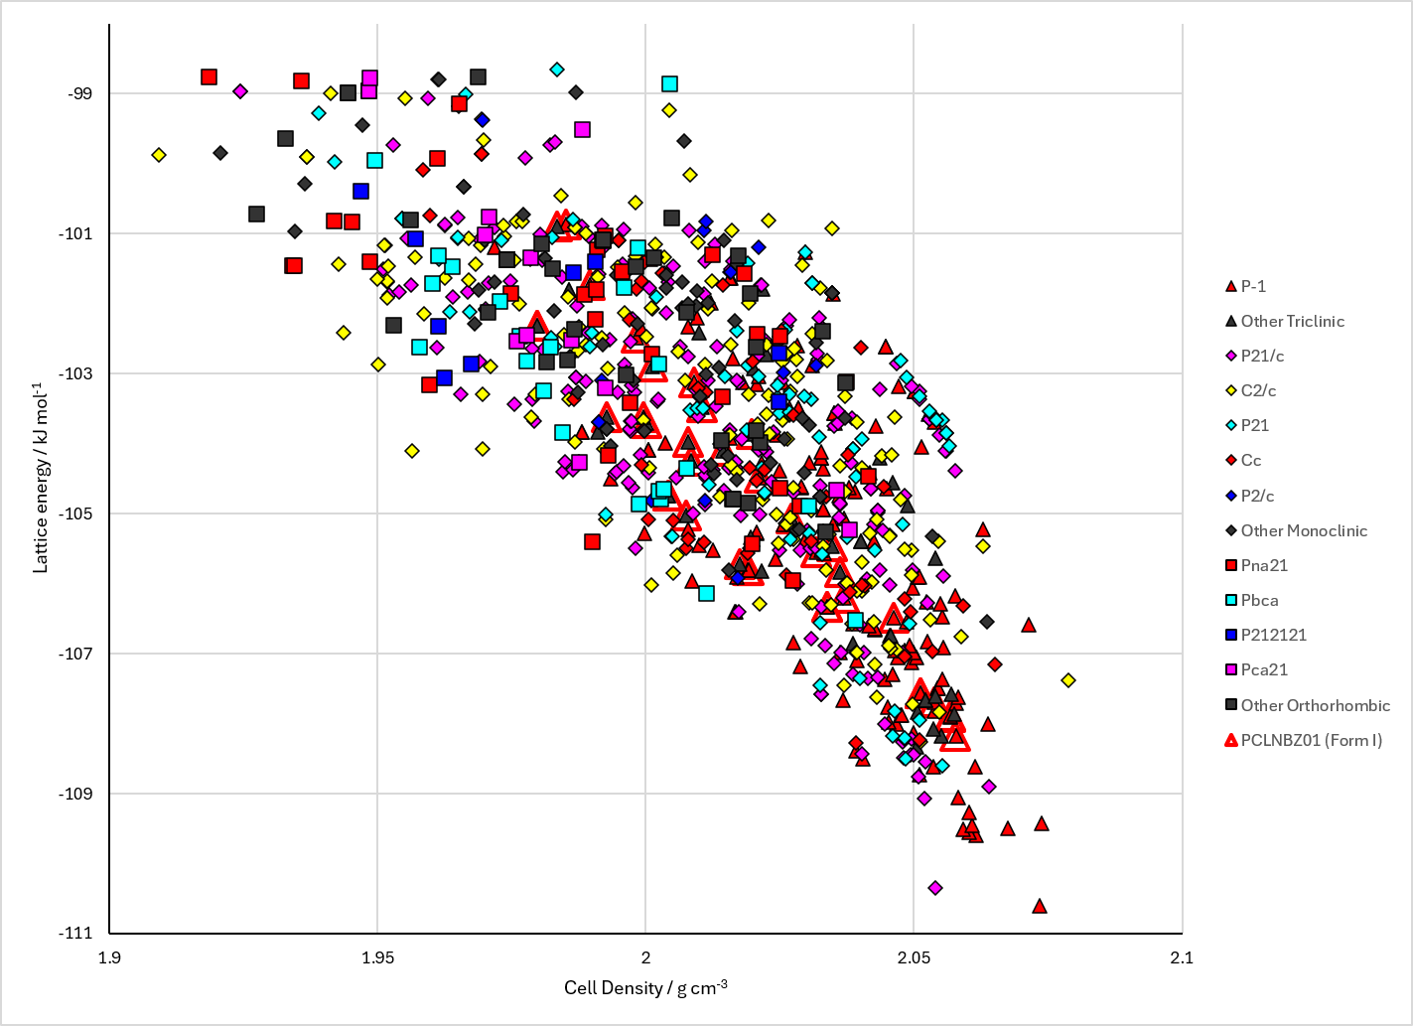
Figure 2. Crystal energy landscape of Pentachloronitrobenzene from previous work.

CSD structures (CSD version 6.01 with Feb and May 2026 updates)

Table 1. Crystallographic information for CSD entries for Pentachloronitrobenzene. Different polymorphs are coloured differently.
REFCODE | space group | Z’ | a / Å | b / Å | c / Å | α / ° | β / ° | γ / ° | density / g cm⁻³ | Form
PCLNBZ | R3 | 0.33 | 8.751 | 8.751 | 11.111 | 90.0 | 90.0 | 120.0 | 2.8582 | None
PCLNBZ01 | R-3 | 0.1667 | 8.71600 | 8.71600 | 10.946 | 90.0 | 90.0 | 120.0 | 1.7777 | None
PCLNBZ02 | R-3 | 0.1667 | 8.744 | 8.744 | 11.068 | 90.0 | 90.0 | 120.0 | 1.7469 | None

Table 2. Experimental information for CSD entries for Pentachloronitrobenzene.
REFCODE | space group | R factor | T / K | Year | Comments
PCLNBZ | R3 | 10.70 | None | 1974 | 10.1107/S0567740874005231
PCLNBZ01 | R-3 | 4.29 | 100.2 K | 2023 | 10.1039/D3CP02633G
PCLNBZ02 | R-3 | 5.43 | 200.2 K | 2023 | 10.1039/D3CP02633G

Make this table include whether polymorphs are solution-grown, sublimation grown, templated or otherwise. Add references.

Other notes

