(-)-(2S)-1,2,3,4-Tetrahydro-2,6-dimethylquinoline
(Last updated June 2026)
Figure 1. The molecular diagram of (-)-(2S)-1,2,3,4-Tetrahydro-2,6-dimethylquinoline.

CSP studies
REFCODE | UCLPKB
Formula | C11 H15 N1
Common Name | (-)-(2S)-1,2,3,4-Tetrahydro-2,6-dimethylquinoline
IUPAC Systematic Name | (-)-(2S)-1,2,3,4-Tetrahydro-2,6-dimethylquinoline
Other Names
CSD Refcodes
Search Identifier | A
Scientist | Panos Karamertzanis
Date | pre-2010
Publication | No publication planned.
Energy model | 1
Study_ID | 0
Programs | MOLPAK, DMAREL (4.1.1)
Location on S Drive | \CHEMISTRY_CPOSS\0-EarlySearches\home\louise_price.eminerals\tetrahydrodimethylquinoline
Potential Description | DMA + FIT
Intramolecular Description | MP2/6-31G(d,p)

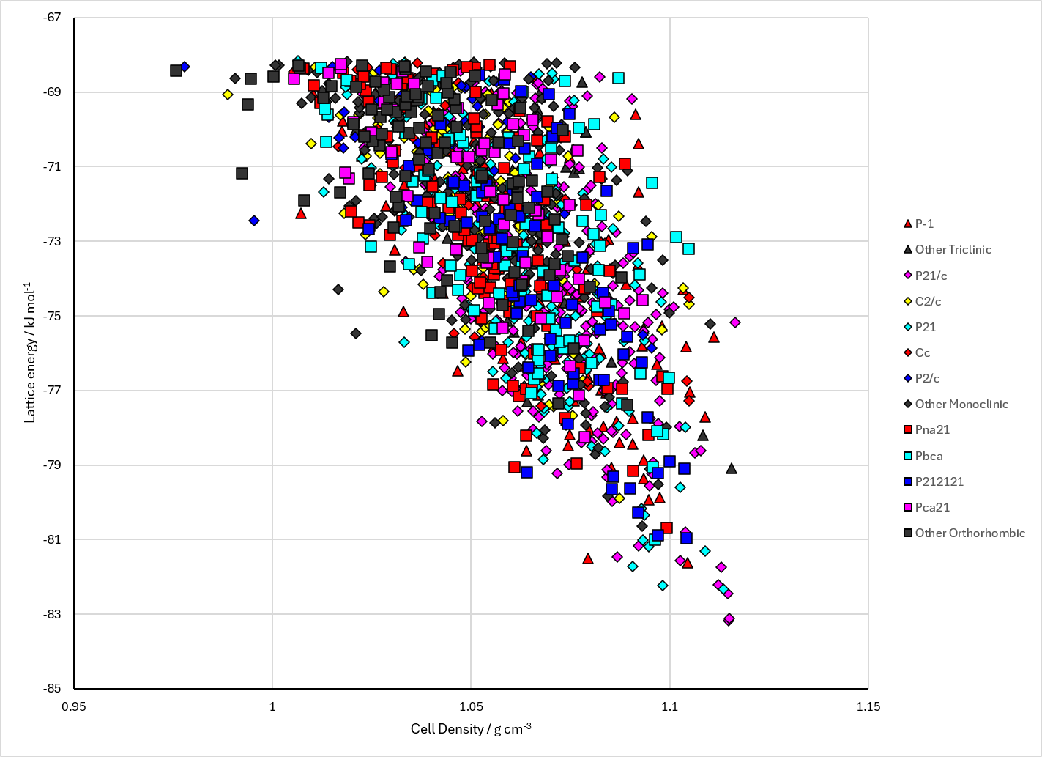
Figure 2. Crystal energy landscape of (-)-(2S)-1,2,3,4-Tetrahydro-2,6-dimethylquinoline from previous work.

CSD structures (CSD version 6.01 with Feb 2026 update)

Table 1. Crystallographic information for CSD entries for (-)-(2S)-1,2,3,4-Tetrahydro-2,6-dimethylquinoline. Different polymorphs are coloured differently.
REFCODE | space group | Z’ | a / Å | b / Å | c / Å | α / ° | β / ° | γ / ° | density / g cm⁻³ | Form

Table 2. Experimental information for CSD entries for (-)-(2S)-1,2,3,4-Tetrahydro-2,6-dimethylquinoline.
REFCODE | space group | R factor | T / K | Year | Comments

Make this table include whether polymorphs are solution-grown, sublimation grown, templated or otherwise. Add references.

Other notes

