Trifluoroethanol
(Last updated June 2026)
Figure 1. The molecular diagram of Trifluoroethanol.

CSP studies
REFCODE | KOHCUI
Formula | C2 H3 O1 F3
Common Name | Trifluoroethanol
IUPAC Systematic Name | 2,2,2-trifluoroethanol
Other Names
CSD Refcodes | KOHCUI, KOHCUI01, KOHCUI02, KOHCUI04
Search Identifier | B
Scientist | Louise Price
Date | 2019
Publication | No publication planned.
Energy model | 1
Study_ID | 11
Programs | CrystalPredictor, CrystalOptimizer, DMACRYS (2.0.3)
Location on S Drive | \CHEMISTRY_CPOSS\Trifluoroethanol\CrystOptZ2
Potential Description | CrystalOptimizer with GDMA2.2(PBE1PBE/aug-cc-pVDz) + FIT
Intramolecular Description | PBE0/aug-cc-pVDZ
Search Identifier | A
Scientist | Louise Price
Date | 2019
Publication | No publication planned.
Energy model | 1
Study_ID | 10
Programs | CrystalPredictor, CrystalOptimizer, DMACRYS (2.0.3)
Location on S Drive | \CHEMISTRY_CPOSS\Trifluoroethanol\CrystOpt
Potential Description | CrystalOptimizer with GDMA2.2(PBE1PBE/aug-cc-pVDz) + FIT
Intramolecular Description | PBE0/aug-cc-pVDZ

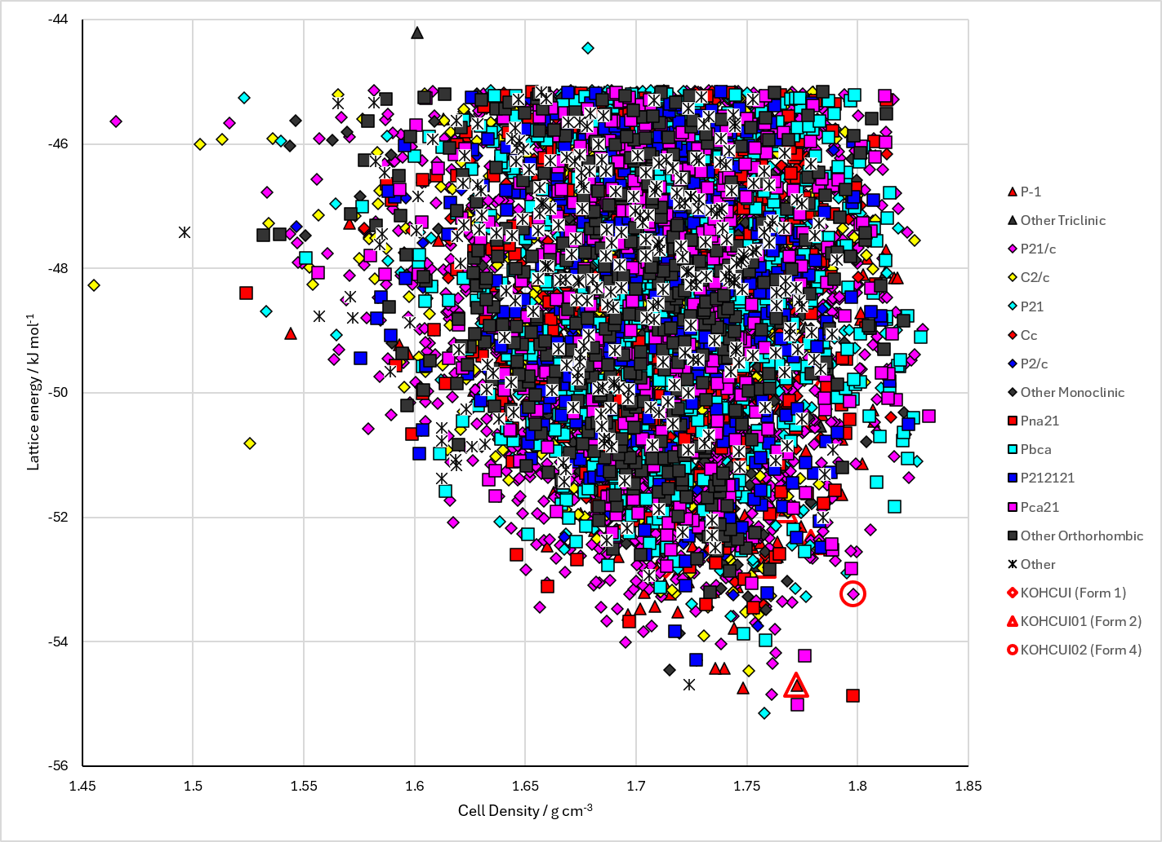
Figure 2. Crystal energy landscape of Trifluoroethanol from previous work. Energy model B1.

CSD structures (CSD version 6.01 with Feb and May 2026 updates)

Table 1. Crystallographic information for CSD entries for Trifluoroethanol. Different polymorphs are coloured differently.
REFCODE | space group | Z’ | a / Å | b / Å | c / Å | α / ° | β / ° | γ / ° | density / g cm⁻³ | Form
KOHCUI | Pca21 | 2.0 | 8.60400 | 10.0578 | 9.1461 | 90.0 | 90.0 | 90.0 | 1.6790 | Form 1
KOHCUI01 | P-1 | 2.0 | 4.91590 | 8.8894 | 9.226 | 111.71000 | 103.03 | 90.97 | 1.8321 | Form 2
KOHCUI02 | P21/c | 2.0 | 4.6413 | 16.1899 | 8.557 | 90.0 | 91.691 | 90.0 | 2.0677 | Form 4
KOHCUI03 | P21/c | 2.0 | 4.654 | 16.259 | 8.577 | 90.0 | 91.615 | 90.0 | 2.0484 | Form 4
KOHCUI04 | P21/c | 4.0 | 4.863 | 33.054 | 8.8694 | 90.0 | 91.519 | 90.0 | 1.8649 | Form 3

Table 2. Experimental information for CSD entries for Trifluoroethanol.
REFCODE | space group | R factor | T / K | Year | Comments
KOHCUI | Pca21 | 3.309 | 229 K | 2019 | 10.1039/C9CE00485H
KOHCUI01 | P-1 | 4.78 | 295 K | 2019 | 10.1039/C9CE00485H
KOHCUI02 | P21/c | 6.93 | 295 K | 2023 | 10.1039/D3CE00737E
KOHCUI03 | P21/c | 7.810 | 295 K | 2023 | 10.1039/D3CE00737E
KOHCUI04 | P21/c | 5.56 | 295 K | 2023 | 10.1039/D3CE00737E

Make this table include whether polymorphs are solution-grown, sublimation grown, templated or otherwise. Add references.

Other notes

