Benzyl-(4-(4-methyl-5-(p-tolylsulfonyl)-1,3-thiazol-2-yl)phenyl)carbamate (Blind Test XX)
(Last updated March 2026)
Figure 1. The molecular diagram of Benzyl-(4-(4-methyl-5-(p-tolylsulfonyl)-1,3-thiazol-2-yl)phenyl)carbamate.

CSP studies
REFCODE | OBEQIX
Formula | C25 H22 N2 O4 S2
Common Name | Blind Test 2010 XX
IUPAC Systematic Name | Benzyl-(4-(4-methyl-5-(p-tolylsulfonyl)-1,3-thiazol-2-yl)phenyl)carbamate
Other Names
CSD Refcodes | OBEQIX
Search Identifier | A
Scientist | Andrei Kazantsev
Date | 2010
Publication | Bardwell DA, et al. 2011. Acta Crystallogr , Sect B 67, 535-551.; Kazantsev AV, Karamertzanis PG, Adjiman CS, Pantelides CC, Price SL, Galek PTA, Day GM, Cruz-Cabeza AJ 2011. Int J Pharm 418, 168-178.
Energy model | 2
Study_ID | 11
Programs | Study_ID=10, CrystalOptimizer (full convergrence), DMACRYS (2.0.2)
Location on S Drive | \CHEMISTRY_CPOSS\BlindTest2010\OBEQIX\OBEQIX_2
Potential Description | DMA/PBE0 6-31G(d,p) + FIT, CryOpt(19)
Intramolecular Description | PBE1PBE 6-31G(d,p)
Energy model | 1
Study_ID | 10
Programs | CrystalPredictor, CrystalOptimizer (limited iterations), DMACRYS (2.0.2)
Location on S Drive | \CHEMISTRY_CPOSS\BlindTest2010\OBEQIX\OBEQIX
Potential Description | DMA + FIT
Intramolecular Description | PBE1PBE 6-31G(d,p)
Search Identifier | B
Scientist | Luca Iuzzolino
Date | 2018
Publication | Iuzzolino, L.; McCabe, P.; Price, S. L.; Brandenburg, J. G., Faraday Discussions 2018, 211, 275-296.
Energy model | 1
Study_ID | 60
Programs | Rigid CrystalPredictor, DFTB3-D3, DMACRYS (2.2.0.1)
Location on S Drive | \CHEMISTRY_CPOSS\LucasSearches\BlindTest_XX
Potential Description | CrystalPredictor, followed by DFTB3-D3 refinement, followed by DMACRYS with GDMA2.2(PBE0/6-31G(d,p)) + FIT
Intramolecular Description | PBE1/6-31G(d,p)

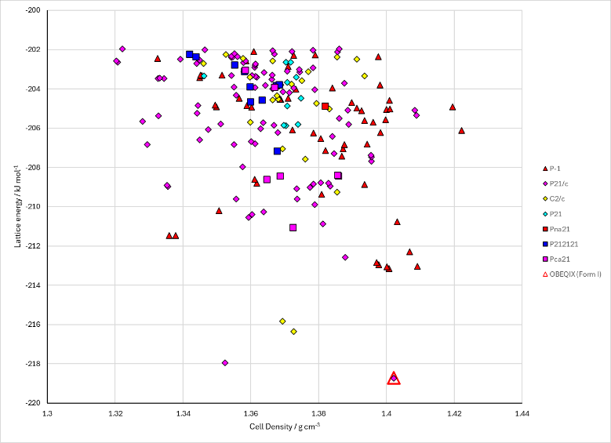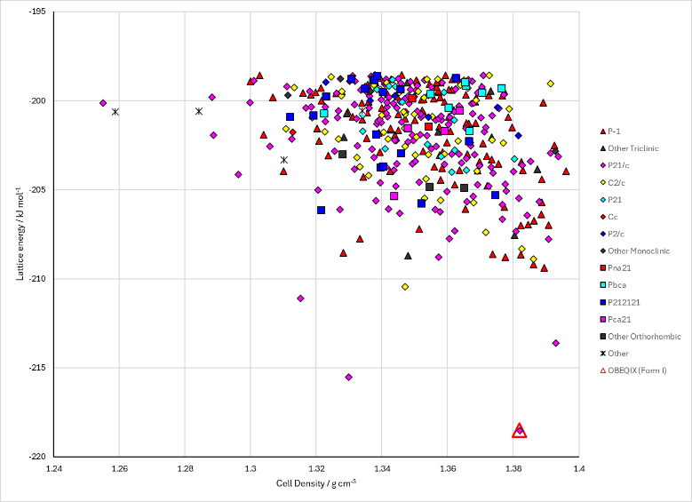
Figure 2. Crystal energy landscape of Benzyl-(4-(4-methyl-5-(p-tolylsulfonyl)-1,3-thiazol-2-yl)phenyl)carbamate from previous work. Left: Study_ID=11, Energy Model A2. Right: Study_ID=60, Energy Model B1.

CSD structures (CSD version 6.01)

Table 1. Crystallographic information for CSD entries for Benzyl-(4-(4-methyl-5-(p-tolylsulfonyl)-1,3-thiazol-2-yl)phenyl)carbamate. Different polymorphs are coloured differently.
REFCODE | space group | Z’ | a / Å | b / Å | c / Å | α / ° | β / ° | γ / ° | density / g cm⁻³ | Form
OBEQIX | P21/n | 1.0 | 14.0779 | 6.3559 | 25.3100 | 90.0 | 96.063 | 90.0 | 1.4115 | None

Table 2. Experimental information for CSD entries for Benzyl-(4-(4-methyl-5-(p-tolylsulfonyl)-1,3-thiazol-2-yl)phenyl)carbamate.
REFCODE | space group | R factor | T / K | Year | Comments
OBEQIX | P21/n | 3.9 | at 150 K | 2011 | None

Make this table include whether polymorphs are solution-grown, sublimation grown, templated or otherwise. Add references.

Other notes
I think Study_ID=11 is more iterations of CrystalOptimizer, properly clustered, and cutoff at 200 structures. It’s hard to tell though. It is definitely the submitted structures.

