Methyl anthranilate
(Last updated January 2026)
Figure 1. The molecular diagram of Methyl anthranilate.

CSP studies
REFCODE | FASMEV
Formula | C8 O2 N1 H9
Common Name | Methyl anthranilate
IUPAC Systematic Name | Methyl 2-aminobenzoate
Other Names
CSD Refcodes | FASMEV
Search Identifier | A
Scientist | Sally Price
Date | January 2021
Publication | Hunnisett LM, et al, Acta Cryst B, 2024, 80(6), 517-547
Energy model | 1
Study_ID | 10
Programs | CrystalPredictor (2.4.3), CrystalOptimizer (2.4.7.1), DMACRYS (2.3.1.1)
Location on S Drive | CHEMISTRY_CPOSS\BlindTest2020-2022\XXIX\Z1
Potential Description | CrystalOptimizer with GDMA2.2(PBE0/6-31G(d,p)) + FIT
Intramolecular Description | PBE0/6-31G(d,p)

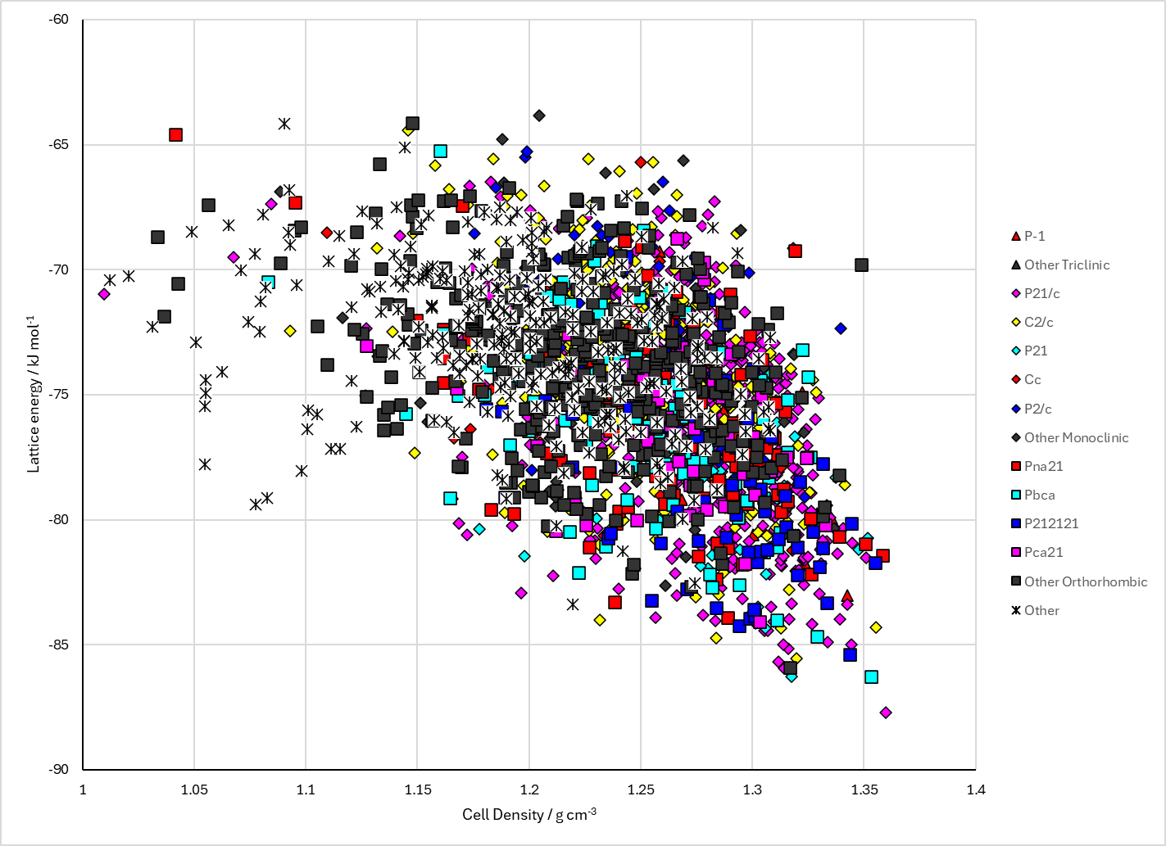
Figure 2. Crystal energy landscape of Methyl anthranilate from previous work.

CSD structures (CSD version 6.01)

Table 1. Crystallographic information for CSD entries for Methyl anthranilate. Different polymorphs are coloured differently.
REFCODE | space group | Z’ | a / Å | b / Å | c / Å | α / ° | β / ° | γ / ° | density / g cm⁻³ | Form
FASMEV | P21/c | 3.0 | 25.1585 | 9.983 | 9.3583 | 90.0 | 93.258 | 90.0 | 1.2836 | None

Table 2. Experimental information for CSD entries for Methyl anthranilate.
REFCODE | space group | R factor | T / K | Year | Comments
FASMEV | P21/c | 4.82 | 273.9 K | 2022 | None

Make this table include whether polymorphs are solution-grown, sublimation grown, templated or otherwise. Add references.

Other notes

