Cannabinol tetramethylpyrazine cocrystal (Blind Test XXX)
(Last updated February 2026)
Figure 1. The molecular diagrams of cannabinol and tetramethylpyrazine.
This was a stoichiometry study in the Blind Test. Two stoichiometries exist, with fewer than four molecules in the asymmetric unit.

CSP studies
REFCODE | CANNOL
Formula | C21 O2 H26
Common Name | Cannabinol
IUPAC Systematic Name | 6,6,9-trimethyl-3-pentyl-6H-dibenzo[b,d]pyran-1-ol
Other Names
CSD Refcodes | CANNOL01
Search Identifier | A
Scientist | Yiming Ding
Date | January 2021
Publication | Blind Test 7 (one component of XXX cocrystals)
Energy model | 1
Study_ID | 10
Programs | CrystalPredictor (2.4.3.2), CrystalOptimizer (2.4.7.1), DMACRYS (2.3.1.1)
Location on S Drive | CHEMISTRY_CPOSS\BlindTest2020-2022\XXX\CANNOL
Potential Description | CrystalPredictor2.4.3.2(torsion groups) + CrystalOptimizer with GDMA2.2(PBE1PBE/6-31G(d,p)) + FIT
Intramolecular Description | PBE0/6-31G(d,p)
REFCODE | MPYRAZ
Formula | C8 N2 H12
Common Name | Tetramethylpyrazine
IUPAC Systematic Name | Tetramethylpyrazine
Other Names
CSD Refcodes | MPYRAZ02
Search Identifier | A
Scientist | Yiming Ding
Date | January 2021
Publication | Blind Test 7 (one component of XXX cocrystals)
Energy model | 1
Study_ID | 20
Programs | CrystalPredictor (2.4.3), CrystalOptimizer (2.4.7.1), DMACRYS (2.3.1.1)
Location on S Drive | CHEMISTRY_CPOSS\BlindTest2020-2022\XXX\MPYRAZ\
Potential Description | Rigid CrystalPredictor + DMACRYS with GDMA2.2(PBE1PBE/6-31G(d,p)) + FIT
Intramolecular Description | PBE1PBE/6-31G(d,p)
Energy model | 2
Study_ID | 10
Programs | CrystalPredictor (2.4.3), CrystalOptimizer (2.4.7.1), DMACRYS (2.3.1.1)
Location on S Drive | CHEMISTRY_CPOSS\BlindTest2020-2022\XXX\MPYRAZ\
Potential Description | CrystalOptimizer with GDMA2.2(PBE0/6-31G(d,p)) + FIT
Intramolecular Description | PBE1PBE/6-31G(d,p)
REFCODE | MIVZIE
Formula | C21 O2 H26 - C8 N2 H12
Common Name | Blind Test XXX, stoichiometry test; Cannabinol Tetramethylpyrazine 1-1 cocrystal
IUPAC Systematic Name | 6,6,9-trimethyl-3-pentyl-6H-dibenzo[b,d]pyran-1-ol - Tetramethylpyrazine cocrystal
Other Names
CSD Refcodes | MIVZIE
Search Identifier | A
Scientist | Yiming Ding
Date | June 2021
Publication | Hunnisett LM, et al, Acta Cryst B, 2024, 80(6), 517-547
Energy model | 1
Study_ID | 10
Programs | CrystalPredictor (2.4.3.2) CrystalOptimize (2.4.7.1)
Location on S Drive | \CHEMISTRY_CPOSS\BlindTest2020-2022\BXXXCT
Potential Description | CrystalPredictor2.4.3.2(torsion groups) + CrystalOptimizer with GDMA2.2(PBE0/6-31G(d,p)) + FIT
Intramolecular Description | PBE0/6-31G(d,p)
REFCODE | MIVZEA
Formula | 2 [ C21 O2 H26 ] - C8 N2 H12
Common Name | Blind Test XXX, stoichiometry test; Cannabinol Tetramethylpyrazine 2-1 cocrystal
IUPAC Systematic Name | 6,6,9-trimethyl-3-pentyl-6H-dibenzo[b,d]pyran-1-ol - Tetramethylpyrazine 2-1 cocrystal
Other Names
CSD Refcodes | MIVZEA
Search Identifier | A
Scientist | Yiming Ding
Date | June 2021
Publication | Hunnisett LM, et al, Acta Cryst B, 2024, 80(6), 517-547
Energy model | 1
Study_ID | 10
Programs | CrystalPredictor (2.4.3.2) CrystalOptimize (2.4.7.1)
Location on S Drive | \CHEMISTRY_CPOSS\BlindTest2020-2022\XXXCCT
Potential Description | CrystalPredictor2.4.3.2(torsion groups) + CrystalOptimizer with GDMA2.2(PBE0/6-31G(d,p)) + FIT
Intramolecular Description | PBE0/6-31G(d,p)
REFCODE | XXXCTT
Formula | C21 O2 H26 - 2 [ C8 N2 H12 ]
Common Name | Blind Test XXX, stoichiometry test; Cannabinol Tetramethylpyrazine 1-2 cocrystal
IUPAC Systematic Name | 6,6,9-trimethyl-3-pentyl-6H-dibenzo[b,d]pyran-1-ol - Tetramethylpyrazine 1-2 cocrystal
Other Names
CSD Refcodes
Search Identifier | A
Scientist | Yiming Ding
Date | June 2021
Publication | Hunnisett LM, et al, Acta Cryst B, 2024, 80(6), 517-547
Energy model | 1
Study_ID | 10
Programs | CrystalPredictor (2.4.3.2) CrystalOptimizer (2.4.7.1)
Location on S Drive | \CHEMISTRY_CPOSS\BlindTest2020-2022\XXXCTT
Potential Description | CrystalPredictor2.4.3.2(torsion groups) + CrystalOptimizer with GDMA2.2(PBE0/6-31G(d,p)) + FIT
Intramolecular Description | PBE0/6-31G(d,p)

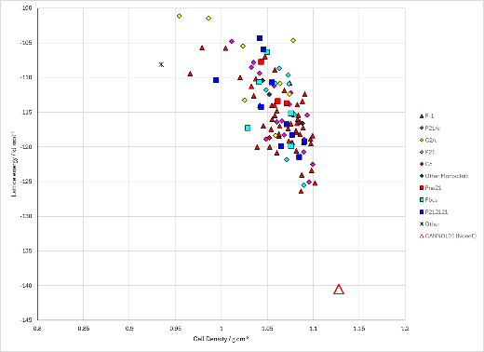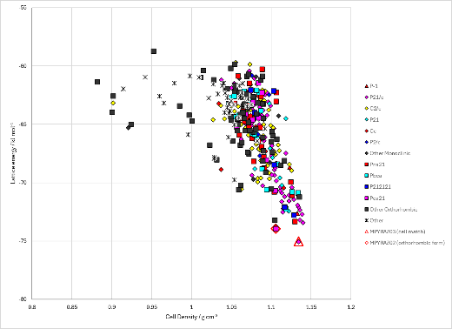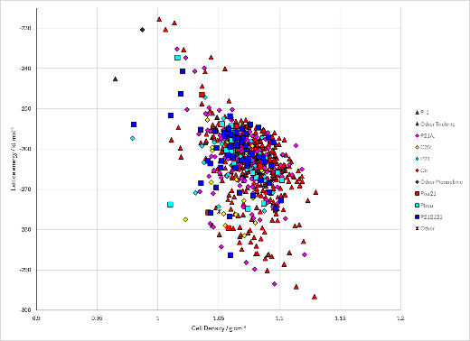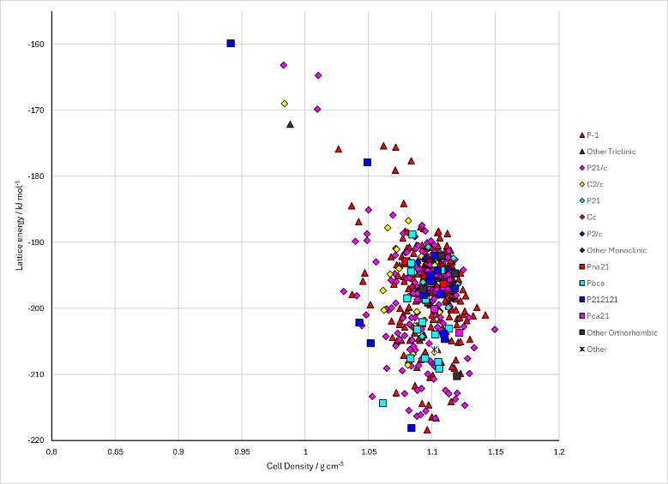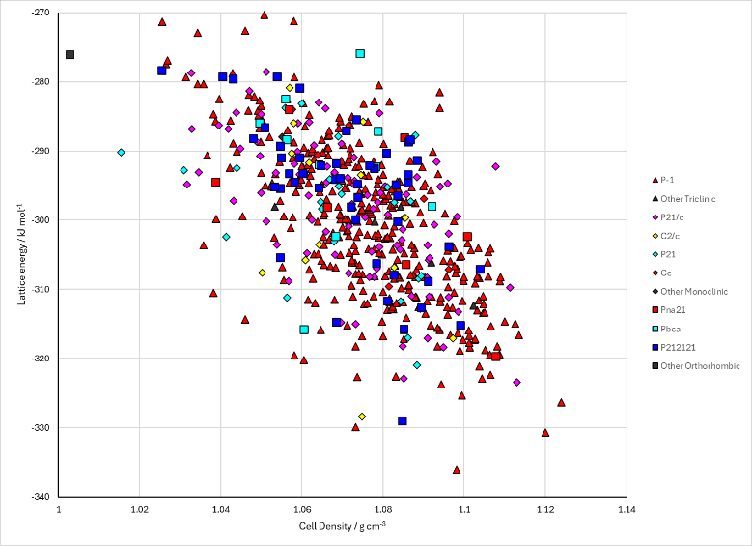
Figure 2. Crystal energy landscape of cannabinol tetramethylpyrazine cocrystal from previous work. Top row: Cannabinol_A1, Tetramethylpyrazine_A1, . Bottom row: CannabinolTetramethylpyrazine_A1, 2CannabinolTetramethylpyrazine_A1.

CSD structures (CSD version 6.01)

Table 1. Crystallographic information for CSD entries for cannabinol tetramethylpyrazine cocrystal. Different polymorphs are coloured differently.
REFCODE | space group | Z’ | a / Å | b / Å | c / Å | α / ° | β / ° | γ / ° | density / g cm⁻³ | Form
CANNOL | P21/c | 2.0 | 20.658 | 18.166 | 13.517 | 90.0 | 133.56 | 90.0 | 1.1218 | None
CANNOL01 | P21/c | 2.0 | 14.7920 | 17.8307 | 13.4231 | 90.0 | 91.849 | 90.0 | 1.1654 | None
MPYRAZ | Pbca | 0.5 | 8.35 | 9.27 | 10.6200 | 90.0 | 90.0 | 90.0 | 1.1004 | orthorhombic polymorph
MPYRAZ01 | Pbca | 0.5 | 8.328 | 9.27 | 10.2000 | 90.0 | 90.0 | 90.0 | 1.1488 | orthorhombic polymorph
MPYRAZ02 | Pbca | 0.5 | 8.331 | 9.225 | 10.148 | 90.0 | 90.0 | 90.0 | 1.1599 | orthorhombic polymorph
MIVZIE | P21/n | 1.0 | 14.8774 | 10.119 | 17.5619 | 90.0 | 104.42800 | 90.0 | 1.1585 | None
MIVZIE01 | P21/n | 1.0 | 14.8774 | 10.119 | 17.5619 | 90.0 | 104.42800 | 90.0 | 0.0 | None
MIVZEA | P21/c | 1.0 | 24.3576 | 8.7626 | 22.1068 | 90.0 | 114.51870 | 90.0 | 1.1713 | None
MIVZEA01 | P21/c | 1.0 | 24.3576 | 8.7626 | 22.1068 | 90.0 | 114.51870 | 90.0 | 0.0 | None

Table 2. Experimental information for CSD entries for cannabinol tetramethylpyrazine cocrystal.
REFCODE | space group | R factor | T / K | Year | Comments
CANNOL | P21/c | 9.1 | None | 1977 | 10.3891/acta.chem.scand.31b-0781
CANNOL01 | P21/c | 5.64 | 173 K | 2022 | Private communication
MPYRAZ | Pbca | 23.0 | None | 1951 | 10.1021/ja01156a025
MPYRAZ01 | Pbca | 8.4 | None | 1981 | 10.1107/S056774088100410X
MPYRAZ02 | Pbca | 4.5 | at 100 K | 1981 | 10.1107/S056774088100410X
MIVZIE | P21/n | 4.100 | 100 K | 2023 | Private communication
MIVZIE01 | P21/n | 4.100 | 100 K | 2024 | 10.1107/S2052520624007492
MIVZEA | P21/c | 3.719 | 100 K | 2023 | Private communication
MIVZEA01 | P21/c | 3.719 | 100 K | 2024 | 10.1107/S2052520624007492

Make this table include whether polymorphs are solution-grown, sublimation grown, templated or otherwise. Add references.

Other notes

