3-[difluoro(2-fluorophenyl)methanesulfonyl]-5,5-dimethyl-4,5-dihydro-1,2-oxazole (Blind Test XXXI)
(Last updated January 2026)
Figure 1. The molecular diagram of Blind Test XXXI.

CSP studies
REFCODE | ZEHFUR
Formula | C12 H12 N1 O3 F3 S1
Common Name | Blind Test XXXI
IUPAC Systematic Name | 3-[difluoro(2-fluorophenyl)methanesulfonyl]-5,5-dimethyl-4,5-dihydro-1,2-oxazole
Other Names
CSD Refcodes | ZEHFUR02, ZEHFUR, ZEHFUR01
Search Identifier | A
Scientist | Sally Price
Date | September 2021
Publication | Hunnisett LM, et al, Acta Cryst B, 2024, 80(6), 517-547
Energy model | 1
Study_ID | 10
Programs | CrystalPredictor (2.4.3), CrystalOptimizer (2.4.7), DMACRYS (2.3.1.1)
Location on S Drive | CHEMISTRY_CPOSS\BlindTest2020-2022\XXXI\CrystOpt1\
Potential Description | CrystalOptimizer PBE1PBE/6-31G(d,p) intramolecular + GDMA2.2(PBE1PBE/6-31G(d,p)) DMA + FIT + Scheraga SO2 parameters
Intramolecular Description | PBE0/6-31G(d,p)
Search Identifier | B
Scientist | Sally Price
Date | January 2022
Publication | Hunnisett LM, et al, Acta Cryst B, 2024, 80(6), 548-574
Energy model | 1
Study_ID | 11
Programs | CCDC supplied crystal structures, CrystalOptimizer (2.4.7), DMACRYS (2.3.1.1)
Location on S Drive | CHEMISTRY_CPOSS\BlindTest2020-2022\XXXI\CrystOpt2\
Potential Description | CrystalOptimizer PBE1PBE/6-31G(d,p) intramolecular + GDMA2.2(PBE1PBE/6-31G(d,p)) DMA + FIT + Scheraga SO2 parameters
Intramolecular Description | PBE0/6-31G(d,p)
Energy model | 2
Study_ID | 12
Programs | CCDC supplied crystal structures, CrystalOptimizer (2.4.7), DMACRYS (2.3.1.1), single point DMACRYS
Location on S Drive | CHEMISTRY_CPOSS\BlindTest2020-2022\XXXI\CrystOpt_fit\
Potential Description | Single point DMACRYS optimization on Study_id=11 structures with GDMA2.2(PBE1PBE/6-31G(d,p)) DMA + FIT + Halgren S parameters
Intramolecular Description | PBE0/6-31G(d,p)
Energy model | 3
Study_ID | 13
Programs | CCDC supplied crystal structures, CrystalOptimizer (2.4.7), DMACRYS (2.3.1.1), single point DMACRYS
Location on S Drive | CHEMISTRY_CPOSS\BlindTest2020-2022\XXXI\CrystOpt_BowFpot\
Potential Description | Single point DMACRYS optimization on Study_id=11 structures with GDMA2.2(PBE1PBE/6-31G(d,p)) DMA + FIT with Bowskill f15x alternative F parameters
Intramolecular Description | PBE0/6-31G(d,p)

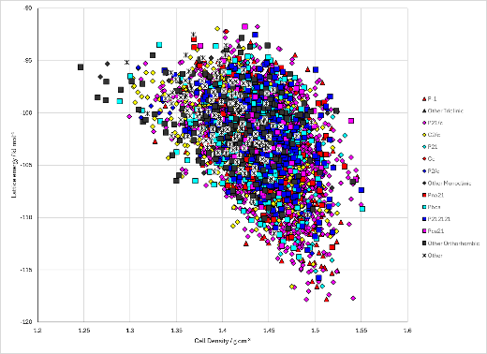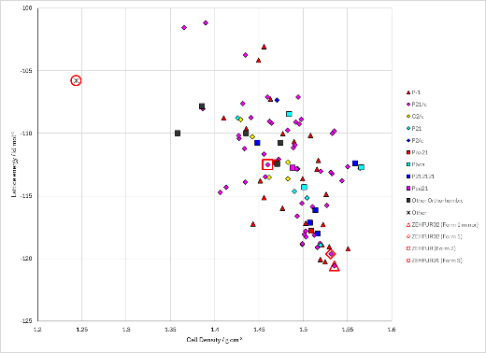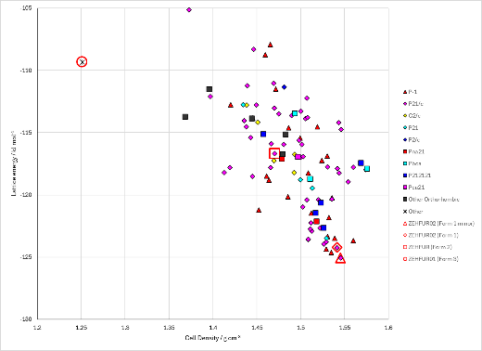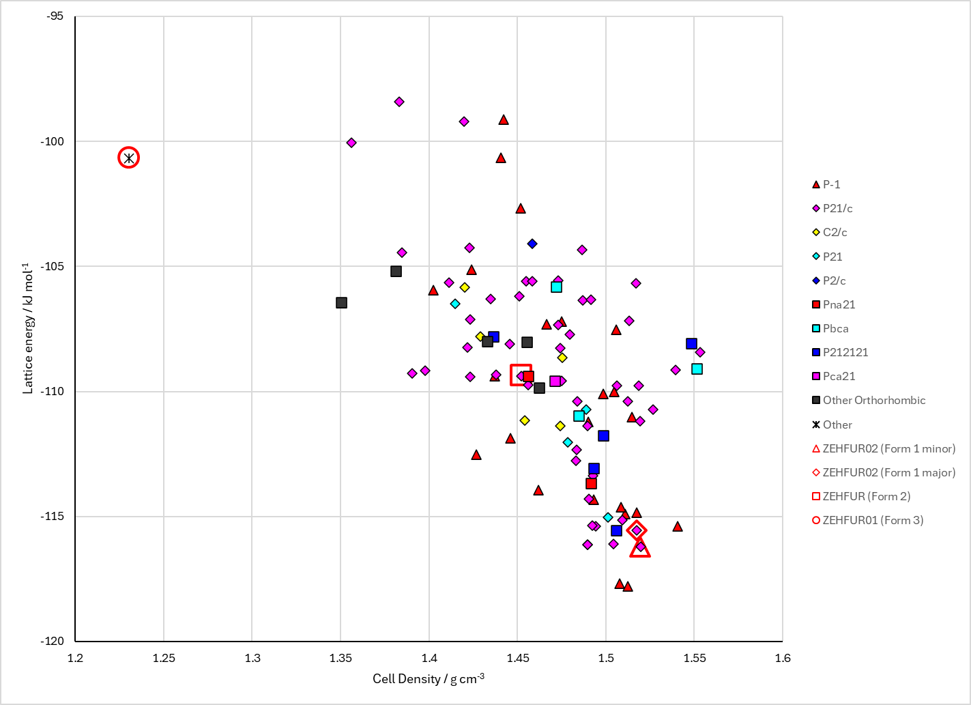
Figure 2. Crystal energy landscape of Blind Test XXXI from previous work. Top left to right: Study_ID=10, Study_ID=12, Study_ID=13. Bottom: Study_ID=11.

CSD structures (CSD version 6.01)

Table 1. Crystallographic information for CSD entries for Blind Test XXXI. Different polymorphs are coloured differently.
REFCODE | space group | Z’ | a / Å | b / Å | c / Å | α / ° | β / ° | γ / ° | density / g cm⁻³ | Form
ZEHFUR | P21/c | 1.0 | 7.2362 | 8.7359 | 21.9759 | 90.0 | 96.236 | 90.0 | 1.4779 | Form 2
ZEHFUR01 | R-3 | 1.0 | 36.8294 | 36.8294 | 6.04780 | 90.0 | 90.0 | 120.0 | 1.2928 | Form 3
ZEHFUR02 | P21/c | 1.0 | 15.5708 | 6.7969 | 12.7975 | 90.0 | 104.551 | 90.0 | 1.5569 | Form 1

Table 2. Experimental information for CSD entries for Blind Test XXXI.
REFCODE | space group | R factor | T / K | Year | Comments
ZEHFUR | P21/c | 3.969 | 200 K | 2022 | None
ZEHFUR01 | R-3 | 7.46 | 120 K | 2022 | None
ZEHFUR02 | P21/c | 3.91 | 120 K | 2022 | None

Make this table include whether polymorphs are solution-grown, sublimation grown, templated or otherwise. Add references.

Other notes

