N-[3-[2-(difluoromethoxy)-5-methylsulfanyl-phenyl]-1-[2-(4-morpholino-1-piperidyl)-2-oxo-ethyl]pyrazol-4-yl]pyrazolo[1,5-a]pyrimidine-3-carboxamide (Blind Test XXXII)
(Last updated February 2026)
Figure 1. The molecular diagram of Blind Test XXXII (JEKVII).

CSP studies
REFCODE | JEKVII
Formula | C29 H32 N8 O4 F2 S1
Common Name | Blind Test XXXII
IUPAC Systematic Name | N-[3-[2-(difluoromethoxy)-5-methylsulfanyl-phenyl]-1-[2-(4-morpholino-1-piperidyl)-2-oxo-ethyl]pyrazol-4-yl]pyrazolo[1,5-a]pyrimidine-3-carboxamide
Other Names
CSD Refcodes | JEKVII, JEKVII01
Search Identifier | A
Scientist | Louise Price
Date | August 2021
Publication | Blind Test 7, 2020-2022
Energy model | 2
Study_ID | 60
Programs | CrystalPredictor (2.4.3), DMACRYS (2.3.1.1), DFTB, DMACRYS (2.3.1.1)
Location on S Drive | CHEMISTRY_CPOSS\BlindTest2020-2022\XXXII\RigidCryPred\
Potential Description | CrystalPredictor2.4.3(rigid) (+DMACRYS), followed by DFTB3-D3 refinement, followed by DMACRYS with GDMA2.2(PBE1PBE/6-31G(d,p)) + FIT
Intramolecular Description | PBE0/6-31G(d,p)
Energy model | 1
Study_ID | 20
Programs | CrystalPredictor (2.4.3), DMACRYS (2.3.1.1)
Location on S Drive | CHEMISTRY_CPOSS\BlindTest2020-2022\XXXII\RigidCryPred\
Potential Description | CrystalPredictor2.4.3(rigid) + DMACRYS + GDMA2.2(PBE1PBE/6-31G(d,p) + FIT
Intramolecular Description | PBE0/6-31G(d,p)
Search Identifier | B
Scientist | Louise Price
Date | May 2022
Publication | Blind Test 7, 2020-2022
Energy model | 2
Study_ID | 10
Programs | CCDC supplied crystal structures, CrystalOptimizer (2.4.8_07_05), DMACRYS (2.3.1.1)
Location on S Drive | CHEMISTRY_CPOSS\BlindTest2020-2022\XXXII\CrystOpt
Potential Description | CrystalOptimizer PBE0/6-31G(d,p) intramolecular + GDMA2.2(PBE0/6-31G(d,p)) DMA + FIT
Intramolecular Description | PBE0(6-31G(d,p))
Energy model | 1
Study_ID | 61
Programs | CCDC supplied crystal structures, DFTB, DMACRYS (2.3.1.1)
Location on S Drive | CHEMISTRY_CPOSS\BlindTest2020-2022\XXXII\DFTB2
Potential Description | CCDC supplied structures, followed by DFTB3-D3 refinement, followed by DMACRYS with GDMA2.2(PBE1PBE/6-31G(d,p)) + FIT
Intramolecular Description | PBE0/6-31G(d,p)

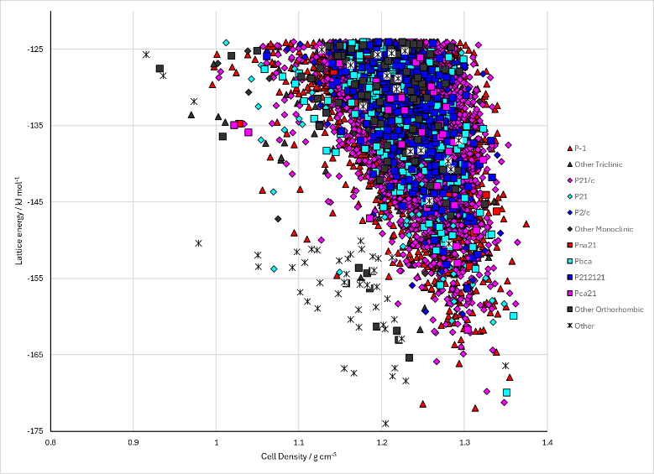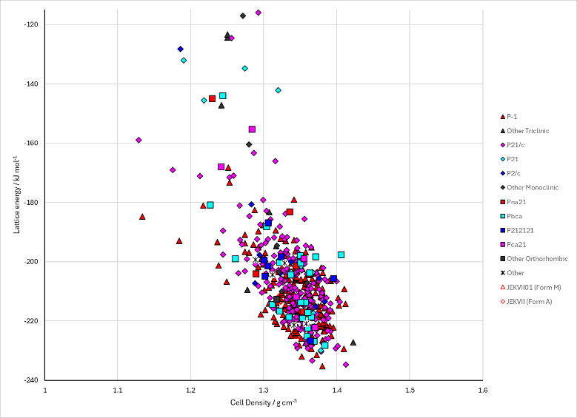
Figure 2. Crystal energy landscape of Blind Test XXXII (JEKVII) from previous work. Left: Energy Model A2. Right Energy Model B2.

CSD structures (CSD version 6.01)

Table 1. Crystallographic information for CSD entries for Blind Test XXXII (JEKVII). Different polymorphs are coloured differently.
REFCODE | space group | Z’ | a / Å | b / Å | c / Å | α / ° | β / ° | γ / ° | density / g cm⁻³ | Form
JEKVII | P-1 | 1.0 | 11.0558 | 11.3091 | 12.5973 | 81.552 | 84.717 | 72.255 | 1.4043 | Form A
JEKVII01 | P-1 | 2.0 | 10.1421 | 11.8057 | 26.359 | 88.987 | 86.485 | 66.486 | 1.4410 | Form M
JEKVII02 | P-1 | 1.0 | 11.0558 | 11.3091 | 12.5973 | 81.552 | 84.717 | 72.255 | 0.0 | Form A
JEKVII03 | P-1 | 2.0 | 10.1421 | 11.8057 | 26.359 | 88.987 | 86.485 | 66.486 | 0.0 | Form M

Table 2. Experimental information for CSD entries for Blind Test XXXII (JEKVII).
REFCODE | space group | R factor | T / K | Year | Comments
JEKVII | P-1 | 4.37 | 90 K | 2022 | None
JEKVII01 | P-1 | 7.689 | 90 K | 2022 | None
JEKVII02 | P-1 | 4.37 | 90 K | 2024 | 10.1107/S2052520624007492
JEKVII03 | P-1 | 7.689 | 90 K | 2024 | 10.1107/S2052520624007492

Make this table include whether polymorphs are solution-grown, sublimation grown, templated or otherwise. Add references.

Other notes

