Gentisic Acid
(Last updated March 2026)
Figure 1. The molecular diagram of Gentisic Acid.

CSP studies
REFCODE | BESKAL
Formula | C7 H6 O4
Common Name | Gentisic Acid
IUPAC Systematic Name | 2,5-dihydroxybenzoic acid
Other Names | Gentisic Acid
CSD Refcodes | BESKAL04, BESKAL14
Search Identifier | A
Scientist | Doris Braun
Date | 2010
Publication | Braun DE, Karamertzanis PG, Price SL 2011. Chem Commun 47, 5443-5445.
Energy model | 1
Study_ID | 20
Programs | Rigid Crystal Predictor (x), DMACRYS (2.0.2)
Location on S Drive | \CHEMISTRY_CPOSS\0-EarlySearches\home\louise_price.eminerals\gentisic_acid
Potential Description | Crystal Predictor with FIT potential and GDMA2 charges
Intramolecular Description | SCF
Search Identifier | B
Scientist | Doris Braun
Date | 2010
Publication | Braun DE, Karamertzanis PG, Price SL 2011. Chem Commun 47, 5443-5445.
Energy model | 1
Study_ID | 21
Programs | Rigid Crystal Predictor (x), DMACRYS (2.0.2)
Location on S Drive | \CHEMISTRY_CPOSS\0-EarlySearches\home\louise_price.eminerals\gentisic_acidZ2
Potential Description | Crystal Predictor with FIT potential and GDMA2 charges
Intramolecular Description | SCF

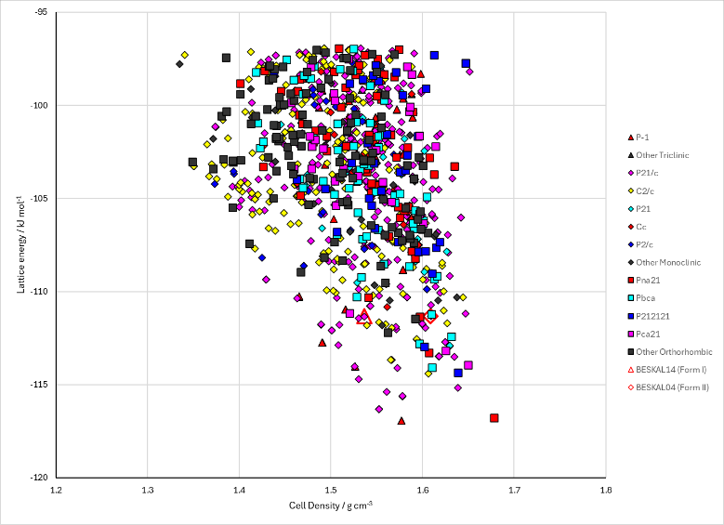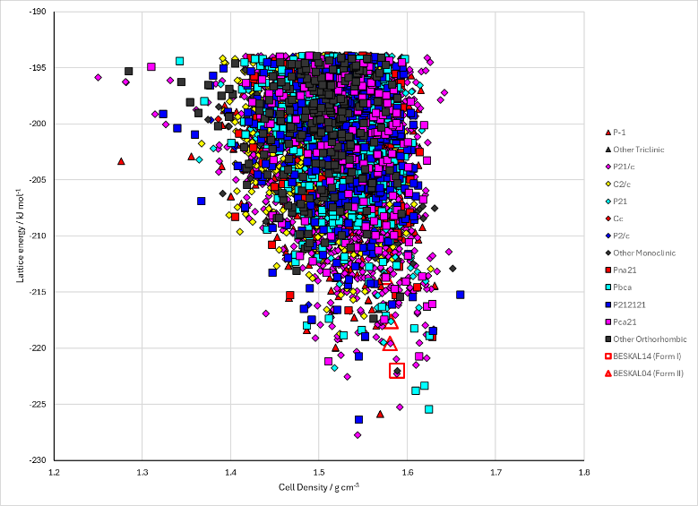
Figure 2. Crystal energy landscape of Gentisic Acid from previous work. Left: Z’=1 search; Energy model A1. Right: Z’=2 search; Energy model B1.

CSD structures (CSD version 6.01)

Table 1. Crystallographic information for CSD entries for Gentisic Acid. Different polymorphs are coloured differently.
REFCODE | space group | Z’ | a / Å | b / Å | c / Å | α / ° | β / ° | γ / ° | density / g cm⁻³ | Form
BESKAL | P21/a | 1.0 | 23.945 | 4.908 | 5.621 | 90.0 | 100.98100 | 90.0 | 1.5785 | ordered polymorph II
BESKAL01 | Pa | 2.0 | 11.299 | 11.83 | 4.966 | 90.0 | 90.5 | 90.0 | 1.5523 | disordered polymorph I
BESKAL02 | P21/c | 1.0 | 4.91100 | 11.8280 | 11.058 | 90.0 | 91.059 | 90.0 | 1.5939 | disordered polymorph I
BESKAL03 | P21/c | 1.0 | 5.561 | 4.86900 | 23.6880 | 90.0 | 100.191 | 90.0 | 1.6216 | ordered polymorph II
BESKAL04 | P21/n | 1.0 | 5.5591 | 4.86980 | 23.3593 | 90.0 | 93.448000 | 90.0 | 1.6217 | polymorph II
BESKAL05 | P21/n | 1.0 | 5.5751 | 4.8787 | 23.4030 | 90.0 | 93.223 | 90.0 | 1.6107 | polymorph II
BESKAL06 | P21/n | 1.0 | 5.5929 | 4.8891 | 23.4513 | 90.0 | 92.978000 | 90.0 | 1.5985 | polymorph II
BESKAL07 | P21/n | 1.0 | 5.6215 | 4.8939 | 23.492 | 90.0 | 92.76 | 90.0 | 1.5857 | polymorph II
BESKAL08 | P21/n | 1.0 | 5.6218 | 4.9063 | 23.526 | 90.0 | 92.48 | 90.0 | 1.5790 | polymorph II
BESKAL09 | P21/n | 1.0 | 5.64910 | 4.9306 | 23.6191 | 90.0 | 92.277 | 90.0 | 1.5572 | polymorph II
BESKAL10 | P21/n | 1.0 | 5.545 | 4.877 | 23.3506 | 90.0 | 93.62 | 90.0 | 1.6243 | polymorph II
BESKAL11 | P21/n | 1.0 | 5.564 | 4.87900 | 23.3903 | 90.0 | 93.43 | 90.0 | 1.6150 | polymorph II
BESKAL12 | P21/n | 1.0 | 5.597 | 4.897 | 23.47 | 90.0 | 92.97 | 90.0 | 1.5935 | polymorph II
BESKAL13 | Pc | 2.0 | 4.9705 | 11.8380 | 11.2480 | 90.0 | 90.405 | 90.0 | 1.5467 | ordered polymorph I
BESKAL14 | Pc | 2.0 | 4.9736 | 11.826 | 11.22 | 90.0 | 90.477 | 90.0 | 1.5512 | ordered polymorph I

Table 2. Experimental information for CSD entries for Gentisic Acid.
REFCODE | space group | R factor | T / K | Year | Comments
BESKAL | P21/a | 3.5 | None | 1982 | 10.1107/S0567740882006189
BESKAL01 | Pa | 3.9 | None | 1982 | 10.1107/S0567740882006189
BESKAL02 | P21/c | 5.66 | at 130 K | 2007 | 10.1021/cg060887w
BESKAL03 | P21/c | 5.51 | at 130 K | 2007 | 10.1021/cg060887w
BESKAL04 | P21/n | 4.3 | at 100 K | 2010 | 10.1039/b9nj00353c
BESKAL05 | P21/n | 4.94 | at 150 K | 2010 | 10.1039/b9nj00353c
BESKAL06 | P21/n | 5.310 | at 200 K | 2010 | 10.1039/b9nj00353c
BESKAL07 | P21/n | 6.78 | at 250 K | 2010 | 10.1039/b9nj00353c
BESKAL08 | P21/n | 7.12 | at 300 K | 2010 | 10.1039/b9nj00353c
BESKAL09 | P21/n | 6.26 | at 350 K | 2010 | 10.1039/b9nj00353c
BESKAL10 | P21/n | 9.27 | at 20 K | 2010 | 10.1039/b9nj00353c
BESKAL11 | P21/n | 7.96 | at 100 K | 2010 | 10.1039/b9nj00353c
BESKAL12 | P21/n | 8.15 | at 200 K | 2010 | 10.1039/b9nj00353c
BESKAL13 | Pc | 4.63 | 296 K | 2022 | 10.1039/D2TC00233G
BESKAL14 | Pc | 4.36 | 295 K | 2022 | 10.1039/D2TC00233G

Make this table include whether polymorphs are solution-grown, sublimation grown, templated or otherwise. Add references.

Other notes

