Gallic Acid Monohydrate (Blind Test XXI)
(Last updated March 2026)
Figure 1. The molecular diagram of Gallic acid monohydrate.

CSP studies
REFCODE | KONTIQ
Formula | C7 H6 O5 - H2 O1
Common Name | Gallic Acid Monohydrate
IUPAC Systematic Name | 3,4,5-Trihydroxybenzoic acid
Other Names | Gallic Acid Monohydrate
CSD Refcodes | KONTIQ, KONTIQ10, KONTIQ11, KONTIQ09, KONTIQ06
Search Identifier | A
Scientist | Doris Braun
Date | 2010
Publication | Bardwell DA, et al. 2011. Acta Crystallogr , Sect B 67, 535-551.
Energy model | 2
Study_ID | 10
Programs | Study_ID=20, CrystalOptimizer, DMACRYS (2.0.2)
Location on S Drive | \CHEMISTRY_CPOSS\BlindTest2010\KONTIQ\GallicAcid_COZ1
Potential Description | Crystal Optimizer from Crystal Predictor DMA(PBE0/aug-cc-pVTE) + FIT
Intramolecular Description | PBE0/6-31G(d,p)
Energy model | 1
Study_ID | 20
Programs | Rigid CrystalPredictor, DMACRYS (2.0.2)
Location on S Drive | \CHEMISTRY_CPOSS\BlindTest2010\KONTIQ\GallicAcid_rigid
Potential Description | Crystal Predictor DMA(PBE0/aug-cc-pVTE) + FIT
Intramolecular Description | PBE0/6-31G(d,p)
Search Identifier | B
Scientist | Doris Braun
Date | 2010
Publication | Bardwell DA, et al. 2011. Acta Crystallogr , Sect B 67, 535-551.
Energy model | 2
Study_ID | 11
Programs | Study_ID=21, CrystalOptimizer, DMACRYS (2.0.2)
Location on S Drive | \CHEMISTRY_CPOSS\BlindTest2010\KONTIQ\GallicAcid_COZ2
Potential Description | Crystal Optimizer from Crystal Predictor DMA(PBE0/aug-cc-pVTE) + FIT
Intramolecular Description | PBE0/6-31G(d,p)
Energy model | 1
Study_ID | 21
Programs | Rigid CrystalPredictor, DMACRYS (2.0.2)
Location on S Drive | \CHEMISTRY_CPOSS\BlindTest2010\KONTIQ\GallicAcid_rigidZ2
Potential Description | Crystal Predictor DMA(PBE0/aug-cc-pVTE) + FIT
Intramolecular Description | PBE0/6-31G(d,p)

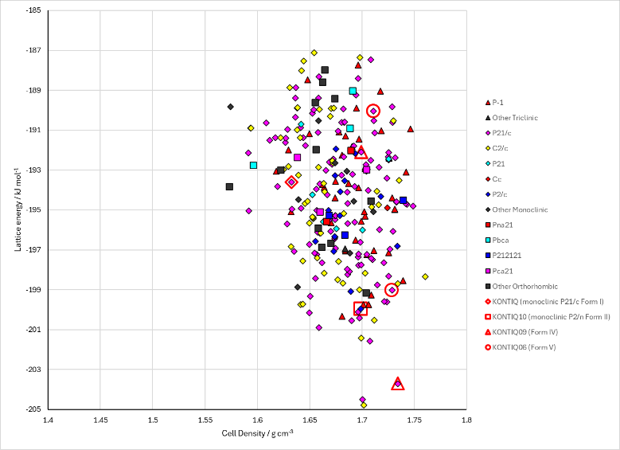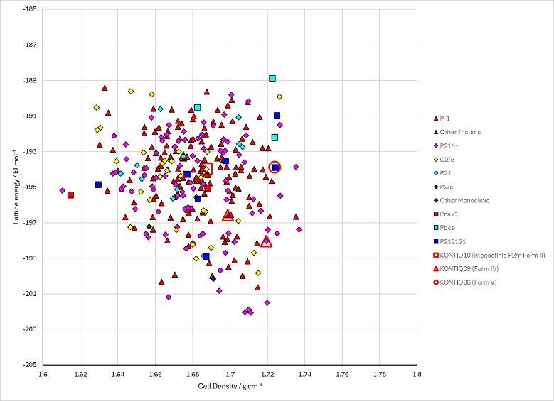
Figure 2. Crystal energy landscape of Gallic acid monohydrate from previous work. Left: from the Z’=1 search (Energy Model A2). Right from the Z’=2 search (Energy Model B2).

CSD structures (CSD version 6.01)

Table 1. Crystallographic information for CSD entries for Gallic acid monohydrate. Different polymorphs are coloured differently.
REFCODE | space group | Z’ | a / Å | b / Å | c / Å | α / ° | β / ° | γ / ° | density / g cm⁻³ | Form
KONTIQ | P21/c | 1.0 | 5.79400 | 4.719 | 28.688 | 90.0 | 95.08 | 90.0 | 1.5994 | P21/c polymorph
KONTIQ01 | P2/n | 1.0 | 14.15 | 3.622 | 15.028 | 90.0 | 97.52 | 90.0 | 1.6365 | P2/n polymorph
KONTIQ02 | P2/n | 1.0 | 14.158 | 3.624 | 15.036 | 90.0 | 97.600000 | 90.0 | 1.6341 | P2/n polymorph
KONTIQ03 | P21/c | 1.0 | 9.7943 | 3.6122 | 21.5905 | 90.0 | 91.268 | 90.0 | 1.6363 | polymorph 3
KONTIQ04 | P-1 | 4.0 | 7.117 | 7.506 | 30.6790 | 86.557 | 83.814000 | 68.531 | 1.6486 | triclinic P-1 form III polymorph
KONTIQ05 | P21/c | 1.0 | 9.79000 | 3.609 | 21.5830 | 90.0 | 91.462 | 90.0 | 1.6392 | monoclinic P21/c form IV polymorph
KONTIQ06 | P21/c | 1.0 | 7.60719 | 3.64133 | 26.7915 | 90.0 | 98.4212 | 90.0 | 1.7021 | polymorph V
KONTIQ07 | P21/c | 3.0 | 23.7685 | 3.5428 | 28.7556 | 90.0 | 112.831 | 90.0 | 1.6798 | polymorph IV'
KONTIQ08 | P21/c | 1.0 | 9.7824 | 3.5428 | 21.4669 | 90.0 | 91.149 | 90.0 | 1.6799 | polymorph IV
KONTIQ09 | P21/c | 1.0 | 9.7573 | 3.55790 | 21.517 | 90.0 | 91.338000 | 90.0 | 1.6733 | polymorph IV
KONTIQ10 | P2/n | 1.0 | 14.172 | 3.6057 | 15.022 | 90.0 | 97.577 | 90.0 | 1.6422 | monoclinic polymorph
KONTIQ11 | P-1 | 2.0 | 7.1208 | 7.5087 | 15.5879 | 100.581 | 91.114500 | 111.44500 | 2.4653 | triclinic polymorph
KONTIQ12 | P2/n | 1.0 | 14.192 | 3.62870 | 15.065 | 90.0 | 97.547 | 90.0 | 1.6247 | P2/n polymorph
KONTIQ13 | P-1 | 2.0 | 7.10340 | 7.4941 | 15.5567 | 100.593 | 91.274 | 111.56400 | 1.6586 | triclinic P-1 form III polymorph

Table 2. Experimental information for CSD entries for Gallic acid monohydrate.
REFCODE | space group | R factor | T / K | Year | Comments
KONTIQ | P21/c | 4.2 | None | 2000 | 10.1107/S0108270100001827
KONTIQ01 | P2/n | 4.92 | at 296.2 K | 2001 | 10.1107/S1600536801012041
KONTIQ02 | P2/n | 5.34 | at 293 K | 2007 | 10.1016/j.vibspec.2006.07.008
KONTIQ03 | P21/c | 3.91 | at 296 K | 2011 | 10.1107/S1600536811018848
KONTIQ04 | P-1 | 9.07 | at 100K | 2011 | 10.1021/cg2001865
KONTIQ05 | P21/c | 9.85 | at 298K | 2011 | 10.1021/cg2001865
KONTIQ06 | P21/c | 4.179 | 123 K | 2013 | 10.1021/cg301506x
KONTIQ07 | P21/c | 5.140 | 10 K | 2017 | 10.1039/C6CC06799A
KONTIQ08 | P21/c | 5.18 | 10 K | 2017 | 10.1039/C6CC06799A
KONTIQ09 | P21/c | 3.500 | 123 K | 2017 | 10.1039/C6CC06799A
KONTIQ10 | P2/n | 3.91 | 250 K | 2018 | None
KONTIQ11 | P-1 | 4.130 | 150 K | 2018 | None
KONTIQ12 | P2/n | 7.91 | 298 K | 2023 | 10.1039/D2CE01149B
KONTIQ13 | P-1 | 5.84 | 100 K | 2023 | 10.1039/D3CE00766A

Make this table include whether polymorphs are solution-grown, sublimation grown, templated or otherwise. Add references.

Other notes
The conformations have been changed from Conf1, Conf2, etc to A, B, etc. Structure numbers that did not include the conformation now do. This will stop potential conflicts between Conf2_1602 and Conf3_1602 for example.
Although the energies are compatible, the Z’=1 and Z’=2 searches have not been merged.

