Dimethylurea
(Last updated December 2025)
Figure 1. The molecular diagram of Dimethylurea.

CSP studies
REFCODE | NIJHUJ
Formula | C3 H8 N2 O1
Common Name | Dimethylurea
IUPAC Systematic Name | N,N'-dimethylurea
CSD Refcodes | NIJHUJ03, NIJHUJ04
Search Identifier | A
Scientist | Ricarda Duss
Date | May 2023
Publication | Masters thesis
Energy model | 2
Study_ID | 10
Programs | Study_ID=20, CrystalOptimizer (2.4.7), DMACRYS (2.3.1.1)
Location on S Drive | /CHEMISTRY_CPOSS/Dimethylurea/CrystOpt/
Potential Description | CrystalOptimizer with GDMA2.2(B3LYP/6-31G(d,p) + Day2016
Energy model | 1
Study_ID | 20
Programs | rigid CrystalPredictor (2.4.3), DMACRYS (2.3.1.1)
Location on S Drive | /CHEMISTRY_CPOSS/Dimethylurea/CrystPred/
Potential Description | Rigid CrystalPredictor + DMACRYS with GDMA2.2(B3LYP/6-31G(d,p)) + Day2016

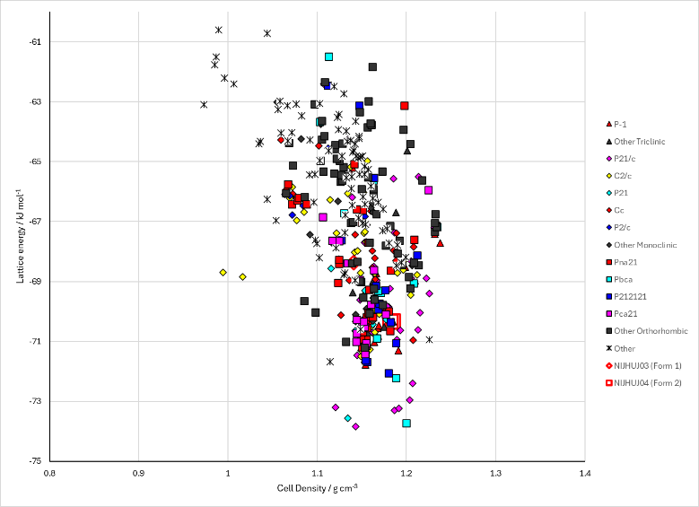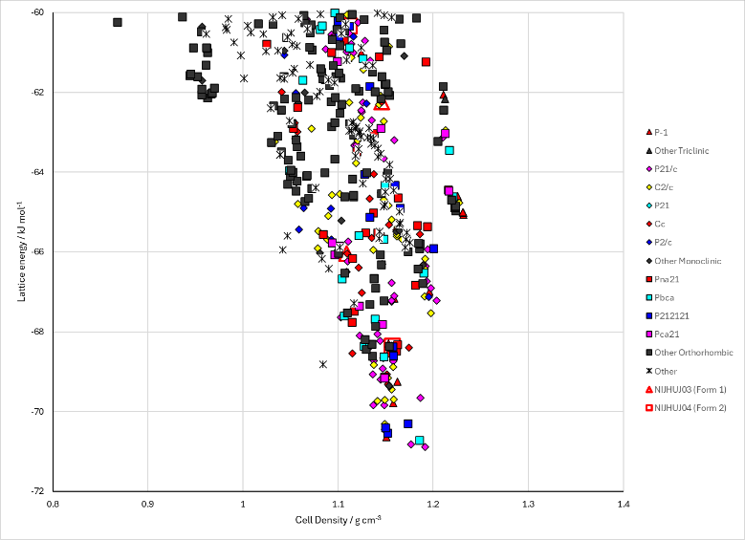
Figure 2. Crystal energy landscape of Dimethylurea from previous work. Left: CrystalOptimizer landscape. Right: CrystalPredictor landscape.

CSD structures (CSD version 5.43 with Mar, Jun, Sep and Nov 2022 updates)

Table 1. Crystallographic information for CSD entries for Dimethylurea. Different polymorphs are coloured differently.
REFCODE | space group | Z’ | a / Å | b / Å | c / Å | α / ° | β / ° | γ / ° | density / g cm⁻³ | Form
NIJHUJ | Cc | 1.0 | 4.569 | 11.4 | 10.348 | 90.0 | 102.74000 | 90.0 | 1.1131 | 1
NIJHUJ01 | Fdd2 | 0.5 | 11.4 | 20.186 | 4.569 | 90.0 | 90.0 | 90.0 | 1.1132 | 1
NIJHUJ02 | P21212 | 0.5 | 4.979 | 10.775 | 4.57640 | 90.0 | 90.0 | 90.0 | 1.1918 | 2
NIJHUJ03 | Fdd2 | 0.5 | 11.3837 | 19.6293 | 4.56079 | 90.0 | 90.0 | 90.0 | 1.1484 | 1
NIJHUJ04 | P21212 | 0.5 | 10.8522 | 4.91020 | 4.5766 | 90.0 | 90.0 | 90.0 | 1.1998 | 2

Table 2. Experimental information for CSD entries for Dimethylurea.
REFCODE | space group | R factor | T / K | Year | Comments
NIJHUJ | Cc | 5.8 | None | 1997 | 10.1007/BF02576570
NIJHUJ01 | Fdd2 | None | None | 2004 | 10.1107/S0108768104003878
NIJHUJ02 | P21212 | 3.62 | at 150 K | 2009 | 10.1021/jp900141q
NIJHUJ03 | Fdd2 | 2.94 | at 180 K | 2013 | 10.1107/S0108768112049324
NIJHUJ04 | P21212 | 2.88 | at 100 K | 2013 | 10.1107/S0108768112049324

Make this table include whether polymorphs are solution-grown, sublimation grown, templated or otherwise. Add references.

Other notes

