Alditols
(Last updated February 2026)
Figure 1. The molecular diagram of the Alditols.

CSP studies
REFCODE | DMANTL
Formula | C6 H14 O6
Common Name | Mannitol
IUPAC Systematic Name | (2R,3R,4R,5R)-hexan-1,2,3,4,5,6-hexol
Other Names
CSD Refcodes | DLMANT, DMANTL08, DMANTL09, DMANTL10
Search Identifier | A
Scientist | Louise Price
Date | 2015
Publication | No publication planned
Energy model | 1
Study_ID | 0
Programs | MOLPAK, DMACRYS (2.2.0.1)
Location on S Drive | \CHEMISTRY_CPOSS\alditols\ConOptSearches_FIT\mannitol
Potential Description | MOLPAK + DMA(PBE0/6-31G(d,p)) + FIT
Intramolecular Description | PBE1PBE/6-31G(d,p)
REFCODE | GLUCIT
Formula | C6 H14 O6
Common Name | Sorbitol
IUPAC Systematic Name | (2S,3R,4R,5R)-hexan-1,2,3,4,5,6-hexol
Other Names | Glucitol
CSD Refcodes | GLUCIT04, GLUCIT02, GLUCIT03
Search Identifier | A
Scientist | Louise Price
Date | 2015
Publication | No publication planned
Energy model | 1
Study_ID | 0
Programs | MOLPAK, DMACRYS (2.2.0.1)
Location on S Drive | \CHEMISTRY_CPOSS\alditols\ConOptSearches_FIT\sorbitol
Potential Description | MOLPAK + DMA(PBE0/6-31G(d,p)) + FIT
Intramolecular Description | PBE1PBE/6-31G(d,p)
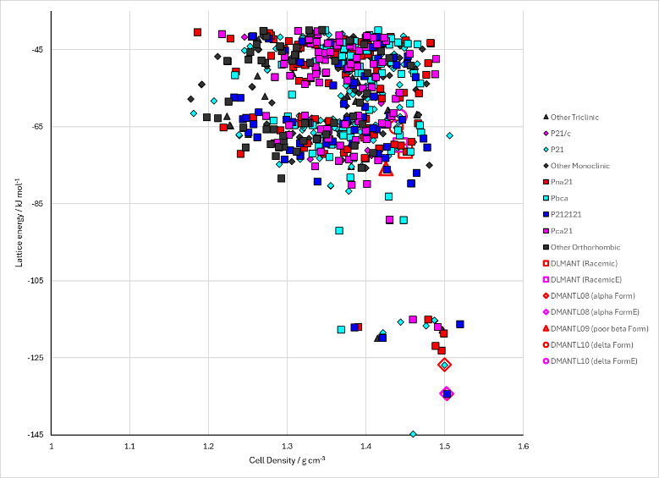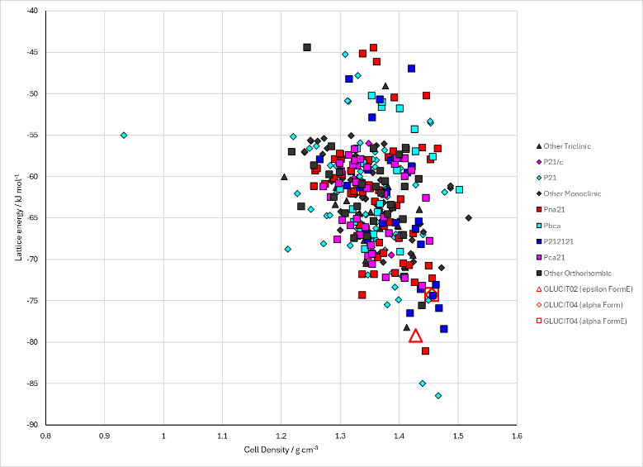
Figure 2. Crystal energy landscape of the Alditols from previous work. Left: mannitol. Right: sorbitol.

CSD structures (CSD version 6.01)

Table 1. Crystallographic information for CSD entries for the Alditols. Different polymorphs are coloured differently.
REFCODE | space group | Z’ | a / Å | b / Å | c / Å | α / ° | β / ° | γ / ° | density / g cm⁻³ | Form
DLMANT | Pna21 | 1.0 | 9.048 | 4.87 | 18.262 | 90.0 | 90.0 | 90.0 | 1.5036 | Racemic
DMANTL | P212121 | 1.0 | 8.672 | 16.875 | 5.56000 | 90.0 | 90.0 | 90.0 | 1.4871 | beta polymorph
DMANTL01 | P212121 | 1.0 | 8.942 | 18.7980 | 4.893 | 90.0 | 90.0 | 90.0 | 1.4711 | Kappa polymorph
DMANTL07 | P212121 | 1.0 | 8.694 | 16.902 | 5.549 | 90.0 | 90.0 | 90.0 | 1.4839 | beta polymorph
DMANTL08 | P212121 | 1.0 | 4.8653 | 8.873 | 18.739 | 90.0 | 90.0 | 90.0 | 1.4957 | alpha polymorph
DMANTL09 | P212121 | 1.0 | 5.5381 | 8.58 | 16.795 | 90.0 | 90.0 | 90.0 | 1.5162 | beta polymorph
DMANTL10 | P21 | 1.0 | 4.899 | 18.268 | 5.043 | 90.0 | 118.39000 | 90.0 | 1.5237 | delta polymorph
DMANTL11 | P212121 | 1.0 | 8.679 | 16.8962 | 5.54972 | 90.0 | 90.0 | 90.0 | 1.4868 | beta polymorph
DMANTL12 | P21 | 1.0 | 5.08941 | 18.2504 | 4.91702 | 90.0 | 118.303 | 90.0 | 1.5045 | delta polymorph
DMANTL14 | P21 | 1.0 | 4.9089 | 18.2086 | 5.08090 | 90.0 | 118.35900 | 90.0 | 1.5138 | delta polymorph
DMANTL15 | P212121 | 1.0 | 5.52950 | 8.56590 | 16.7722 | 90.0 | 90.0 | 90.0 | 1.5231 | beta polymorph
DMANTL16 | P212121 | 1.0 | 5.52830 | 8.5512 | 16.7568 | 90.0 | 90.0 | 90.0 | 1.5274 | beta polymorph
DMANTL17 | P212121 | 1.0 | 5.5233 | 8.5832 | 16.7912 | 90.0 | 90.0 | 90.0 | 1.5200 | beta polymorph
DMANTL18 | P212121 | 1.0 | 5.5513 | 8.602 | 16.8454 | 90.0 | 90.0 | 90.0 | 1.5042 | beta polymorph
DMANTL19 | P212121 | 1.0 | 5.5553 | 8.6534 | 16.8527 | 90.0 | 90.0 | 90.0 | 1.4935 | beta polymorph
DMANTL20 | P212121 | 1.0 | 5.533 | 8.6173 | 16.8575 | 90.0 | 90.0 | 90.0 | 1.5054 | beta polymorph
DMANTL21 | P212121 | 1.0 | 5.509 | 8.66110 | 16.789 | 90.0 | 90.0 | 90.0 | 1.5104 | beta polymorph
DMANTL22 | P212121 | 1.0 | 5.5387 | 8.65800 | 16.8284 | 90.0 | 90.0 | 90.0 | 1.4994 | beta polymorph
DMANTL23 | P212121 | 1.0 | 5.54620 | 8.5929 | 16.8341 | 90.0 | 90.0 | 90.0 | 1.5082 | beta polymorph
DMANTL24 | P212121 | 1.0 | 5.5624 | 8.6929 | 16.9222 | 90.0 | 90.0 | 90.0 | 1.4787 | beta polymorph
DMANTL25 | P212121 | 1.0 | 5.5347 | 8.5755 | 16.7801 | 90.0 | 90.0 | 90.0 | 1.5192 | beta polymorph
DMANTL26 | P212121 | 1.0 | 4.95 | 9.06 | 19.27 | 90.0 | 90.0 | 90.0 | 1.4001 | Kappa polymorph
GLUCIT | P212121 | 1.0 | 8.677 | 9.311 | 9.727 | 90.0 | 90.0 | 90.0 | 1.5397 | alpha polymorph
GLUCIT01 | P212121 | 1.0 | 8.677 | 9.311 | 9.727 | 90.0 | 90.0 | 90.0 | 1.5397 | alpha polymorph
GLUCIT02 | P21 | 2.0 | 4.7907 | 9.4884 | 17.7307 | 90.0 | 94.446 | 90.0 | 1.5058 | epsilon polymorph
GLUCIT03 | P21212 | 3.0 | 24.3012 | 20.5726 | 4.86719 | 90.0 | 90.0 | 90.0 | 1.4918 | gamma polymorph
GLUCIT04 | P212121 | 1.0 | 8.6164 | 9.28460 | 9.669 | 90.0 | 90.0 | 90.0 | 1.5642 | alpha polymorph

Table 2. Experimental information for CSD entries for the Alditols.
REFCODE | space group | R factor | T / K | Year | Comments
DLMANT | Pna21 | 3.0 | at -150 deg.C | 1977 | 10.1107/S0567740877011777
DMANTL | P212121 | 18.0 | 295 K | 1968 | 10.1107/S0567740868002530
DMANTL01 | P212121 | 4.9 | None | 1968 | 10.1107/S0567740868004462
DMANTL07 | P212121 | 2.760 | None | 1997 | 10.1524/zkri.1997.212.4.283
DMANTL08 | P212121 | 5.4 | at 100 K | 2003 | 10.1107/S0108270103018961
DMANTL09 | P212121 | 3.6 | at 100 K | 2003 | 10.1107/S0108270103018961
DMANTL10 | P21 | 3.1 | at 100 K | 2003 | 10.1107/S0108270103018961
DMANTL11 | P212121 | 6.8 | None | 2003 | 10.1154/1.1582460
DMANTL12 | P21 | 5.24 | None | 2003 | 10.1154/1.1582460
DMANTL14 | P21 | 3.9 | at 293 K | 2012 | None
DMANTL15 | P212121 | 2.26 | 99.9 K | 2019 | None
DMANTL16 | P212121 | 3.42 | 125 K | 2019 | None
DMANTL17 | P212121 | 3.37 | 150 K | 2019 | None
DMANTL18 | P212121 | 3.94 | 200 K | 2019 | None
DMANTL19 | P212121 | 3.690 | 225 K | 2019 | None
DMANTL20 | P212121 | 4.17 | 250 K | 2019 | None
DMANTL21 | P212121 | 4.43 | 274.9 K | 2019 | None
DMANTL22 | P212121 | 3.599 | 294.5 K | 2019 | None
DMANTL23 | P212121 | 3.35 | 175 K | 2019 | None
DMANTL24 | P212121 | 3.55 | 300 K | 2019 | None
DMANTL25 | P212121 | 2.53 | 100 K | 2022 | 10.1016/j.xcrp.2021.100723
DMANTL26 | P212121 | 12.65 | 80 K | 2024 | 10.1021/acscentsci.3c01365
GLUCIT | P212121 | 3.2 | None | 1971 | 10.1107/S0567740871005934
GLUCIT01 | P212121 | 6.600 | None | 1971 | 10.1107/S0567740871005934
GLUCIT02 | P21 | 5.0 | at 100 K | 1998 | 10.1016/S0008-6215(98)00243-2
GLUCIT03 | P21212 | 3.77 | at 295 K | 2004 | 10.1107/S0021889804016206
GLUCIT04 | P212121 | 2.63 | 95 K | 2017 | 10.1021/acs.jpca.7b04313

Make this table include whether polymorphs are solution-grown, sublimation grown, templated or otherwise. Add references.

Other notes
The conformations used in the searches were partially optimized from the experimentally observed conformations, with constrained C-C-O-H angles. They are far higher in energy that the best located conformation. A full search with no experimental input was not possible with tools at the time.
The gamma polymorph of sorbitol is Z’=3. The hydrogen atoms were “placed in idealized position”. Unfortunately, these positions were a little incorrect, and hydrogen bond donors did not point to acceptors. Minimizing the structure with DMACRYS caused it to go somewhere else. Louise tried placing hydrogens in better positions, and the structure stayed better and was far lower energy, but this was guessing and not real. Therefore, the structure was disregarded entirely.

