Amoxapine
(Last updated December 2025)
Figure 1. The molecular diagram of Amoxapine.

CSP studies
REFCODE | AMOXAP
Formula | C17 H16 N3 O1 Cl1
Common Name | Amoxapine
IUPAC Systematic Name | 2-Chloro-11-(1-piperazinyl)-dibenz(b,f)(1,4)oxazepine
Other Names
CSD Refcodes | AMOXAP
Search Identifier | B
Scientist | Louise Price
Date | 2015
Publication | No publication planned.
Energy model | 2
Study_ID | 10
Programs | Study_id=20, CrystalOptimizer (2.3), DMACRYS (2.0.8)
Location on S Drive | CHEMISTRY_CPOSS\Olanzapine\Amoxapine\Amox-CO
Potential Description | CrystalOptimizer PBE1PBE/6-31G(d,p) intramolecular + GDMA2.2(PBE1PBE/6-31G(d,p)) DMA + FIT
Energy model | 1
Study_ID | 20
Programs | Flexible CrystalPredictor (2.1), DMACRYS (2.0.8)
Location on S Drive | CHEMISTRY_CPOSS\Olanzapine\Amoxapine\Amox-CP
Potential Description | CrystalPredictor + DMACRYS with GDMA2.2(PBE1PBE/6-31G(d,p)) + FIT
Search Identifier | A
Scientist | Louise Price
Date | 2012
Publication | No publication planned.
Energy model | 1
Study_ID | 0
Programs | Molpak, DMACRYS (2.0.4)
Location on S Drive | CHEMISTRY_CPOSS\Olanzapine\Amoxapine\pbe_molpak
Potential Description | DMA + FIT

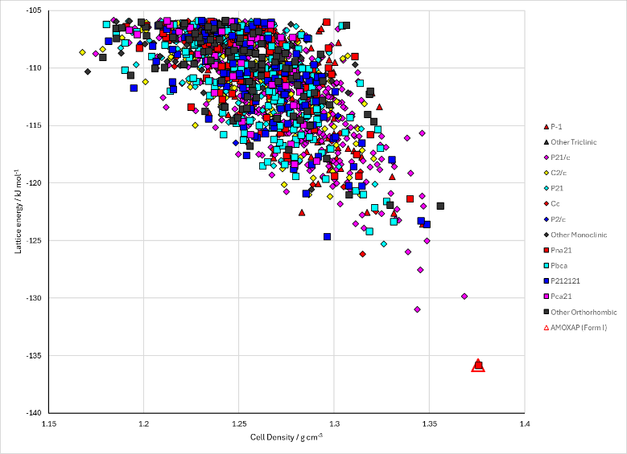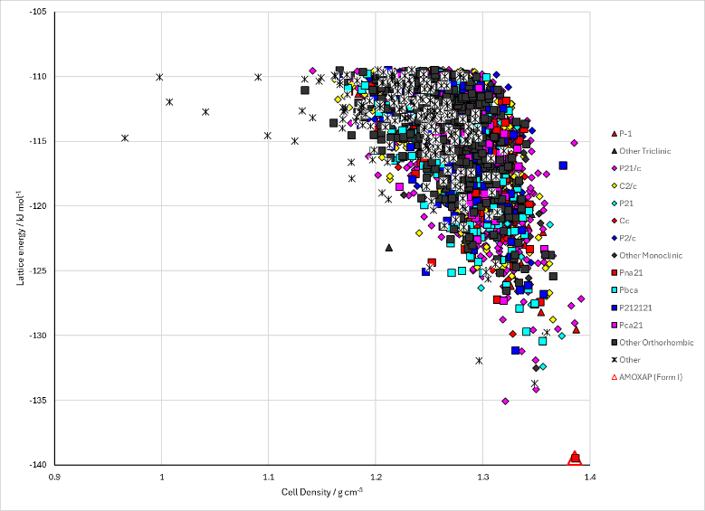
Figure 2. Crystal energy landscape of Amoxapine from previous work. Left: from rigid molecule MOLPAK search. Right: CrystalOptimizer refinement of CrystalPredictor search.

CSD structures (CSD version 6.01)

Table 1. Crystallographic information for CSD entries for Amoxapine. Different polymorphs are coloured differently.
REFCODE | space group | Z’ | a / Å | b / Å | c / Å | α / ° | β / ° | γ / ° | density / g cm⁻³ | Form
AMOXAP | Pna21 | 1.0 | 11.765 | 9.743 | 12.99 | 90.0 | 90.0 | 90.0 | 1.3997 | None

Table 2. Experimental information for CSD entries for Amoxapine.
REFCODE | space group | R factor | T / K | Year | Comments
AMOXAP | Pna21 | 4.9 | None | 1977 | 10.1107/S056774087700555X

Make this table include whether polymorphs are solution-grown, sublimation grown, templated or otherwise. Add references.

Other notes

