Loxapine
(Last updated November 2025)
Figure 1. The molecular diagram of Loxapine.

CSP studies
REFCODE | NDOCLH
Formula | C18 H18 N3 O1 Cl1
Common Name | Loxapine
IUPAC Systematic Name | 2-Chloro-11-(4-methylpiperazin-1-yl)-dibenzo(b,f)(1,4)oxazepine
Other Names
CSD Refcodes | NDOCLH01, NDOCLH10
Search Identifier | B
Scientist | Louise Price
Date | 2016
Publication | No publication planned.
Energy model | 2
Study_ID | 10
Programs | Study_ID=20, CrystalOptimizer (2.4.4), DMACRYS (2.2.1.0)
Location on S Drive | \CHEMISTRY_CPOSS\Olanzapine\Loxapine\CrystOpt
Potential Description | CrystalOptimizer PBE1PBE/6-31G(d,p) intramolecular + GDMA2.2(PBE1PBE/6-31G(d,p)) DMA + FIT
Energy model | 1
Study_ID | 20
Programs | Flexible CrystalPredictor (2.x), DMACRYS (2.2.1.0)
Location on S Drive | \CHEMISTRY_CPOSS\Olanzapine\Loxapine\CrystPred
Potential Description | CrystalPredictor + DMACRYS with GDMA2.2(PBE1PBE/6-31G(d,p)) + FIT
Search Identifier | A
Scientist | Louise Price
Date | 2013
Publication | No publication planned.
Energy model | 1
Study_ID | 0
Programs | MOLPAK, DMACRYS (2.0.4)
Location on S Drive | \CHEMISTRY_CPOSS\Olanzapine\Loxapine\pbe_molpak
Potential Description | GDMA2.2(PBE0/6-31G(d,p)) + FIT

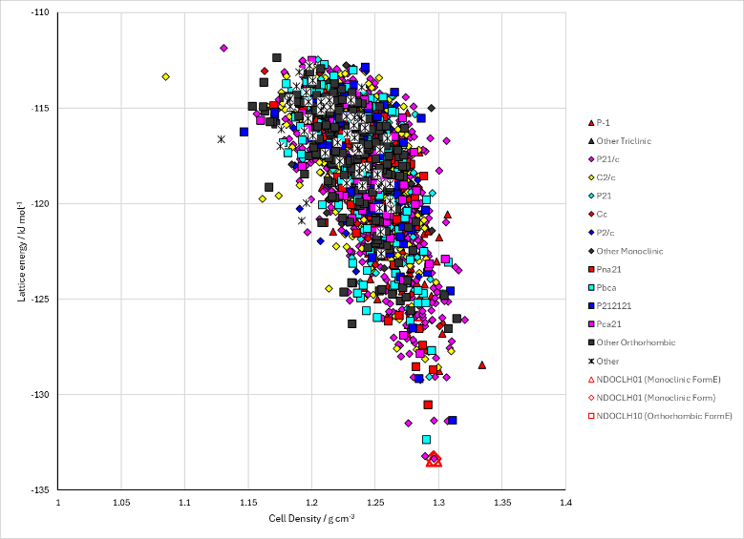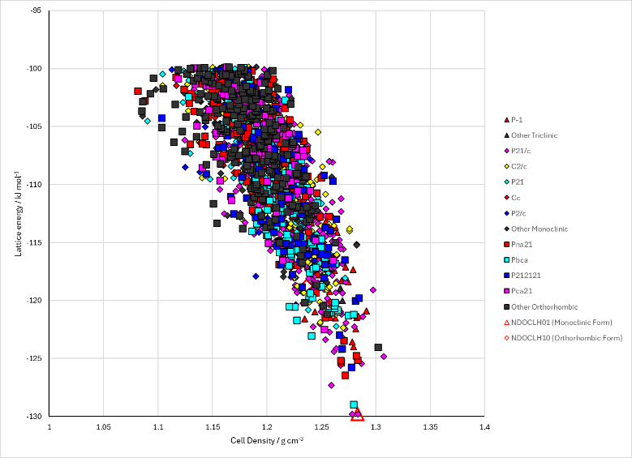
Figure 2. Crystal energy landscape of Loxapine from previous work. Left: the CrystalOptimizer refinement of the CrystalPredictor search. Right: the rigid molecule MOLPAK search with the optimized conformation.

CSD structures (CSD version 6.01)

Table 1. Crystallographic information for CSD entries for Loxapine. Different polymorphs are coloured differently.
REFCODE | space group | Z’ | a / Å | b / Å | c / Å | α / ° | β / ° | γ / ° | density / g cm⁻³ | Form
NDOCLH01 | P21/c | 1 | 12.953 | 10.908 | 12.584 | 90 | 109.53 | 90 | 1.299 | Monoclinic
NDOCLH10 | Pbca | 1 | 17.96 | 14.13 | 13.01 | 90 | 90 | 90 | 1.319 | Orthorhombic

Table 2. Experimental information for CSD entries for Loxapine.
REFCODE | space group | R factor | T / K | Year | Comments
NDOCLH01 | P21/c | 5.4 | 295 | 1977 | Slow evaporation from methanol/water mixtures¹
NDOCLH10 | Pbca | 6.4 | 295 | 1976 | Slow evaporation of saturated 1:1 methanol-water solution²

Other notes

1. D. B. Cosulich and F. M. Lovell, Acta Crystallographica Section B, 1977, 33, 1147-1154.
2. T. J. Petcher and H.-P. Weber, Journal of the Chemical Society, Perkin Transactions 2, 1976, 1415-1420.

