Methyl-p-hydroxybenzoate
(Last updated April 2026)
Figure 1. The molecular diagram of Methyl-p-hydroxybenzoate.

CSP studies
REFCODE | CEBGOF
Formula | C8 H8 O3
Common Name | methyl-p-hydroxybenzoate
IUPAC Systematic Name | 4-hydroxybenzoic acid methyl ester
Other Names | methyl-4-hydroxybenzoate
CSD Refcodes | CEBGOF01, CEBGOF04, CEBGOF05, CEBGOF06
Search Identifier | A
Scientist | Doris Braun
Date | 2010
Publication | No publication planned.
Energy model | 2
Study_ID | 10
Programs | Study_ID=0, dmaflex, DMAREL (4.1.1)
Location on S Drive | \CHEMISTRY_CPOSS\0-EarlySearches\home\louise_price.eminerals\Methyl-p-hydroxybenzoate_dmaflex
Potential Description | DMA + FIT
Intramolecular Description | SCF
Energy model | 1
Study_ID | 0
Programs | MOLPAK, DMAREL (4.1.1)
Location on S Drive | \CHEMISTRY_CPOSS\0-EarlySearches\home\louise_price.eminerals\Methyl-p-hydroxybenzoate
Potential Description | DMA + FIT
Intramolecular Description | MP2/6-31G(d,p)

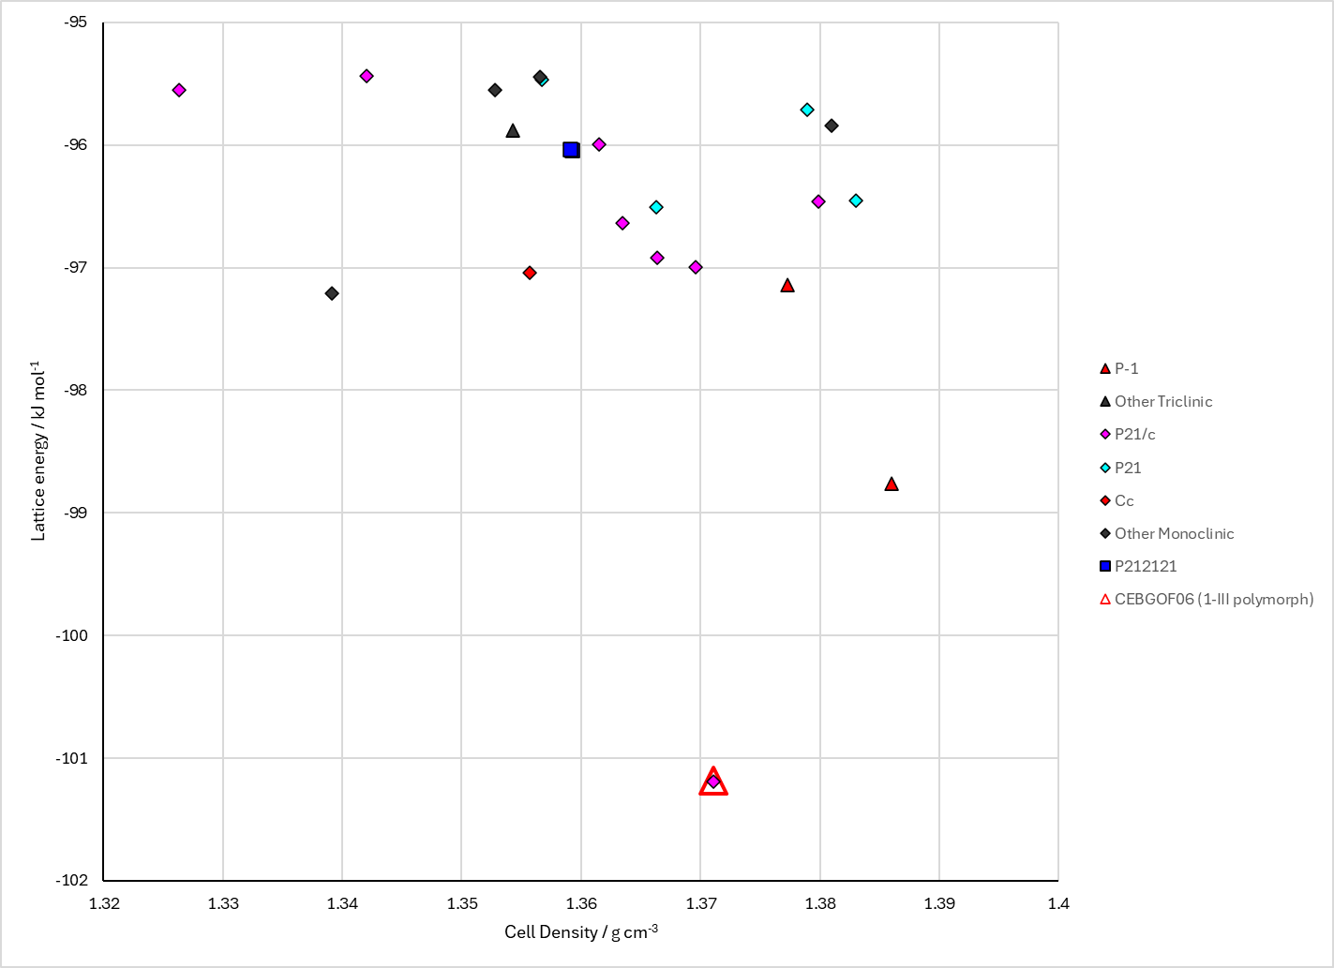
Figure 2. Crystal energy landscape of Methyl-p-hydroxybenzoate from previous work. Energy model = A2.

CSD structures (CSD version 6.01)

Table 1. Crystallographic information for CSD entries for Methyl-p-hydroxybenzoate. Different polymorphs are coloured differently.
REFCODE | space group | Z’ | a / Å | b / Å | c / Å | α / ° | β / ° | γ / ° | density / g cm⁻³ | Form
CEBGOF | Cc | 3.0 | 13.568 | 16.959 | 12.458 | 90.0 | 130.1 | 90.0 | 1.3826 | 1-I polymorph
CEBGOF01 | Cc | 3.0 | 13.006 | 17.261 | 12.209 | 90.0 | 129.12 | 90.0 | 1.4257 | low temperature polymorph 1-I
CEBGOF02 | Cc | 3.0 | 12.9708 | 17.2485 | 10.8428 | 90.0 | 119.26 | 90.0 | 1.4325 | low temperature monoclinic polymorph 1-I
CEBGOF03 | P21/c | 1.0 | 4.8186 | 14.63 | 10.239 | 90.0 | 99.81 | 90.0 | 1.4208 | monoclinic P21/c polymorph 1-III
CEBGOF04 | P21/c | 1.0 | 5.98450 | 8.3384 | 14.4209 | 90.0 | 96.526 | 90.0 | 1.4134 | 1-112 polymorph
CEBGOF05 | Cc | 1.0 | 17.517 | 7.2602 | 6.224 | 90.0 | 107.61 | 90.0 | 1.3394 | 1-107 polymorph
CEBGOF06 | P21/c | 1.0 | 4.89800 | 14.698 | 10.3341 | 90.0 | 98.774 | 90.0 | 1.3744 | 1-III polymorph

Table 2. Experimental information for CSD entries for Methyl-p-hydroxybenzoate.
REFCODE | space group | R factor | T / K | Year | Comments
CEBGOF | Cc | 5.4 | None | 1983 | None
CEBGOF01 | Cc | 3.300 | at 113 K | 2006 | 10.1021/cg050639k
CEBGOF02 | Cc | 4.25 | at 100.00 K | 2008 | 10.1107/S1600536808017327
CEBGOF03 | P21/c | 8.01 | at 100 K | 2011 | 10.1021/cg2001909
CEBGOF04 | P21/c | 4.89 | at 173 K | 2013 | 10.1021/cg301639r
CEBGOF05 | Cc | 5.3 | at 298 K | 2013 | 10.1021/cg301639r
CEBGOF06 | P21/c | 3.54 | at 298 K | 2013 | 10.1021/cg301639r

Make this table include whether polymorphs are solution-grown, sublimation grown, templated or otherwise. Add references.

Other notes

